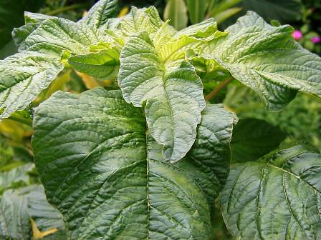

**Recipe**

**Sauté Callaloo**

**Ingredients**

2 tablespoon olive oil

1 medium onion, sliced

2 garlic cloves, sliced

1 boullion cube

Salt and black pepper

2 tablespoon butter or margarine

1 pound callaloo, stripped, washed, and coarsely chopped

**Direction**

In a large skillet over medium heat, add oil and onion. Stir and cook for 2 minutes.

Add callaloo and stir until it has completely collapse, then season with boullion cube, butter, salt, and black pepper, stir to get even distribution.

Reduce heat and leave to cook for 10 -15 minutes or until tender.

Value Added Products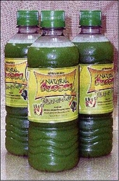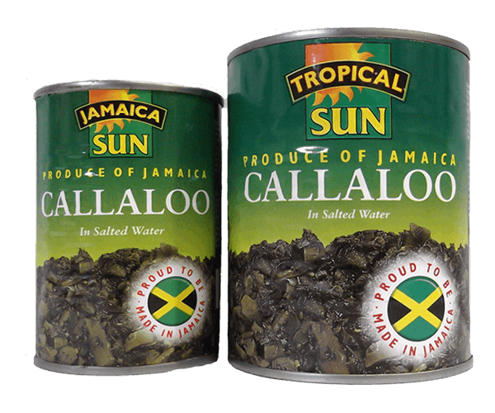

**Photochemistry**

**Nutritional Values:** *A. viridis* is rich in nutrients and has many health benefits and is found have high concentration of 0.28 Na, 3.34 Mg, 0.89 Al, 2.98 Si, 1.7 P, 2.24 S, 1.46 Cl, 4.35 K, 3.52 Ca 1.52 percent Fe A. *viridis* has awealth of other nutritional properties such as vitamin A, vitamin C, fatty acids (Omega-3, Omega-6, α-linoleic), fiber, carbohydrates, and proteins.

Phytonutrients: A. viridis produce phytochemicals that can offer pharmacological benefits. These includes antioxidants, phenolic compounds, **c**arotenoids cardiac glycoside and glucosinolates.

Health Benefits: Phenolic compounds exhibit anti-flammatory, antihepatotoxic, antiulcer, antiallergic, antiviral actions and provide protection against cardiovascular mortality.

Glucosinolates give these vetgetable their sharp odor and flavor. It has expectorative, anti- inflammatory activity and anti-microbial properties and it may keep in check the growth and development of cancer.

Antioxidants are scavengers, which are able to destroy free radicals that are associated with pathogenesis of various disorders like cancer, diabetes, cardiovascular diseases, autoimmune diseases, neurodegenerative disorders and are implicated in aging.

Carotenoids act as antioxidants in our bodies. They have strong cancer-fighting properties, Some carotenoids are converted by the body to vitamin A, which is essential to vision and normal growth and development.

**2. *Amaranthus viridis Linn***

*Amaranthus viridis* Linn. (*A. viridis* ) belongs to Amaranthacae family, is of the genus Amaranth. It is an annual plant that is used as vegetable, cereal and ornamental by different ethnic groups *A. viridis* is commonly known as slender amaranth but is known by a variety of names worldwide. In Asia the plant is commonly called Cheg-Kruk, Kuppacheera, and “Note Shak” which mean leafy vegetable. The Greeks called it “Vita”, while Jamaicans called it Callaloo or greens *Amaranthus viridis* is a fast growing herb and mainly cultivated in Asia, Africa, Latin America, and the Caribbean. It is drought tolerant and does not require a lot to produce. In the last decade, the use of *A.* *viridis* has attracted much attention expanding not only in the common diet, but also of its potential that can contributes to food security, health, income generation, and environment services.

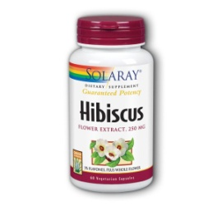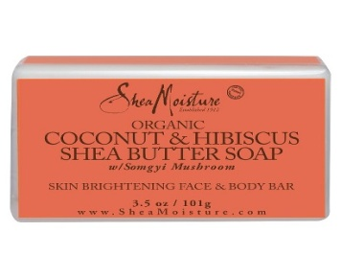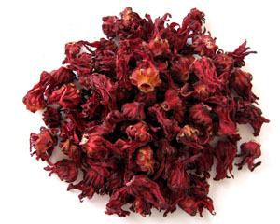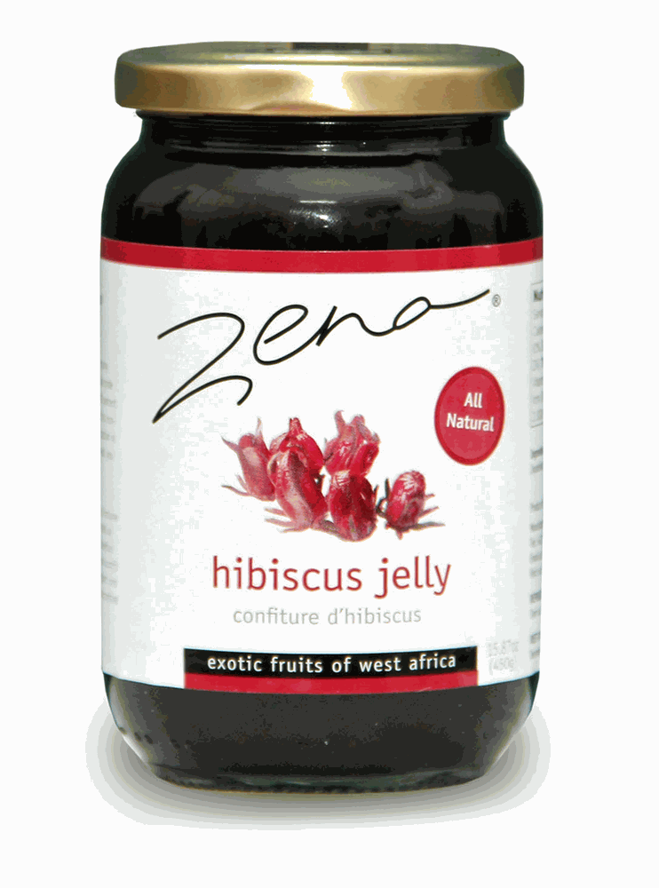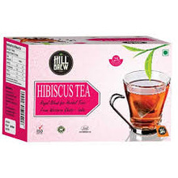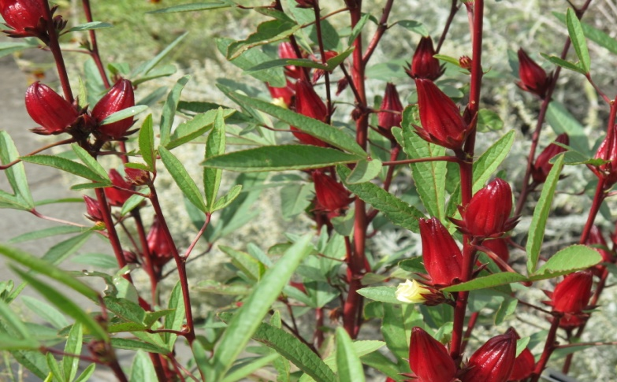

**Ideal Crops**

**1. *Hibiscus Sabdarrifa L.***

*Hibiscus sabdariffa* L., (Hs) is an ethnic crop that is rich in nutritive value and has been shown to possess phytochemical and pharmacological properties. *Hibiscus sabdariffa* L. is a member of the Malvaceae family. It is commonly known in English speaking countries as roselle, hibiscus, and Jamaica sorrel. Due to its ease of growth, multifunctional properties, and its ability to tolerate poor soils, it is seen as an ideal crop for the region.

**Photochemistry**

**Nutritive Value:** The fresh calyces have 89.5% moisture and 10.5% dry matter. The calyces has the following composition based on 100 g dried weight basis: 2.6 mg Al, 3.4 mg B, 0.4 mg Cu, 3.8 mg Fe, 22.8 mg Mn, 12.6 mg Na and 8.6 mg Zn, 1.3% N, 0.3%P, 1.3% K, 1.3% Ca, 0.3% Mg, 0.1% S and 39.5% C.

**Phytochemicals:** The main constituents of *H. sabdariffa* relevant in the context of its pharmacological are organic acids, anthocyanins, antioxidants, and flavonoids.

**Health Benefits:** Phytochemical are associated with pathogenesis of various disorders like cancer, diabetes, cardiovascular diseases, autoimmune diseases, neurodegenerative disorders, anti-inflammatory, antiulcer, antiallergic, and antiviral.

**Value Added Products**

**Benefits of Ethnic Crops**

The incorporation of high yielding ethnic crops by means of crop diversification and intensification using sustainable production practices can be beneficial.

* Provides fresh, safe, healthy and nutrition foods
* Provides niche market to satisfy the demands of the increasing ethnic population
* Creates employment for young farmers and entrepreneurs
* Reduce the dependency of chemical fertilizers
* Improve soil biodiversity
* Improve food security

**"Let's eat what we grow"**

**Locally Sustainable Grown Ethnic Crops can make a difference**