Table 1. Berry quality ratings for varieties of Red Primocane­Fruiting raspberries evaluated for Drosophila suzukii infestations in 2014 and 2015.

Vatiety | Hardiness | Harvest | Productivity | Fruit Size | Attractiveness | Firmness | Flavor | Freezing
Autumn Bliss | fair | early | very good | large | very good | good | very good | very good
Polana | good | early | excellent | medium | very good | fair | fair | good
Autumn Britten | fair | early | good | large | very good | very good | excellent | good
Caroline | fair | mid late | good | large | very good | good | very good | good
Joan J | excellent | mid | very good | large | excellent | very good | very good | very good

Table 2. Varieties of Red Primocane­Fruiting raspberries evaluated for Drosophila suzukii infestations in 2014 and 2015.

Average Larvae Per Fruit
 | 10‐Aug | 12‐Aug | 14‐Aug | 15‐Aug | 17‐Aug | 19‐Aug | 20‐Aug | 21‐Aug | 22‐Aug | 24‐Aug | 28‐Aug
Autumn Bliss | 45.75a | 15.75a | 27.63a | 11.50ab | 1.70b | 4.64b | 1.80a | 1.33b | 4.80ab | 2.88b | 3.17b
Autumn Britten | 36.125a | 25.43a | 36.38a | 8.50b | 3.20b | 5.55b | 5.60a | 5.00a | 0.90b | 10.17a | 5.00ab
Caroline | 26.5a | 28.75a | 29.25a | 22.90a | 6.43ab | 12.92a | 5.45a | 4.50ab | 6.00a | 4.92ab | 5.10ab
Joan J | 24.57a | 14.00a | 27.13a | 14.10ab | 10.82a | 5.10b | 3.80a | 2.33ab | 6.00ab | 2.50b | 8.43a
P‐value | 0.21 | 0.21 | 0.45 | 0.02 | 0.002 | 0.007 | 0.18 | 0.02 | 0.02 | 0.02 | 0.005

Fig 1. Varieties of Red Primocane-Fruiting raspberries evaluated for Drosophila suzukii infestations by percent of infested berries in 2014.

Fig 2. Regression of percent infested fruit over time for the varieties of Red Primocane-Fruiting raspberries evaluated for Drosophila suzukii infestations in 2015.

Fig 3. Average larvae per fruit for each variety of Red Primocane-Fruiting raspberries evaluated for Drosophila suzukii infestations in 2015.

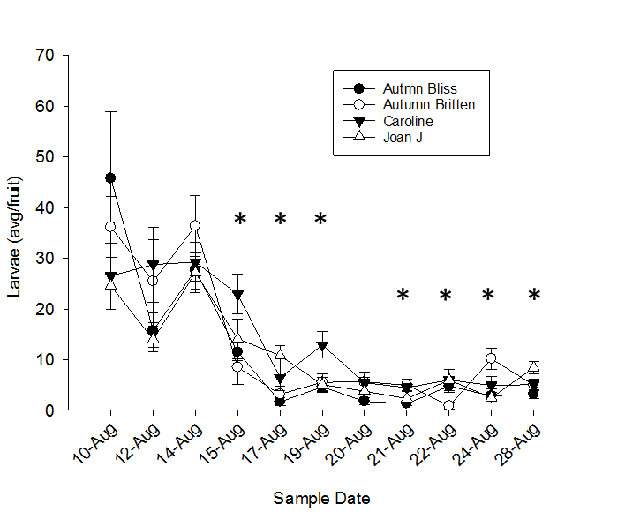
Fig 4. Average number of larvae per fruit over time by varieties of Red Primocane-Fruiting raspberries evaluated for Drosophila suzukii infestations in 2014 and 2015.Dates marked with an asterisk are significantly different.

Fig 5. Regression of the average number per berry over time for the varieties of Red Primocane-Fruiting raspberries evaluated for Drosophila suzukii infestations in 2015.

Table 3. Infestations of identified potential alternative host plants, expressing both average number of D. suzukii per berry and average percent of fruit infested.

Family | Scientific name | Common name | 2015  Mean infestation totals | 2015  Mean % fruit infested | 2016  Mean infestation totals | 2016  Mean % fruit infested
Caprifolicaceae | Lonicera tatarica | Tartarian honeysuckle | N/A | N/A | 0.492 | 18.3%
 | Lonicera morrowii | Morrow’s honeysuckle | 0.204 | 13.1% | 0.386 | 18.6%
Rosaceae | Rubus occidentalis | Wild black raspberry | 0.236 | 13% | 0.121 | 6.06%
 | Fragaria vesca | Wild strawberry | 0 | 0% | 0 | 0%
 | Prunus americana | Wild plum | 0 | 0% | 0 | 0%
Cornaceae | Cornus racemosa | Gray dogwood | 0.0778 | 6.67% | 0.0435 | 2.32%
Rhamnaceae | Rhamnus cathartica l. | Common buckthorn | 0.0015 | 0.15% | 0 | 0%
Grossulariaceae | Ribes spp. | Wild gooseberry | 0 | 0% | 0 | 0%

Table 4. Infestations of identified crop host plants, expressing both average number of D. suzukii per berry and average percent of fruit infested.

Family | Scientific name | Common name | 2015 mean infestation totals | Mean % fruit infested  2015 | 2016 mean infestation totals | Mean % fruit infested 2016
Rosacea | Rubus ideaus | Red raspberry | 0.251 | 10% | 1.59 | 32.2%
Ericacea | Vaccinium corymbosum | Highbush blueberry | 0.0897 | 6.09% | 0.332 | 18.8%
Capricoliaceae | Samucus canadensis | Elderberry | 0 | 0% | 0.121 | 10%

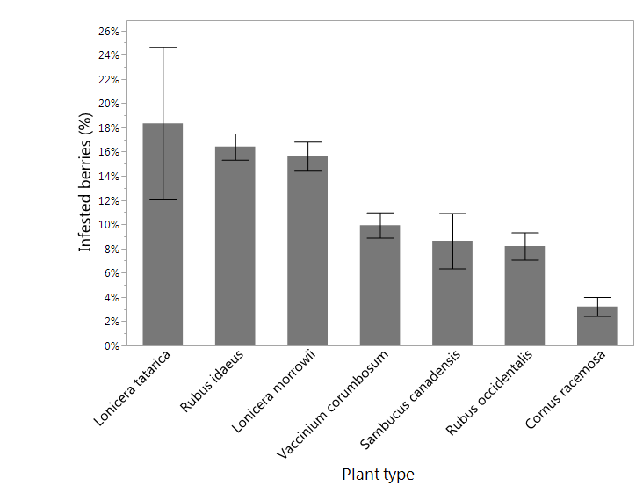
*
*
*
C
B
B
B
A
A
A

Figure 5. Infestation rates for plants to be found to have infestations averaged through both years 2015 and 2016 at 95% confidence interval. Ordered differences are A, B, and C. Asterisks represent crop hosts.

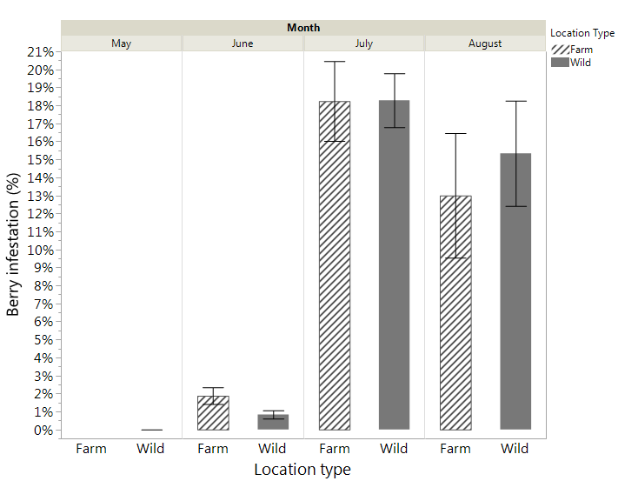
Figure 6. Percent of alternative host fruit infested by D. suzukii over the course of growing seasons 2015 and 2016. Differences are observed between farm and wild locations over time, May through August.

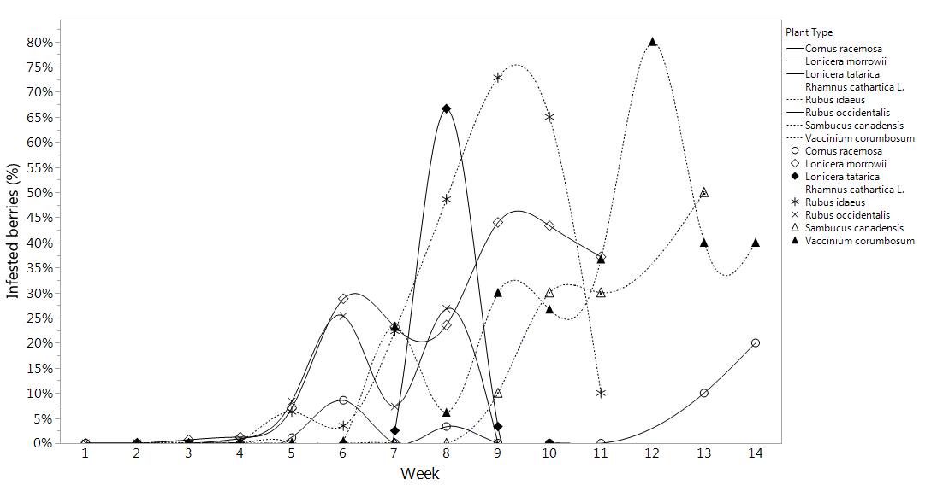
Figure 7. Percent of berries infested by plant type over time for both years 2015 and 2016.
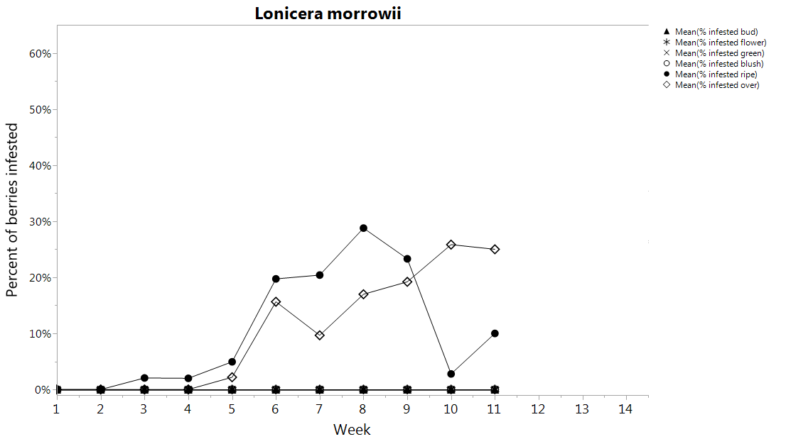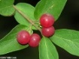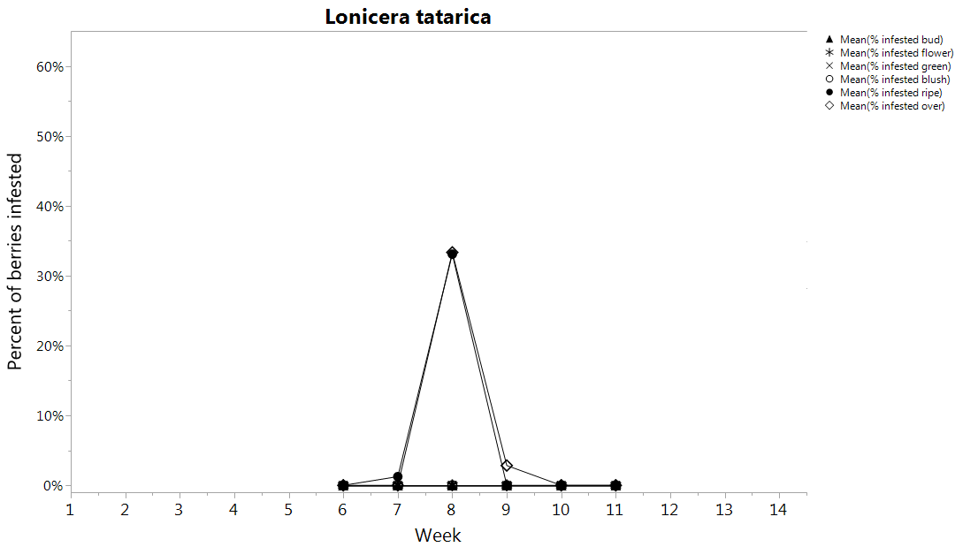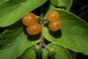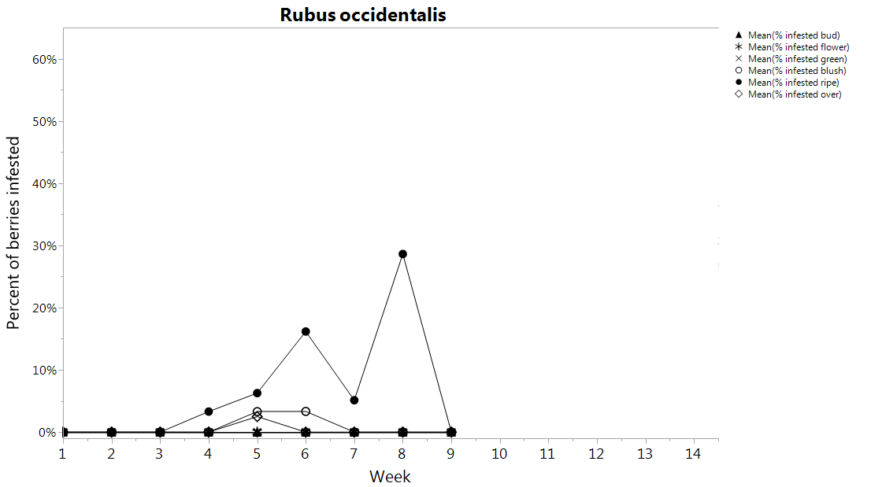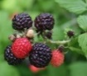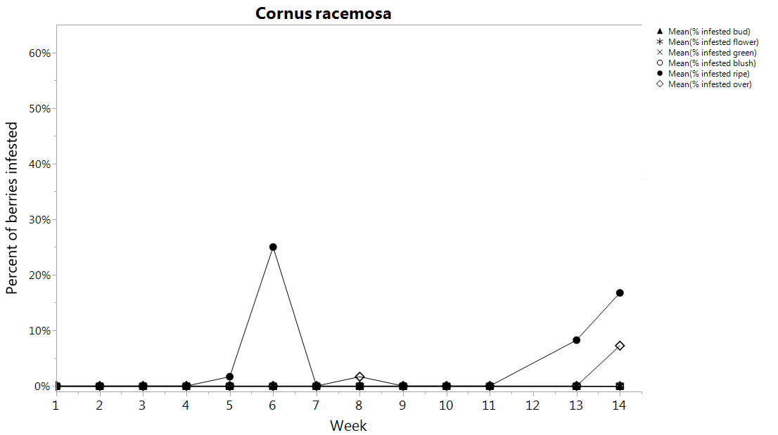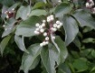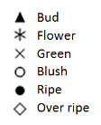
Berry stages infested
Berry phenology
Bud
Flower
Green
Blush
Ripe
Over ripe
Figure 8. Comparison between the berry ripening phenology of each alternative host plant (lower bars) and infestation percent for their respective fruit over time.
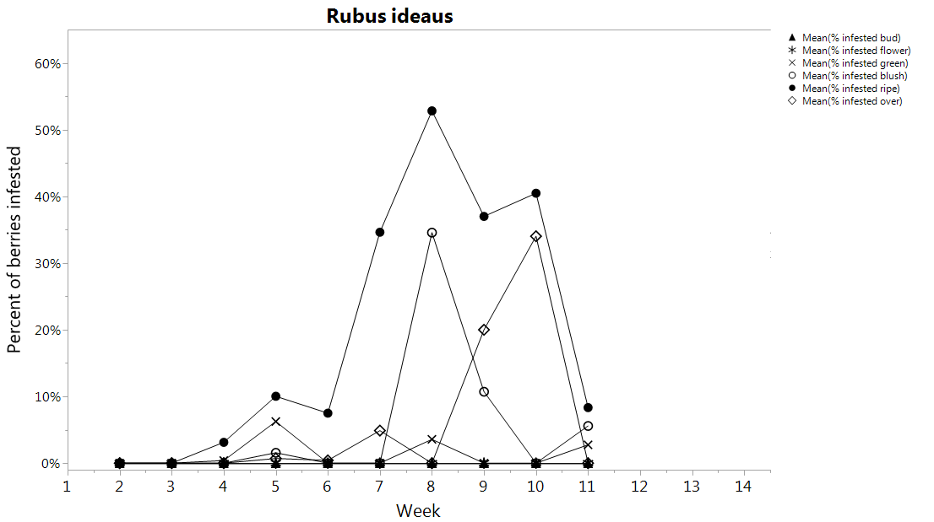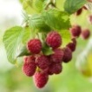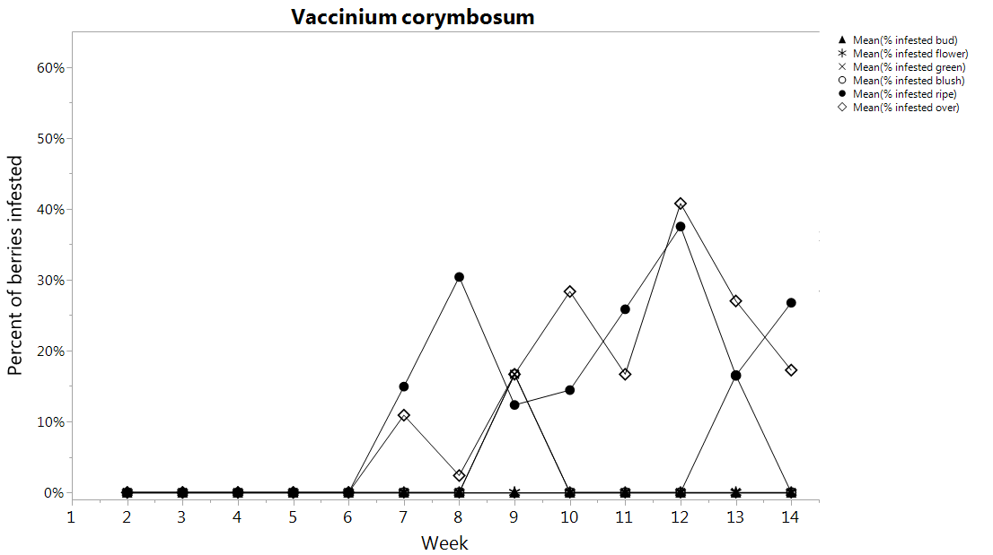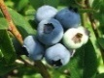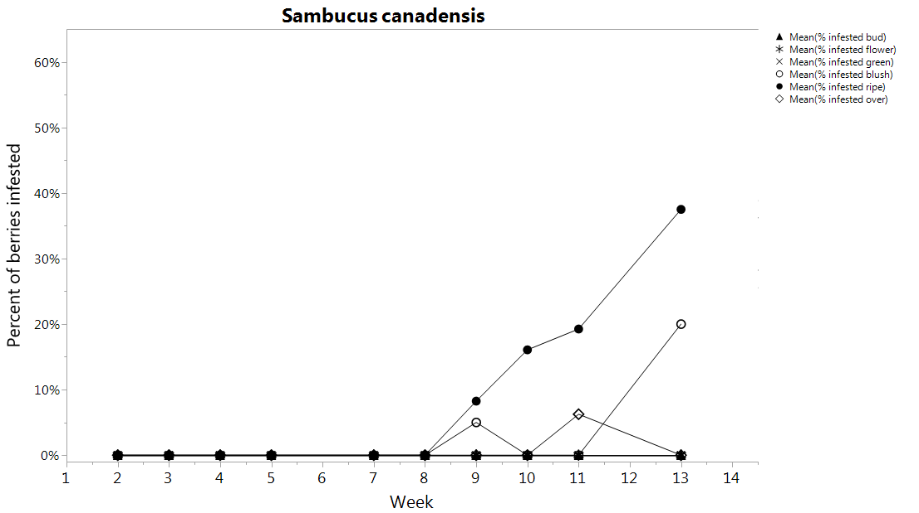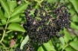
0000000
Berry stages infested
Berry phenology
Bud
Flower
Green
Blush
Ripe
Over ripe
Figure 9. Comparison between the berry ripening phenology of each crop host plant (lower bars) and infestation percent for their respective fruit over time.

