Growing Potatoes
Introduction:
Growing one person, one family, one community at a time!
- Introduce who we are and what our goal is….
- We have been gardening for 30 years…
- Canning for just as many to feed 5 children.
- So our heart goes to the low income to teach and help them provide for their family or sell to bring income in for them.
- What about the potato? 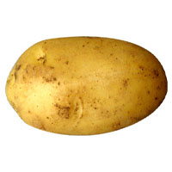 It is in the Solanaceae family (potato, tomato, peppers and eggplant),
There is a new hybrid out that has taken the inferior potato root and an inferior tomato stem and grafted them together to grow both products.
- The potato originally came from tropical and central America, Andes Mountains. Because they came from this climate they require very rich, damp and fertile soil. They love something similar to rich leafmold of the tropical jungle.
- Because of this the vines cannot handle a frost, they are not frost hardy. That is why they are put out after St. Patrick’s Day here in zone 6.5. The vines are what cannot handle the frost by putting them out at this time of year the vines will be safe when they start emerging from the soil.
- Potatoes thrive in acidic soil, anything over a PH of 4.8 to 5.5. So never lime your potatoes. Plenty of compost or manure is what the potato loves. A little nitrogen helps produce a greater yield of potatoes.
- Getting ready to plant the potato seed. You can grow potatoes from seeds but it is a long process it is better to buy seed potatoes. There a hundreds of different types to choose from. One potato plant will grow anywhere from 6 to 12 potatoes. You can cut the seeds (tubers) in half with 2 or 3 eyes in each but I prefer to leave them whole so disease doesn’t get in them. You don’t want to weigh less than 1 ½ ounces. Lay your seed potatoes out single layer on screen or a table single layer thick in a cool dark place to start the chitting process. Chitting is letting the potato sprout a little to get it going for the season. Place the potato rose end up (where at least 3 eyes are located. Chitting is very important for your early crops, you don’t have to do this for your later crops.
- Plant potatoes 1 ft apart in rows. In square foot apart. In vertical cylinders 6 in. from circumference of circle and 8 in apart, some in middle. Early potatoes start out 4 in. deep and layer dirt, straw, compost or leaves as they grow. Later in the season I plant them 6 to 8 in. deep. The potato will form little potatoes above the seed potato that you planted so give it room to produce.

- When the flower comes on that means the tubers are forming. Make sure you are watering while they are forming. You can start harvesting new potatoes about 7 weeks after planting.

- The different ways you can plant a potato…. Traditional, vertical, boxes, bags, containers
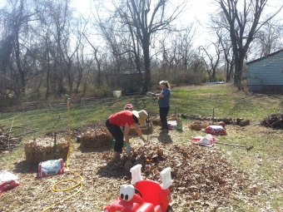
How we planted our vertical towers last year.
The changes we will do this year. The outcome…..
The different methods we will be experimenting with this year. We are looking for 2 induvials to partner with us on growing potatoes in a vertical tower.
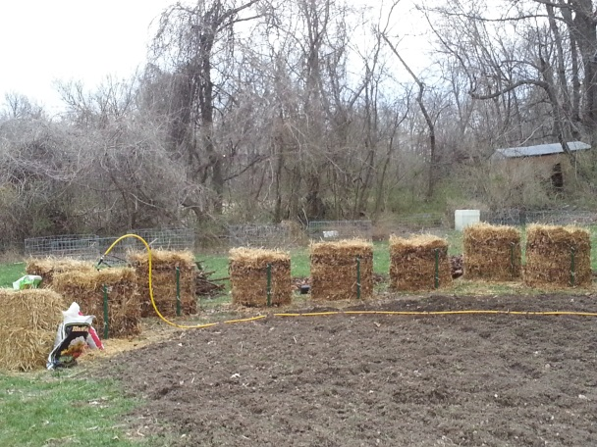
- Hilling or layering to grow your potatoes. This is very 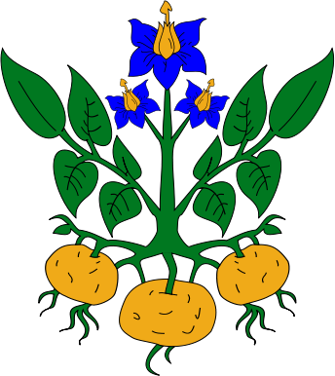important; your potatoes need to have the space between the seed potato and the vine growth to put on new potatoes.

Nutritional info: Potatoes are rich in vitamin C. Antioxidants. Potatoes contain antioxidants including vitamin C, carotenoids, and anthocyanins. The amounts and types are dependent upon the potato variety. So, make sure to include a number of different potato types (e.g., reds, purples, yellow, and russets) in your diet.
Vitamin B₆. Potatoes are a good source vitamin B₆, which is a nutrient that plays an important role in carbohydrate and protein metabolism. It helps turn the energy from food into energy your body can use.
Vitamin C. Potatoes are an excellent source of vitamin C (45% of the DV), in fact they have more vitamin C than one medium tomato (40% DV) or sweet potato (30% DV). Vitamin C plays a key role in the synthesis of collagen (important for healthy skin and gums) and may help support the body’s immune system.
Fiber. One wholesome, satisfying potato with skin contributes 2 grams of fiber to the diet or 8% of the recommended daily value. Dietary fiber has been shown to have numerous health benefits, including improving blood lipid levels, regulating blood glucose, and increasing satiety (makes you feel full longer), which may help with weight loss.
Gluten-Free. Potatoes are naturally gluten-free. An ideal substitution for some of your favorite bread, grain and pasta-based dishes, potatoes add a boost of nutritional benefits too.
Healthy. That’s right, potatoes can be part of a healthy diet. It’s the toppings that typically put spuds over the top in calories and fat. Try salsa, low-fat cheese and broccoli instead!
Glycemic Index. The GI of potatoes is highly variable depending on the variety, origin and preparation methods. Confused? Don’t worry about it–both the 2010 and 2015 Dietary Guidelines committees concluded there is no evidence indicating the GI aids in weight loss or weight loss maintenance.
Just 110 Calories. A medium (5.3 ounce) potato with skin has just 110 calories. Keep them lean by simply roasting with olive oil, herbs and a pinch of salt.
K = Potassium (periodic table, anyone?). Research suggests diets high in potassium and low in sodium may reduce the risk of hypertension and stroke. Potatoes with skin are a good source of potassium.
Label. Look to the FDA-approved nutrition label for all of the facts on potato nutrition.
Magnesium. A medium potato provides 48 mg of magnesium and research indicates potatoes contribute 5% of the total magnesium intake in the diets of Americans. **
Nutrition Facts: One medium potato has no fat, sodium or cholesterol. Just check out the FDA-approved nutrition label!
OMG. Who doesn’t love the taste of potatoes?! Expand your passion for potatoes even further with new types, cooking preparations, and global spices.
Peel. The potato’s skin contains approximately half the total dietary fiber, but the majority (> 50 percent) of the nutrients are found within the potato, itself.
Quick. Potatoes come in hundreds of shapes and sizes. Try the smaller varieties for a quick stove-top meal, and remember to use the microwave to speed the cook time of all your potato recipes.
Resistant Starch. Resistant Starch (RS) is found naturally in potatoes and is a type of carbohydrate that is “resistant” to digestion by human digestive enzymes, just like dietary fiber. It also is believed to deliver similar health benefits to dietary fiber and has been shown in both human and animal studies to improve the health of the gastrointestinal tract and digestive system.
Sweet Potatoes vs. white potatoes. Surprise! Both vegetables supply important nutrients. They are similar in their calorie content as well as the amount of fiber, protein and vitamin B6.. White potatoes pack the greater potassium punch (620 mg vs 440 mg) whereas sweet potatoes definitely lead the way in vitamin A (120% of the daily value). Both potatoes provide an excellent source of vitamin C (45% of the daily value for white potatoes and 30% of the daily value for sweet potatoes).
Types. Russets, reds, yellows, purples/blues, whites, fingerlings and petites. There’s a different type for every day of the week. Try them all!
USA. A vast majority of all potato farms in the U.S. are family owned. From California to the Carolinas, families just like yours work hard year-round to nurture, grow and deliver potatoes from their farm to your local market.
Vegetable. That’s right, folks. Potatoes are a vegetable.
Weight Management. Research shows potatoes (when prepared healthfully) can be part of a weight loss plan.**
Xcellent. Need we say more? Only two more letters to go and it’s pretty obvious potatoes are an excellent staple in our diet.
Yummy. According to consumers**, taste is everything. Tastes good and good for you? Potatoes are the superfood you’ve been dreaming about.
Zero. Did we mention zero fat, sodium or cholesterol?
*References to potato nutrient values are based on a medium, 5.3 oz potato with skin.
**All research references can be found in the Potato Nutrition Handbook. For more in-depth nutrition information visit our Nutrition Professionals pages.

What’s New in Nutrition

POTATO NUTRITION A TO Z
(August 15, 2015) – Potato pop quiz! Are potatoes healthy? Yes! According to a National Eating Trends survey, potatoes are America’s favorite side dish, and that’s great news, America, because...

Before class starts……. Class is being taught at________________ Date_______________

How much do I know about the Mighty Spud?

Does the potato grow produce above ground or below ground? ______

Do new potatoes grow from roots or tubers?__________

True or False Potatoes are frost hardy.

True or False It is important to chitty all your potatoes.

True or False The vines grow from the ears of potato seeds.

True or False Potatoes should be covered with 4 to 6 inch of soil.

The potato originates from the Andes Mountains or from Ireland?_____

Did I learn anything today about the Mighty Spud?

True or False Potatoes are from the Nightshade family, (potato, tomato, pepper and eggplant)?

True or False The potato tuber has eyes that the vines grow from.

What is the correct PH for potatoes to grow 4.8 to 5.5 or 5.5 to 6.5

True or False I can save potatoes every year (up to 5 years) to replant from my garden.

True or False The scientific name for this Nightshade plant is Solanaceae.

In early spring you want to encourage your potato to sprout, this is called _________.

Do you want to add anything?
____________________________________________________________________________________________________________________

Firecracker Potato Salad
½ pound red potatoes cubed and cooked ½ pound blue potatoes cubed and cooked
½ pound white potatoes cubed and diced 1 onion diced
2 tbs. Dijon mustard 1 tbs. horseradish
½ cups mayo Salt & pepper to taste
1/8 tsp. garlic powder 3 tbs. sweet relish
1 lb. Pepper Jack Cheese diced
Cube and cook the potatoes until fork tender. Let cook in refrigerator or immerse in ice. Mix together mustard, horseradish, mayo, garlic powder and sweet relish in a bowl. Set aside. With cold potatoes salt & Pepper them to taste. Add onion and rest of ingredients from bowl. Add diced pepper jack cheese. Taste and adjust seasoning if needed. Keep cold until serving. You can add some boiled eggs to this for a creamier potato salad.
Serves 6
One medium potato with the skin contains 45% of our daily needed vitamin C. They have more potassium than bananas, spinach or broccoli. 10% of our daily value of B6 and small amounts of thiamine, riboflavin, folate, magnesium, phosphorous, iron, and zinc. Only 110 calories. They are a complex carbohydrate, your body’s’ main energy source.

Hash Brown a La Mode
3 large potatoes grated or 4 cups frozen hash browns
1 onion diced 2 celery stalks leaves also diced
1 cup pepper diced (all colors) 1 cup kale cut stems removed
2 tbs. olive oil 1/8 tsp. garlic powder
dash of salt & pepper 1 tomato cut in wedges
1/2 cup cheese (cheddar, Swiss, mozzarella, Monterey jack, etc. any type my favorite is Mexican style)
Put oil in pan and let it get hot. Sautee onions, peppers& celery with a dash of garlic, S & P. About 3 minutes add grated potatoes dash of all 3 seasonings. cook for another 5 minutes. Add kale, garlic, S& P cook for another 3 or 4 minutes. Add tomatoes and cheese put lid on for 1 or 2 minutes. Serve hot.
You can add spinach, broccoli, corn, carrots, etc.to this recipe. You can also add chicken, pork, bacon, sausage or mushrooms. It can make a meal or a side dish. It is easy, good , healthy and pretty all in one!!!.

Zuppa Soup Olive Garden Recipe
1 lb ground Italian Sausage
1 ½ tsp. crushed red pepper
1 large diced white onion
4 bacon stripes
10 cups chicken broth
1 cup heavy cream
1 lb russet potatoes
¼ bunch kale chopped

Cook sausage and red pepper drain and keep cool.

Sauté bacon, onions and garlic on low for 15 min. or until onions are soft and see through.
Add broth & bring to boil.
Add diced potatoes cook until soft.
Stir in sausage & kale. Heat through and serve hot.

