How to Design an On-Farm Experiment: The Nuts & Bolts  
Sam Corcoran, UMass Extension Event: July 12, 2016

SIHERC

**S**tate (the question) – what do you want to know?

**I**nvestigate (the known body of information) – what do we already know about this? What is the *gap* *in knowledge?*

**H**ypothesis – what do you think or expect? *Why?*

**E**xperiment – how can you test your hypothesis?

**R**esults – what does this mean? Did I support or refute my hypothesis? Have I answered the question?

**C**onclusions – what next? Another experiment, a change in management? Communicate your results.

1. **State** the Question – Open Ended

* Work backwards to choose the question – consider *observations* & *needs*
  + **I’ve noticed**…I have less pathogen pressure after a mustard cover crop
  + **I wonder**… if I can direct seed instead of transplant fava beans and get the same yields
  + **How can I**…maximize nutrient capture from fall applied manure
  + **Why is it**…two neighboring fields yield so differently when treated the same
  + **Is there an effect of**...converting a conventional tillage field to conservation tillage
    - What do I want to know? Why am I doing this? WHAT’S THE POINT?
* Consider the desired outcome, but avoid “outcome driven” questions.
  + Poor question: “I know some people use oats as a cover crop. How much nitrogen do oats supply to my summer squash?”
    - What if oats don’t supply much nitrogen at all? What if oats reduce N availability?
    - Doesn’t leave room for an experiment; there is nothing to *manipulate.*
  + Better questions:
    - “How do fall planted oats affect in-season cash crop N needs compared to [using no fall cover crop], [other grasses], [non grass cover crops], [spring planted oats]?”
    - “I know cover crops can supply nitrogen to cash crops. What fall planted cover crop or cover crop mix will provide the most nitrogen to my spaghetti squash?”
  + Bigger ≠ Better? “Are fall planted or spring planted cover crops, or a combination of both, most efficient at providing N to the following cash crop? Is there any difference? Are different cover crops better suited to different planting times or combinations? Does the cash crop affect what cover crops I should use?” 🡪 This could be your life’s work!
* Avoid bias. Use clear language.

A. What’s wrong with this question? “How can I suppress weeds better than by using Round Up?”   
___________________________________________________________________________________________  
___________________________________________________________________________________________  
B. How can we improve/rewrite the above question? _________________________________________________  
 ___________________________________________________________________________________________

2. **Investigate** the Known Body of Information  
*-See “Resources” handout  
-Don’t fear “scholar.google.com”  
-Stick to “.edu” and “.gov” websites. Use “.org” if you know and trust the source of the website (Ex: a museum)  
-Skip the “.com”; any hack with internet access can have a .com website and make up whatever they want.*

* What do we already know? What’s missing from the currently available information? What new information is your experiment going to answer? Refine your question.
  + Difference between “trying something new” on your farm and truly “experimenting”. Be clear about your goal.
  + Seeking a grant? Avoid creating redundant information.
    - If it hasn’t been done in your region, soil type, topography, the crop you are working with, etc, it’s not redundant
      * Ex: Tillage radish can alleviate soil compaction in Hadley Loam soil more effectively than conventional tillage or other cover crops. Does this apply to my clay soil, too?
      * Ex: Sunn Hemp will grow in PA and MA, but not ME. Can I grow it in NH, and if so, what’s the ideal planting date?
      * Ex: Mustard cover crops seem to reduce or prevent *Phytopthora* in the soil, will that work for damping off caused by *Pythium*, too?
      * Novel Ex: We know bats can help reduce mosquito populations. If I install bat boxes around my field, can I reduce insect pressure & insecticide use?
    - You can seek to disprove “known” information or tweak/improve previous work
      * Ex: “Deerfield farm claimed reduced corn yields following a grass cover crop. Is it possible this was a mechanical issue because they used a conventional planter, and these reduced yields wouldn’t occur if they used a no-till planter?
      * Ex: “UMass researchers looked at how much nitrogen the cover crops have in the fall, but I need to know if/how much N the cover crops are releasing when my crop needs it in mid-June.”
  + **Rephrase or refine your question if needed. *Lather, rinse, repeat.***
  + **Use the known body of information to instruct your hypothesis and design your exp.**

Desired outcome: I want to spend less money and time applying herbicide, and my customers want low   
 spray products.   
Question: Is there an economically efficient alternative to conventional herbicide that doesn’t   
 sacrifice yields and isn’t excessively time consuming?   
Known info: Solarization can reduce the seedbank, conservation tillage avoids turning up new weed   
 seeds, cover crops like tillage radish suppress fall and early spring weeds, tine weeding   
 can help manage weeds once the cash crop is planted. No one method works as well as   
 conventional herbicide. **Unknown**: Can I use a combination of these methods to get   
 similar results to herbicide? If the weed suppression is similar, is the expense associated   
 with extra time/materials equal to the cost savings?

NOTES:__________________________________________________________________________________________________________________________________________________________________________________________________________________________________________________________________________  
___________________________________________________________________________________________

3. **Hypothesis** – Closed Statement

* Based on what you know from your observations, prior knowledge, and investigation of the current knowledge, what do you expect or think will occur?
* The hypothesis must be *testable* – this inherently means *measurable.*
  + “Tomatoes should only be planted after mustard greens.”
    - Variables: this hasn’t left anything test. What is it being compared to, and what is the criteria to verify this statement?

C. This could be changed to make it a testable hypothesis. How?:_______________________________________

___________________________________________________________________________________________

* + “All dogs go to heaven.”
    - Dependent on something else unproven: We haven’t proven heaven exists yet, or the alternatives. (Technicality: We can’t test this in our lifetime and report back).
  + “There are dinosaurs still alive at the center of the earth.”
    - Logistics: Right now we can’t get to the center of the earth.

D. Write your own hypothesis for our herbicide question: _____________________________________________  
  
___________________________________________________________________________________________  
  
___________________________________________________________________________________________

* + The hypothesis is set in stone. Never change the hypothesis if your results don’t support your hypothesis. It doesn’t matter if you are “wrong” or “right”.
    - You can change your hypothesis in a future experiment.
  + Null Hypothesis: Turns out my treatments had no effect.
    - Ex: **H:** I hypothesize honey bee colonies will experience increased survival rates over the winter if they have mushroom tea instead of sugar water. **R**: Drinking mushroom tea instead of sugar water didn’t change survival rates.
  + You don’t “prove” your hypothesis. You just don’t “disprove” it, or you support your idea and it’s likelihood of occurring. Karl Popper’s example:
    - **H:** All swans are white. **R:**  You see 1,000,000 white swans. 100 years after you die someone sees 1 black swan.
    - It only takes one to prove something “wrong”, it doesn’t matter how many times something is “right”.

My example for D (above): A combination of spring solarization, fall planted tillage radish, and conservation tillage will provide comparable weed suppression to conventional herbicide, and the increased cash crop value will offset the expenses of cover crop seed and solarization material.

NOTES:__________________________________________________________________________________________________________________________________________________________________________________________________________________________________________________________________________  
_____________________________________________________________________________________________________________________________________________________________________

4. **Experiment** – Test the Hypothesis

* Do you have the basic **EQUIPTMENT** and space to test your hypothesis?
  + Nuts. I don’t have a no-till planter, but I can borrow my neighbor’s tine weeder and try that instead.
    - New hypothesis: A combination of spring solarization, fall planted tillage radish, and ~~conservation tillage~~ tine weeding will provide comparable weed suppression to conventional herbicide, and the increased cash crop value will offset the expenses of cover crop seed and solarization material.
      * **Do you still think this hypothesis is accurate?**
      * *Yes, I still think this can work. If the results are promising, I can look into a no-till planter in the future.*
  + Select the **LOCATION** of the experiment carefully.
    - Don’t put the experiment in your worst field unless that’s the point.
* **VARIABLES**
  + Independent – this is what you manipulate; aka **TREATMENTS**
    - Ex: Seeding rate, planting date, fertilizer – type, amount, timing of application, cover crop species, etc.
  + If you have more than one independent variable, you create interactions
    - Limit independent variables to avoid very complicated experiments
    - Mastermind approach – change one or two things at a time
    - Ex: What is the effect of mustard seeding rate and time of incorporation on suppressing disease and increasing yield?



* + Dependent – this is what you sample to see the effects of your manipulation
    - See “common examples”
    - You can have multiple dependent variables – above: Disease and yield
* **CONTROLS**
  + How will you know if what you did worked/resulted in the desired effect?
    - Negative – no treatment.

E. In mustard example: leave soil bare, or plant non-biofumigation crop. Using both would be best. Why?   
  
___________________________________________________________________________________________

___________________________________________________________________________________________

* + - Positive – guaranteed desired outcome. In mustard example: spray fungicide.

NOTES: ­­­___________________________________________________________________________________  
  
___________________________________________________________________________________________  
  
___________________________________________________________________________________________

F: Our Weed Control Experiment – What are the treatments if we remove solarization?

 

* + Revised Hypothesis: A combination of ~~solarization,~~ fall planted tillage radish and ~~conservation tillage~~ tine weeding will provide comparable weed suppression to conventional herbicide, and the increased cash crop value will offset the expenses of cover crop seed ~~and solarization material~~.
    - **Do you have confidence in your new hypothesis? If not, revise the question & revise the hypothesis. Oftentimes the complications of the experiment limit our abilities to test our ideas, unless we are willing/able to put in the extra work.**
    - *I don’t agree with my new hypothesis. I don’t think this revised experiment will answer my question. I’m going to keep the 9 plot project (7 treatments, 2 controls).*
* What samples will you take (dependent variables)?
  + How will you take them?
  + How many will you/do you need to take?
  + When/how often do you need to take them?
  + How will you label/store/prepare/analyze them?
  + What will they tell you? WHAT’S THE POINT?
* Common examples
  + C:N (of plant tissue – send to lab)
  + Soil nutrients (NPK, micronutrients, soil probe – send to lab)
  + Soil organic matter (soil probe – send to lab)
  + **Insect pressure** (#, %, damage rubric)
  + **Disease pressure** (%, damage rubric, genetics – lab)
  + **Weeds** (count/ID)
  + **Yield** (crop dry weight = drying oven, scale, or milk/animal weight/egg yield)
  + **Biomass** (cover crop dry weight = drying over, scale)
  + PSNT (soil probe – send to lab)
  + **Soil compaction** (penetrometer)
  + **Ground cover** (%, there’s an app)
  + **Worm middens** (per ft2)
  + **Economics** (record expenses - ex. fertilizer, equipment, seed, time - and profits)

G: For our herbicide questions: what samples should you take (see list above)? _____________________

_____________________________________________________________________________________  
  
_____________________________________________________________________________________

H. When/how often should you take those samples? ___________________________________________  
  
_____________________________________________________________________________________

* **REPLICATIONS**
  + Once isn’t proof.
  + Repeat the experiment to:

1. minimize chances of random, normal field variation impacting results (reduce noise)
2. verify results are consistent
   * Repeat:
     + Side by side in one field (at least four replications)
     + In multiple fields or multiple farms
     + Over multiple years (2 minimum)

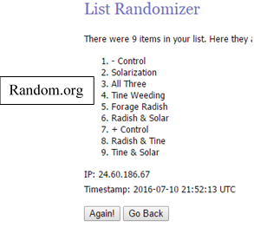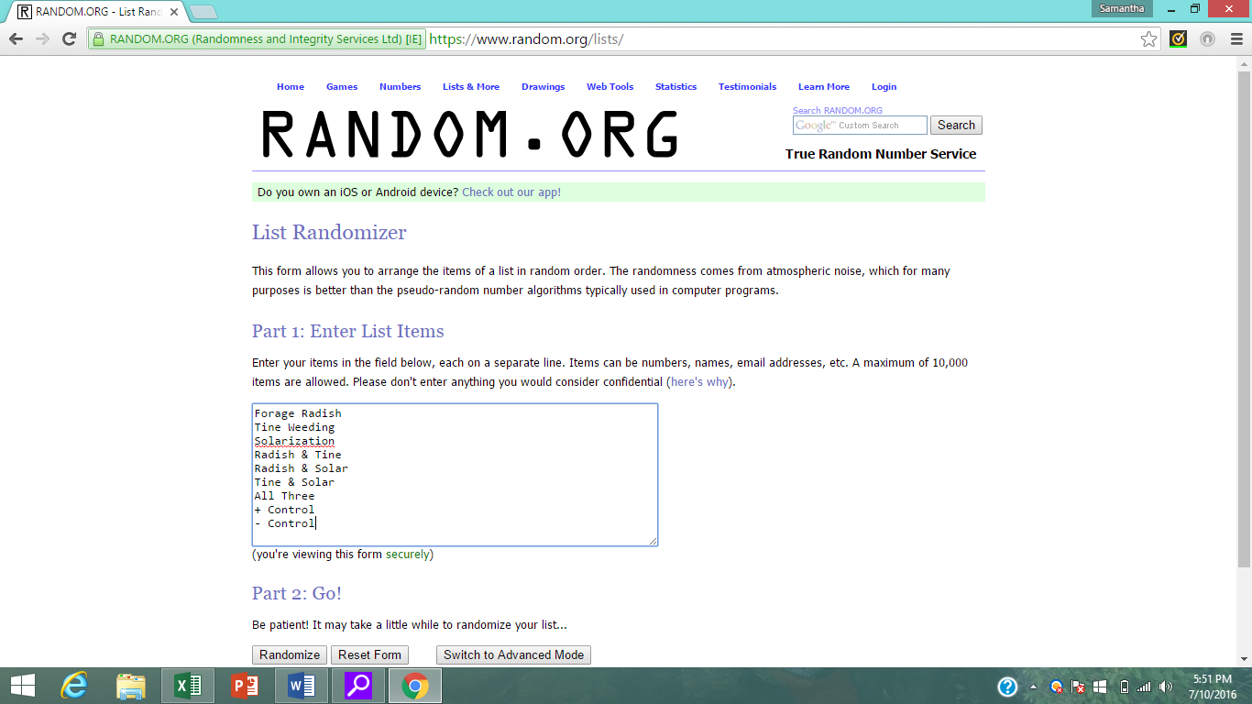

**Complete Random Block Design**

**Random.org**



**Random Strip Design**

* + Complete random block designs – the Classic Academic Design
    - Preferred for statistics
    - Account for unavoidable field variation. Ex: drainage, wind, microbial community
      * the variation *within* one block is less than the variation *between* blocks
      * each block (replication) should be fairly uniform
      * randomization with each block removes bias
    - May not be feasible to accommodate the experimental design. Ex: equipment, need for large space for multiple samples, planting date or tillage experiments
    - More difficult to plant, manage, sample
  + Strip designs – the Classic On-Farm Design
    - still considered a form of random block design
    - easier to plant and get equipment in and out of
  + Split plot – the Makes-My-Life-Easier Design
    - Simplifies space driven treatments
      * Ex. tillage & fertilizer applications – few large sections vs. many small sections
      * Ex. herbicide & pesticide application – same as above & minimize risk of drift

**Spit Plot Design**



* + Other common types (not shown)
    - Factorial
    - Complete random design (no blocks)
      * Biological replicates (Technical replications shown in this handout)
* Adding replications means taking and processing more samples.
  + Weeds: fall, spring, summer: 3 sampling times X 9 plots X 4 reps = 108 samples
  + Cover crop biomass: fall: 1 sampling time X 4 plots X 4 reps = 16 samples
  + Yield: mid-summer: 1 sample time X 9 plots X 4 reps = 36 samples  
     Per Year: 160 samples   
     Two Year Exp: 320 samples
  + PLUS: Economic data (costs, savings, profits)
* **PLOT SIZE**
  + Accommodate equipment
  + Enough room for multiple samples
    - How big will your biomass and yield samples be?
    - Don’t take yield samples where you harvested cover crops or weeds for biomass samples
  + Buffer space in each plot, and around the whole experiment
    - Reduce edge effects
      * Shading of taller plants
      * More light if nothing planted next door
      * Herbicide or pesticide drift (you’ll need a bigger buffer for this)

NOTES:__________________________________________________________________________________________________________________________________________________________________________________________________________________________________________________________________________  
_____________________________________________________________________________________________________________________________________________________________________