TO:
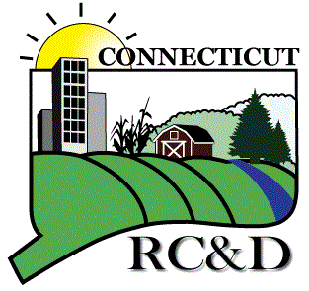
USDA is an equal opportunity provider, employer, and lender.

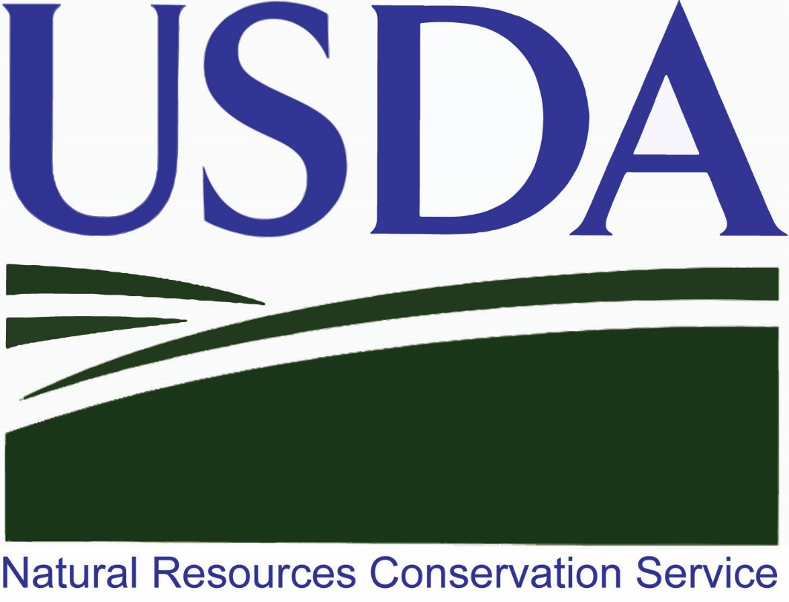
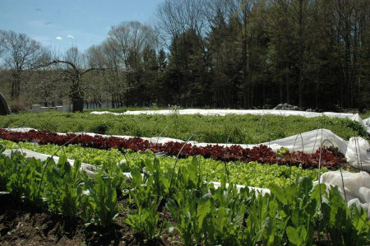

Lebanon Fire Safety Complex
23 Goshen Hill Road
Lebanon, CT 06249

Monday, November 27, 2017
8:30am -3pm
Healthy Soils= Healthy Food

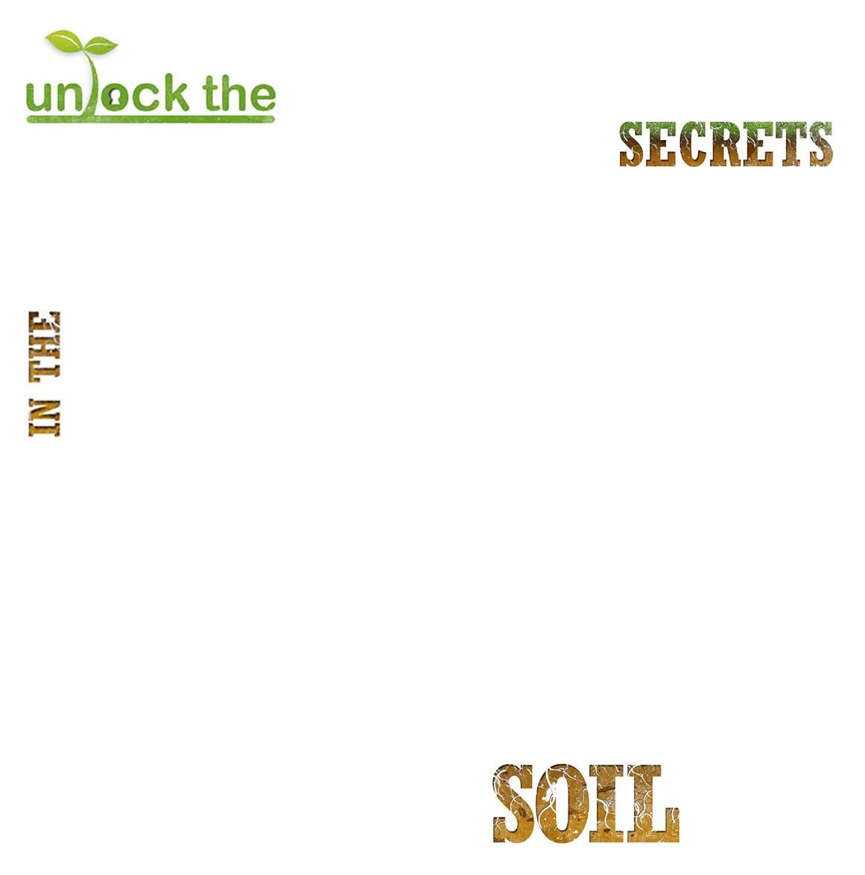
Growing More With Less
For more information, please call Amanda at (860) 345-3977 or email: ajohnson@ctrcd.org Visit www.CTRCD.org
______________________________________________________________ ________________________________________________________
Name Farm/Affiliation
_________________________________________________________________________________________________________________________________
Street Address, City, State, Zip
______________________________________________________________________ Email Address

Cost to attend is $25.00 per person and includes breakfast and lunch $______________________________________ Amount enclosed

Any dietary restrictions? ___________________________________________
Register Early!

November 27, 2017 “Healthy Soils = Healthy Food”
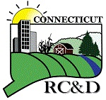
8:30 - 9:00 AM Registration & Morning Refreshments
9:00 - 9:15 AM Welcome
Tom Morgart, CT State Conservationist NRCS
Jeanne Davies, CT RC&D Executive Director

9:15 - 10:50 AM KeyNote Speaker
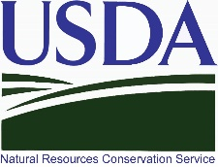
Bryan O’Hara, Tobacco Road Farm

10:50 - 11:00 AM Break

11:00 – 12:00 PM Soil Health Systems
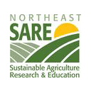
Ray Archuleta, Soil Health Academy School

12:00 PM Lunch
Please make checks payable to: CT RC&D
Mail to: CT RC&D, 1066 Saybrook Road, PO Box 70, Haddam, CT 06438

1:00 - 2:00 PM Soil Health Organics
Ray Archuleta, Soil Health Academy School

2:00 - 2:10 PM BREAK

2:10-2:45 PM How to Get Started with Soil Health
Adam Squire, Unbound Glory Homestead

2:45-3:00 PM Q&A

Should you require special accommodations, please notify Raymond Covino (860.779.0557, Ext. 102)
Information Available at: www.CTRCD.org

