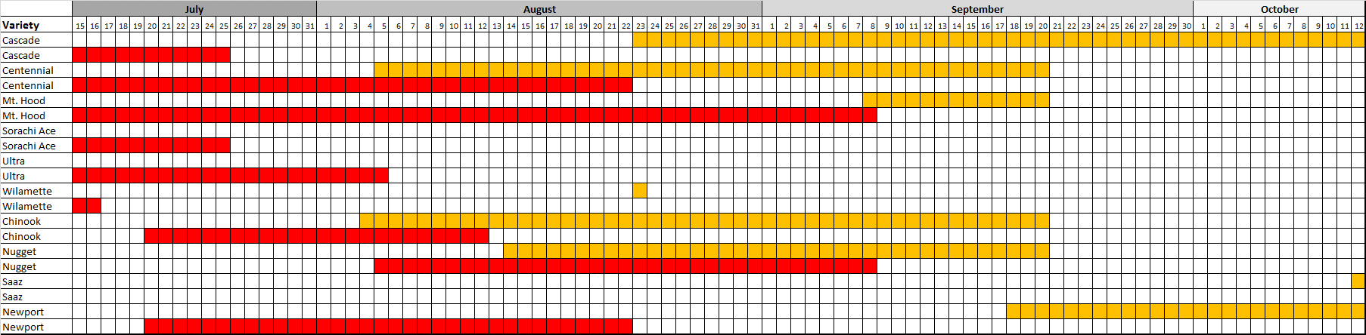Figure 1: The chart depicts the start date, end date, of harvest in both 2015 (orange) and 2016 (red) for each of the hop cultivars grown at the Rutgers University Snyder Research and Extension Farm in Pittstown, NJ.

Figure 2: This figure displays the total yields of each variety harvested from the demonstration plot at the Rutgers University Snyder Research and Extension Farm in Pittstown, NJ (20 plants per variety) included in this study for both the 2015 and 2016 harvest seasons.

|  |  |  |  |  |  |
| --- | --- | --- | --- | --- | --- |
| **Variety** | **Location ID** | **β-myrcene (%)** | **α-Humulene (%)** | **β-caryophyllene(%)** | **% of Total Oil** |
| Cascade | 3 | 61.63 | 12.30 | 5.43 | 79.36 |
| **Cascade** | **YCH HOPS** | **52.50** | **13.00** | **4.50** | **70.00** |
| Cascade | 4 | 56.34 | 15.09 | 6.56 | 78.00 |
| **Chinook** | **YCH HOPS** | **35.50** | **13.00** | **4.50** | **53.00** |
| Chinook | 4 | 47.09 | 19.43 | 7.77 | 74.28 |
| Chinook | 1 | 39.16 | 24.10 | 9.95 | 73.20 |
| Chinook | 5 | 59.46 | 13.86 | 7.49 | 80.81 |
| **Columbus** | **YCH HOPS** | **45.00** | **15.00** | **10.00** | **70.00** |
| Columbus | 1 | 67.41 | 10.22 | 6.99 | 84.62 |
| **Nugget** | **YCH HOPS** | **51.50** | **17.50** | **8.00** | **77.00** |
| Nugget | 5 | 51.47 | 23.71 | 9.76 | 84.94 |

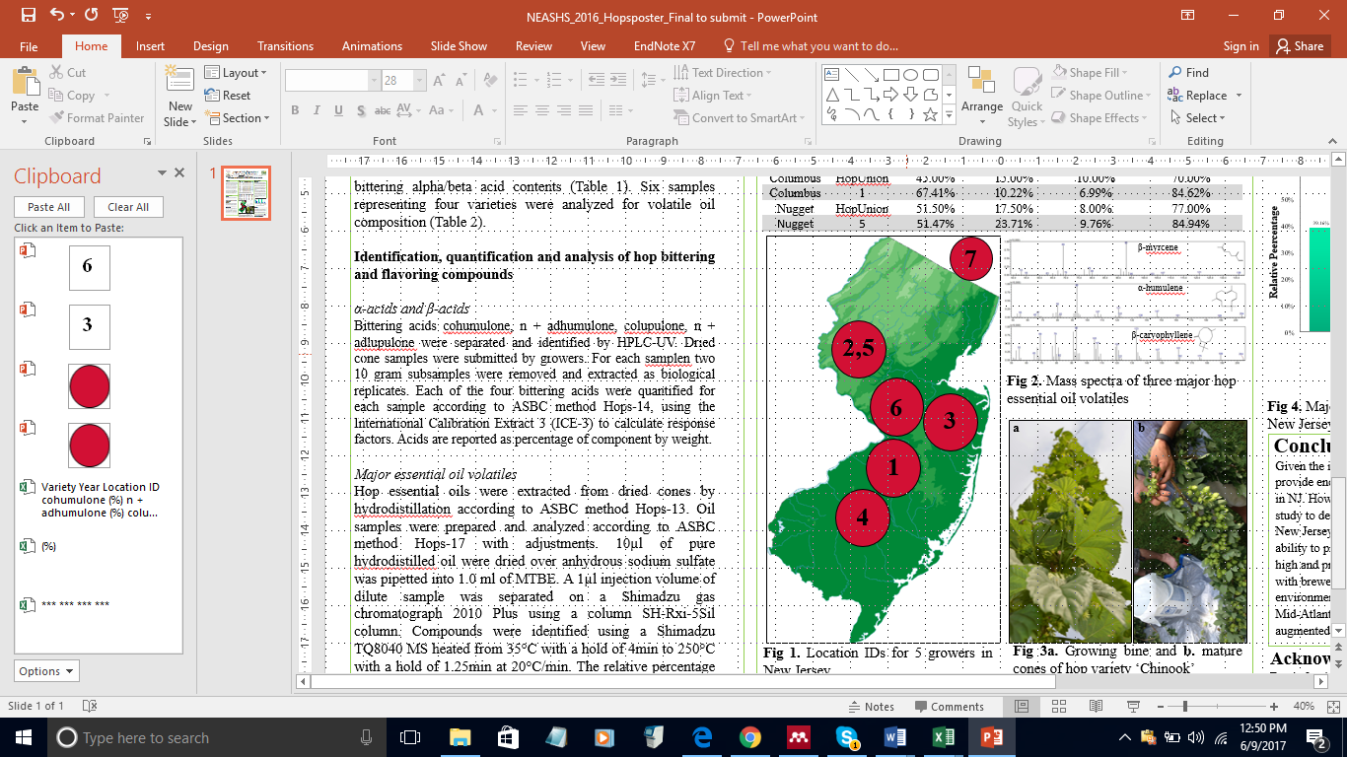

Figure 4: This figure displays the major essential oil volatiles found in seven samples harvested in 2015 from throughout New Jersey alongside those of samples purchased from YCF HOPS LLC.

Figure 3: This figure represented the locations

of all of the farms from which samples were

collected for the study. Each farm is represented

by a number, which corresponds to the

Location ID in Figures 4 and 5. Note sample

7 was from Connecticut.

|  |  |  |  |  |  |  |  |  |
| --- | --- | --- | --- | --- | --- | --- | --- | --- |
| **Variety** | **Year** | **Location ID** | **cohumulone (%)** | **n + adhumulone (%)** | **colupulone (%)** | **n + colupulone (%)** | **α-acids (%)** | **β-acids (%)** |
| **Brewers Gold** | **Quality Standard** | **YCH HOPS** | *** | *** | *** | *** | **8.00 - 11.0** | **4.00 - 6.50** |
| Brewers Gold | 2015 | 2 | 1.97±0.01 | 3.36±0.04 | 2.31±0.02 | 1.33±0.04 | 5.33 | 3.64 |
| **Cascade** | **Quality Standard** | **YCH HOPS** | *** | *** | *** | *** | **5.50 - 9.00** | **6.00 - 7.50** |
| Cascade | 2015 | 2 | 1.30±0.04 | 2.46±0.12 | 3.33±0.05 | 3.36±0 | 3.76 | 6.69 |
| Cascade | 2015 | 3 | 0.73±0.12 | 1.75±0.29 | 1.36±0.27 | 1.50±0.28 | 2.48 | 2.86 |
| Cascade | 2015 | 4 | 1.87±0.11 | 4.30±0.27 | 2.25±0.18 | 2.07±0.18 | 6.17 | 4.32 |
| Cascade | 2016 | 5 | 0.67±0.67 | 1.63±1.63 | 1.38±1.38 | 1.85±1.85 | 2.3 | 3.23 |
| Cascade | 2016 | 7 | 2.15±0.01 | 4.31±0.02 | 3.56±0.04 | 3.40±0.09 | 6.46 | 6.95 |
| Cascade (Field 1) | 2016 | 3 | 1.25±0.07 | 2.77±0.14 | 2.50±0.13 | 2.76±0.11 | 4.02 | 5.26 |
| Cascade (Field 2) | 2016 | 3 | 1.13±0.01 | 2.49±0.025 | 2.02±0.03 | 2.24±0.06 | 3.61 | 4.26 |
| **Centennial** | **Quality Standard** | **YCH HOPS** | *** | *** | *** | *** | **7.00 - 12.0** | **3.50 - 5.50** |
| Centennial | 2015 | 3 | 0.38±0.07 | 1.04±0.17 | 0.31±0.02 | 0.27±0.03 | 1.42 | 0.58 |
| Centennial | 2016 | 5 | 1.54±0.38 | 4.56±0.96 | 1.11±0.25 | 1.27±0.32 | 6.1 | 2.38 |
| **Chinook** | **Quality Standard** | **YCH HOPS** | *** | *** | *** | *** | **11.5 - 15.0** | **3.00 - 4.00** |
| Chinook | 2015 | 1 | 3.29±0.1 | 6.96±0.22 | 1.48±0.04 | 0.99±0.04 | 10.24 | 2.47 |
| Chinook | 2015 | 2 | 2.36±0.04 | 5.12±0.06 | 1.30±0.02 | 1.05±0.02 | 7.48 | 2.34 |
| Chinook | 2015 | 4 | 3.02±0.16 | 7.83±0.21 | 1.35±0.02 | 1.18±0.01 | 10.85 | 2.53 |
| Chinook | 2016 | 3 | 2.12±0.07 | 5.89±0.16 | 1.17±0.02 | 1.01±0.01 | 8.01 | 2.705 |
| Chinook | 2016 | 5 | 2.25±0.01 | 6.39±0.02 | 1.31 | 1.28±0.01 | 8.63 | 2.58 |
| Chinook | 2016 | 7 | 2.66±0.08 | 6.26±0.16 | 1.39±0.06 | 1.17±0.05 | 8.92 | 2.56 |
| Chinook (Field 1) | 2016 | 6 | 2.20±0.05 | 6.90±0.02 | 0.97±0.01 | 1.07±0.02 | 9.1 | 2.03 |
| Chinook (Field 2) | 2016 | 6 | 1.98±0.03 | 6.35±0.24 | 0.95±0.01 | 1.17±0.03 | 8.33 | 2.12 |
| **Columbus** | **Quality Standard** | **YCH HOPS** | *** | *** | *** | *** | **14.5 - 17.5** | **4.50 - 6.00** |
| Columbus | 2015 | 1 | 3.29±0.08 | 8.61±0.02 | 2.07±0 | 1.59±0.02 | 11.91 | 3.67 |
| **Galena** | **Quality Standard** | **YCH HOPS** | *** | *** | *** | *** | **13.0 - 15.0** | **7.50 - 8.50** |
| Galena | 2015 | 2 | 4.34±0.09 | 6.60±0.19 | 4.77±0.16 | 2.82±0.07 | 10.94 | 7.59 |
| **Golding** | **Quality Standard** | **YCH HOPS** | *** | *** | *** | *** | **3.00 - 6.5 0** | **2.00 - 3.50** |
| Golding | 2015 | 2 | 4.68±0.06 | 12.97±0.26 | 2.51±0.06 | 2.16±0.06 | 17.64 | 4.67 |
| **Magnum** | **Quality Standard** | **YCH HOPS** | *** | *** | *** | *** | **12.0 - 15.5** | **5.50 - 8.00** |
| Magnum | 2016 | 6 | 2.56±0.17 | 8.93±0.5 | 2.0±0.135 | 3.53±0.12 | 11.5 | 5.53 |
| **Mt. Hood** | **Quality Standard** | **YCH HOPS** | *** | *** | *** | *** | **4.00 - 6.50** | **4.40 - 7.20** |
| Mt. Hood | 2015 | 3 | 0.51±0.05 | 0.90±0.06 | 1.31±0.06 | 0.87±0.03 | 1.41 | 2.18 |
| Mt. Hood | 2016 | 5 | 0.36±0.03 | 0.83±0.05 | 1.33±0.05 | 1.77±0.08 | 1.19 | 3.09 |
| **Newport** | **Quality Standard** | **YCH HOPS** | *** | *** | *** | *** | **10.0 - 12.5** | **5.50 - 6.50** |
| Newport | 2016 | 5 | 1.98±0.06 | 3.96±0.15 | 2.82±0.03 | 2.00±0.04 | 5.94 | 4.82 |
| **Nugget** | **Quality Standard** | **YCH HOPS** | *** | *** | *** | *** | **13.5 - 16.0** | **4.40 - 5.58** |
| Nugget | 2015 | 2 | 2.06±0.09 | 8.66±0.37 | 1.23±0.09 | 1.66±0.11 | 10.72 | 2.89 |
| Nugget | 2015 | 3 | 1.18±0.19 | 4.34±0.72 | 0.72±0.09 | 0.88±0.12 | 5.52 | 1.59 |
| Nugget | 2016 | 2 | 1.82±0.05 | 1.66±1.66 | 1.30±1.30 | 0.92±0.92 | 3.48 | 2.22 |
| Nugget | 2016 | 5 | 1.30±1.30 | 4.34±4.34 | 0.66±0.66 | 0.84±0.84 | 5.64 | 1.5 |
| Nugget | 2016 | 6 | 2.27±0.05 | 8.50±0.08 | 1.04±0.01 | 1.46±0.02 | 10.77 | 2.49 |
| Nugget (Field 1) | 2016 | 3 | 2.42±0.02 | 9.34±0.11 | 1.31±0.03 | 1.72±0.03 | 11.76 | 3.02 |
| Nugget (Field 2) | 2016 | 3 | 2.05±0.04 | 8.52±0.11 | 1.22±0.02 | 1.69±0.04 | 10.57 | 2.9 |
| **Perle** | **Quality Standard** | **YCH HOPS** | *** | *** | *** | *** | **6.00 - 9.00** | **3.00 - 4.50** |
| Perle | 2016 | 2 | 0.66±0.06 | 1.48±0.15 | 0.62±0.05 | 0.54±0.04 | 2.14 | 1.15 |
| **Sorachi Ace** | **Quality Standard** | **YCH HOPS** | *** | *** | *** | *** | **11.5 - 14.5** | **6.00 - 7.50** |
| Sorachi Ace | 2016 | 5 | 2.35±0.09 | 5.78±0.35 | 3.41±0.145 | 4.31±0.22 | 8.13 | 7.72 |
| **Sterling** | **Quality Standard** | **YCH HOPS** | *** | *** | *** | *** | **5.50 - 8.50** | **4.50 - 6.00** |
| Sterling | 2015 | 3 | 1.08±0.25 | 2.76±0.67 | 0.80±0.14 | 0.72±0.14 | 3.83 | 1.51 |
| Sterling | 2016 | 2 | 2.61±0.13 | 9.1±0.39 | 1.8±0.08 | 2.04±0.07 | 11.71 | 3.84 |
| **Tettnang** | **Quality Standard** | **YCH HOPS** | *** | *** | *** | *** | **4.00 - 6.00** | **2.50 - 4.00** |
| Tettnang | 2015 | 3 | 0.06±0 | 0.14±0 | 0.19±0 | 0.12±0 | 0.2 | 0.31 |
| **Ultra** | **Quality Standard** | **YCH HOPS** | *** | *** | *** | *** | **9.20 - 9.70** | **3.80 - 4.00** |
| Ultra | 2016 | 5 | 1.51±.015 | 3.41±0.08 | 1.40 | 1.11±0.02 | 4.92 | 2.51 |
| **Wilamette** | **Quality Standard** | **YCH HOPS** | *** | *** | *** | *** | **4.50 - 6.50** | **3.00 - 4.50** |
| Wilamette | 2015 | 3 | 0.51±0.02 | 1.38±0.01 | 1.10±0.06 | 1.14±0.03 | 1.89 | 2.24 |
| Wilamette | 2016 | 5 | 0.48±0.48 | 1.08±1.08 | 0.85±0.85 | 0.78±0.78 | 1.56 | 1.63 |

Figure 5: This figure displays the bittering acids found in samples harvested in 2015 and 2016 alongside samples purchased from YCH HOPS LLC.