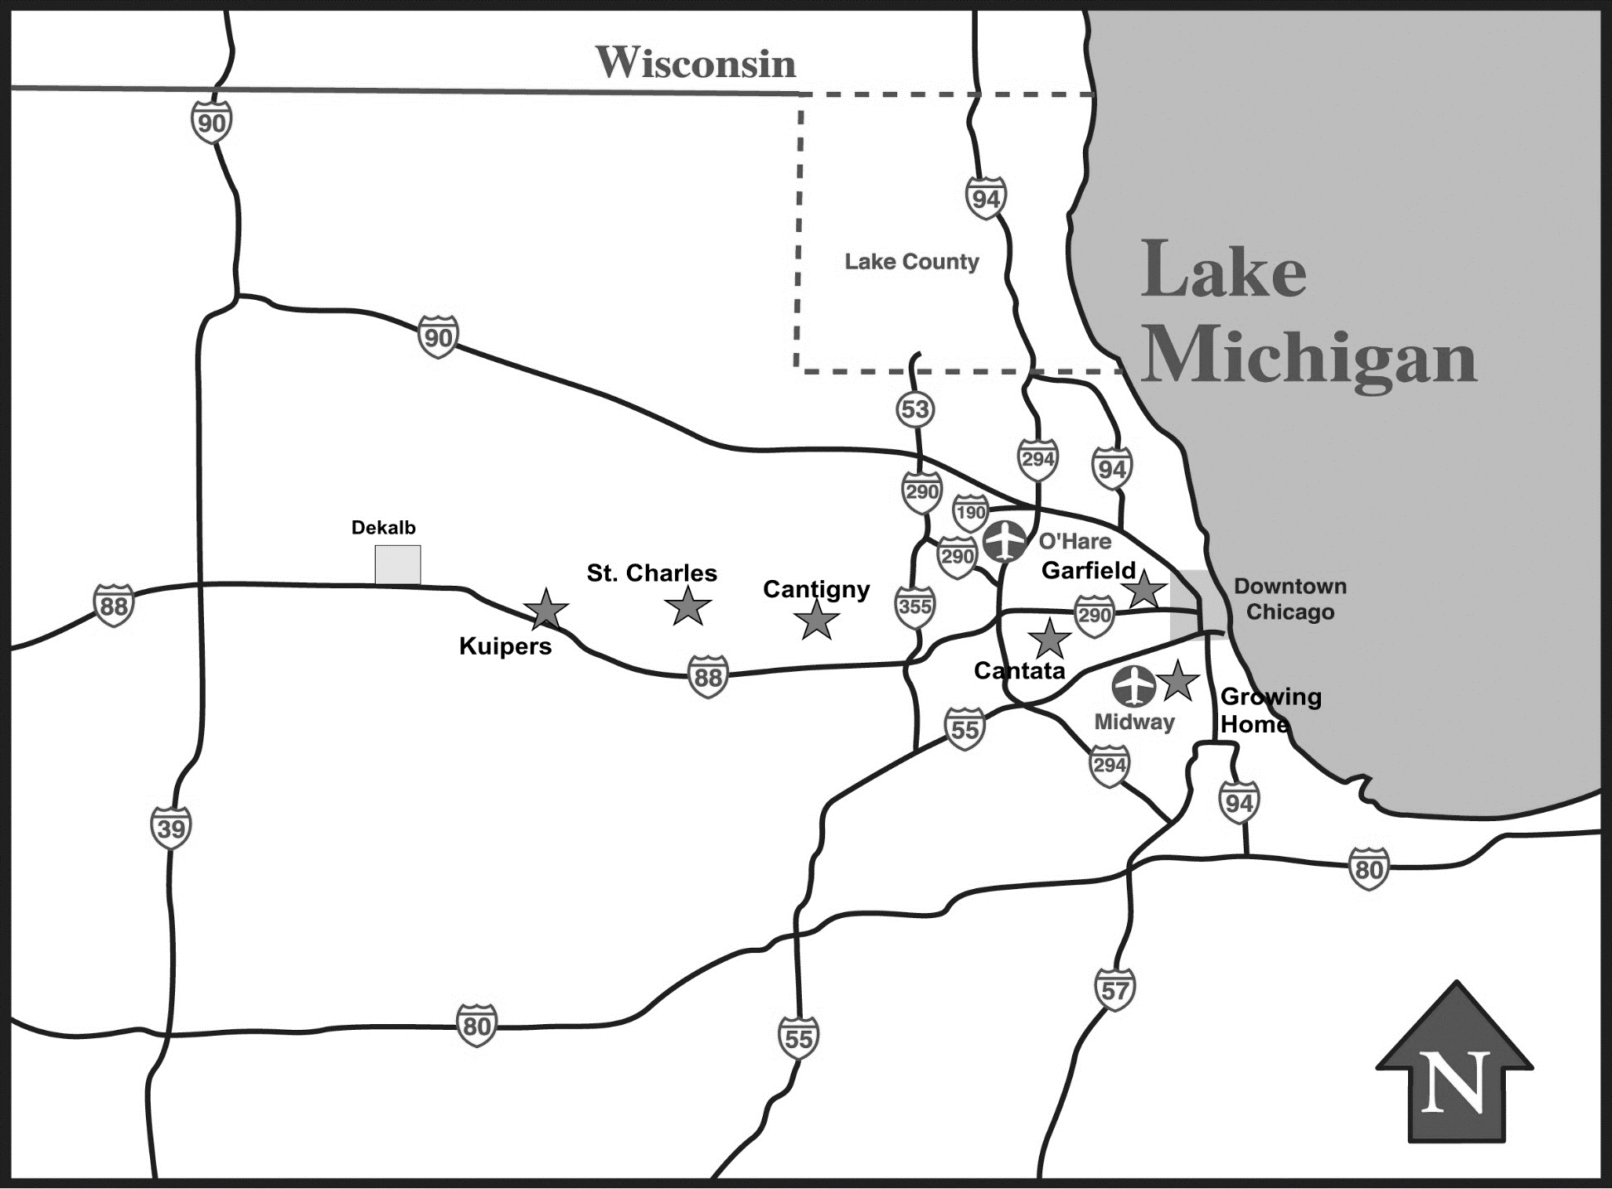

**Figure 1:** Map of test garden sites relative to Chicago area. Sites are represented by stars. Rural sites include Kuipers and St. Charles. Peri-urban sites include Cantigny and Cantata. Urban sites include Garfield and Growing Home.