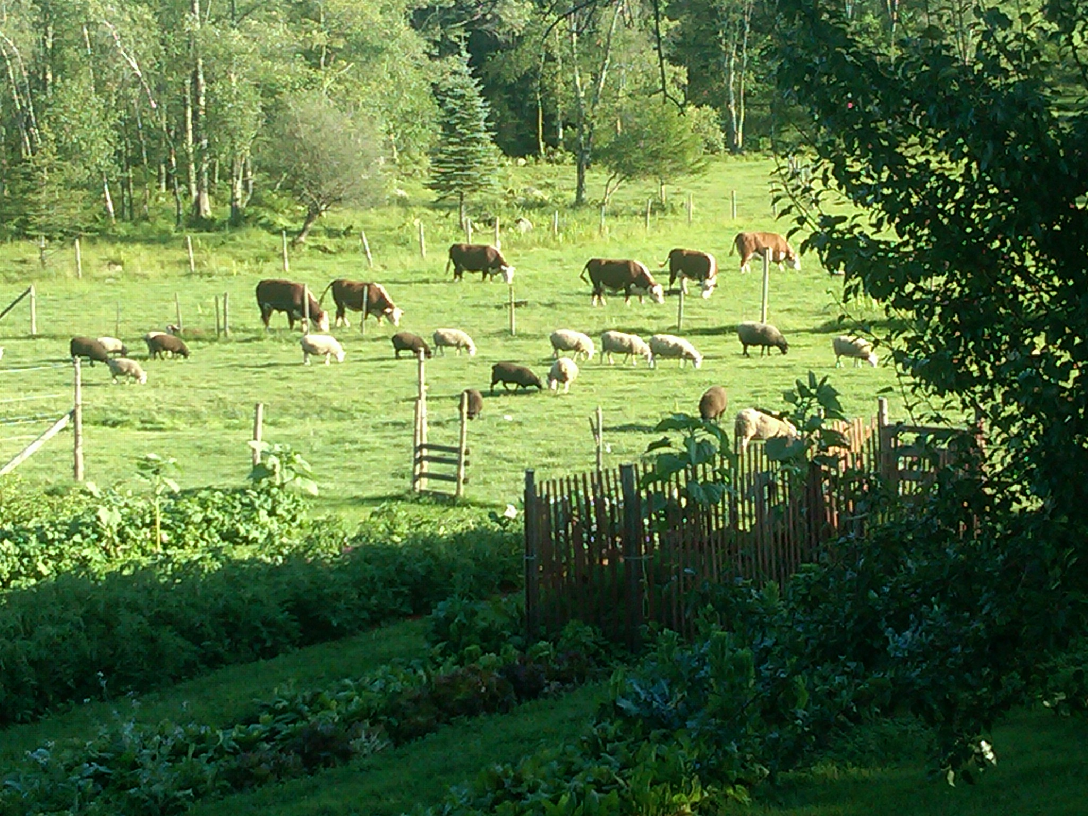
Nutrition's Role in Sustainable Livestock Production Practices
A workshop series for agricultural service providers and farmers on nutrition and its direct link to the health and well-being of animals

REMINDER

SECOND WORKSHOP – Thursday, June 21, 2018 9 am to 1 pm
at Farm Credit East, 240 S Rd. Enfield CT

Sustainably feeding animals and the use of body condition
scoring to evaluate animals

Nicole Burton, MS is a faculty member at the Stockbridge School of Agriculture at the University of Massachusetts Amherst with over 20 years of farming experience focusing on organic livestock and vegetable production. Since completing her master’s degree in Sustainability Science, Nicole has focused on the development of innovative, science-based, sustainable animal husbandry curriculum at UMass. Her experiential learning programming includes poultry and sheep rotations, organic vegetable production, carbon farming systems and on farm slaughter.
Alicia Pedemonti, MPH, grew up raising swine and other livestock on her family's farm in New Hampshire, which now involves her husband and young daughter as well. Alicia works for the New Hampshire Department of Agriculture, Markets & Food as a veterinary technician carrying out disease surveillance programs in livestock and poultry and works with law enforcement on animal cruelty investigations. She serves as the part-time Executive Director for the Northeast Pork Association and sits on the board of directors for National Pork Board.
Dr. Scott Morey, DVM, is a licensed veterinarian in both Connecticut and Massachusetts. A graduate of UConn in 2006 with a degree in Animal Science, he went on to attend veterinary school at Kansas State University and pursued his M.S. in animal science, specializing in dairy cattle nutrition. In 2014 he began providing on-farm veterinary services and in 2015 opened Fenton River Veterinary Hospital with his wife, Dr. Heidi Morey. Scott specializes in large animal medicine.

Click here to REGISTER for any of our workshops
or email jean.king@uconn.edu

NEXT WORKSHOPS
Tuesday July 31, 2018 Animal health and diseases related to nutrition

Three field workshops on these topics will be held in August, September and October.

These workshops are part of a 2017-2020 USDA/NESARE Professional Development Program grant: Nutrition's Role in Sustainable Livestock Production Practices, a joint project among the Universities of Connecticut, Massachusetts, and Rhode Island.

Tri-State Project Director: Rachel Bespuda, UConn rachel.bespuda@uconn.edu

www.meatsystems.uconn.edu

