Developing Best Management Plans for Pulse and Oilseed Crops in the Northeast
SARE PROJECT #LNE17-358

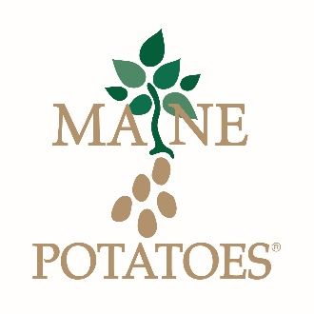
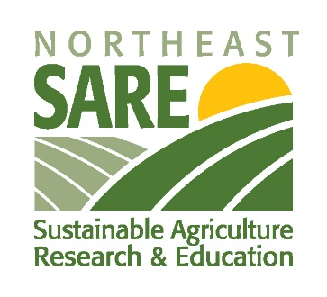
WHO WILL THIS PROJECT BENEFIT?
Northeast Crop and Livestock Producers
Northeast Food and Feed Processors

WHAT IS THE PROJECT FOCUS?
1. Extend and diversify potato crop rotations to include pulse and oilseed crops
2. Develop high value markets for these crops with Northeast food processors
3. Provide a local source of protein and energy to Northeast livestock producers

WHEN WILL THIS PROJECT OCCUR?
The timeline for this project is from September 2017 through May 2020
Workshops and information sessions will be held in late winter of 2018 and 2019
Field scale and research trials will be held in the 2018 and 2019 cropping seasons

WHERE WILL THE PROJECT ACTIVITIES BE HELD?
Workshops and information sessions will be held in the Presque Isle area
Field scale and research trials will be held throughout Aroostook County
Project updates will be presented at field days, industry conferences, and on the web

WHY PULSE AND OILSEEDS?
1. Results from research projects conducted in Maine from 2013 through 2016 focusing
on field peas, lentils, chickpeas, dry beans, flax, and sunflowers showed high yield
potential, reduced inputs, and cropping system flexibility.
2. Demand and popularity of plant based proteins and specialty foods have drastically
increased in recent years. This demand; coupled with increased capacity of Northeast
food processors provides an excellent opportunity for the creation of a diverse local
food system.
3. Pulse and oilseed crops and their by-products are a source of concentrated protein and
energy. Current concentrates used in the livestock industry are heavily imported and
are subject to the volatile commodity market.

HOW CAN I BE INVOLVED IN THIS PROJECT?
Easy, contact Jake Dyer at the Maine Potato Board either by phone or email. He can
provide you with additional details and take down your contact information to keep you
in the loop.

PHONE: 1-(207)-769-5061
EMAIL: jdyer@mainepotatoes.com

