Selection of Missouri Native Plants
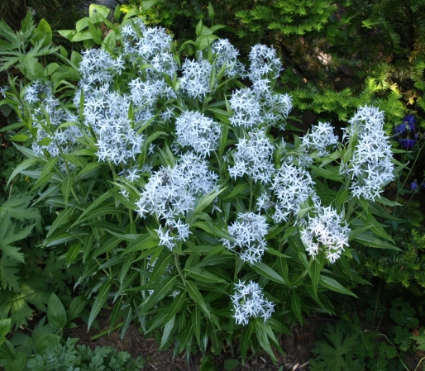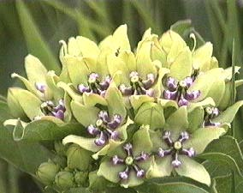
Amsonia Illustris (Shining Bluestar) Asclepias viridis (Spider Milkweed)

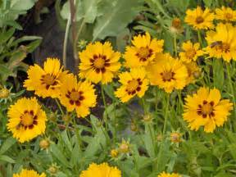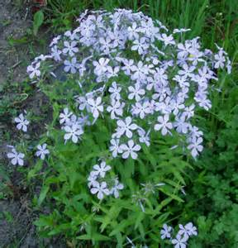
Coreopsis lanceolata (Lanceleaf coreopsis) Phlox divaricata (Wild Sweet William)

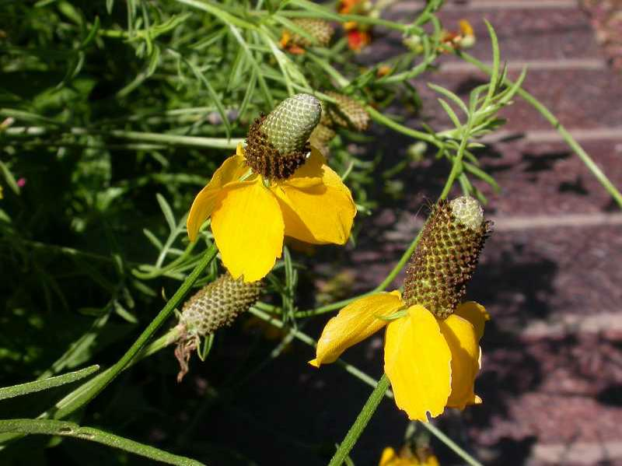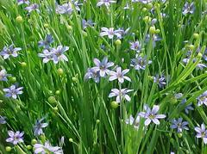
Ratibida columnifera (Prairie coneflower) Sisyrinchium campestre (Prairie blue-eyed grass)

Compiled by Obiagele Lake, October 2017

