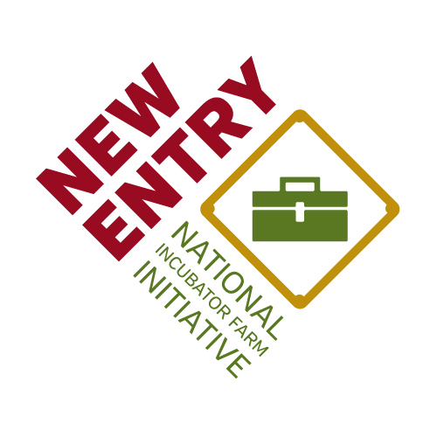

Northeast Incubator Farm Training Initiative
Field School

October 6-7th, 2016
Cold Spring, NY

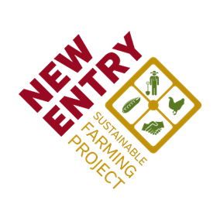
Brought to you by In partnership with With generous support from

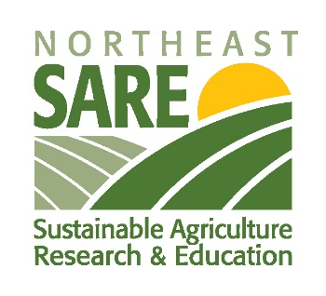

Abundant thanks to the many organizations and individuals that came together to make this Field School possible. In particular, the New Entry Sustainable Farming project would like to thank:

NE SARE for generous funding in support of professional development opportunities for Incubator Farm Project staff.
www.nesare.org

Our fiscal sponsor Third Sector New England.
www.tsne.org

Glynwood and the Hudson Valley Farm Incubator for serving as a local host, supporting the planning and implementation of this Field School, and for their commitment to growing new farmers in the Hudson Valley.

Special thanks to Alena Kaufman for assisting with event planning, food and accommodations.
www.glynwood.org

Agenda

April 14 | Activity | Location
9:30 | Registration, Light Breakfast | Glynwood
9:50 | Welcome | 362 Glynwood Rd  Cold Spring, NY 10516
10:00 | Land Access for Farmers: Pressures & Options for Access & Preservation  Terrence Duvall, Columbia Land Conservancy
11:30 | Resources, Tools & Partnerships for Land Access  Jim Hafner, Land for Good
1:00 | Lunch
1:30 | Farmer Goal Setting and Transition  Noelle Fogg, New Entry Sustainble Farming Project
3:00 | Break
3:15 | On the Ground: Case Studies of Land Access  Ian McSweeney, Russell Farm and Forest Conservation Foundation
4:45 | Shared Metrics Review
5:15 | Closing
6:00 | Dinner
April 15 | Activity | Location
8:30 | Breakfast
9:00 | Workshop M&E
12:00 | Lunch
12:30 | Travel to the Hudson Valley Farm Business Incubator | 60 Gatehouse Rd  New Paltz, NY 12561
1:00 | Farm Tour
2:30 | Farmer Panel
4:00 | Closing & Farewell

Maps & Directions

From Glynwood to the Incubator Farm

Glynwood Farm

362 Glynnwood Road, Cold Spring, NY 10516

Get on I-84 in Fishkill from Glynnwood Rd and U.S. 9 N
19 min (10.3 mi)

Follow I-84 and I-87 N/New York State Thruway to NY-299 W/Main St in New Paltz. Take exit 18 from I-87 N/New York State Thruway
25 min (26.5 mi)

Continue on Main St. Take NY-299 W/New Paltz-Minnewaska Rd to Gatehouse Rd
10 min (3.6 mi)

Once you arrive at 60 Gatehouse Road, take a left onto Butterville Rd., go under the underpass and take an immediate right onto Lenape Lane. Follow that to the white farmhouse.

