Improving Weight Gain in Goats Grazing Cover Crops Selected through Soil Health Samples:
SARE Partnership Grant ONC15-004
By Susan Jaster, Farm Outreach Worker, West Central Region
Writing the grant is not as difficult as coming up with a viable, practical idea, which will actually prove or disprove a point; unless something has been nagging at you. Then the theme for the 2015 NCR SARE Partnership Grant caught my eye. A heavy emphasis would be placed on projects that used cover crops and/or soil health as part of the premise. I was already interested in and using cover crops. I had attended workshops about soil health analysis and understood the underlying use of this tool. But goats were my problem!
Jim and Susie Hallar of Holden, MO, Jeff Yearington of Drumm Farm for Children in Independence, Ralph Williams and Lynne Stark of Lynnewood Farm Harrisonville, MO were interested in using a grant to help them figure out how to get more consumers in the Midwest to try chevon (goat meat). We could try for a feasibility grant, run lots of expensive tests on goat meat, sample barbequed goat meat at farmers markets and grocery stores, create surveys, spend lots of time and money trying to get consumers past what “their friends and relatives had told them about goat meat”, even though we knew that many consumers have an aversion to trying new foods. I discussed the idea with colleagues and the interested goat producers but the SARE Partnership Grant theme afflicted my mind! We brainstormed a little more and came up with a plan which included cover crops, soil health analysis and goats. We were not going to be studying goat meat marketing at all.
The grant application title had to include all aspects of the theme and project to get noticed. I had to fill out most of the application before I came up with the title: Improving Weight Gain in Goats Grazing Cover Crops selected through Soil Samples. The basic plan was to take soil samples and have them analyzed at a soil health analysis lab and select cover crops known to correct or assist in correcting those soil deficiencies. A cocktail of cover crops (CC) was selected (including grasses, legumes and forbs) with the goals of the project in mind. The cover crops had to be tall, since goats prefer to eat with their head up, and they had to improve the soil. The CC, all annual plants, were also selected for the season in which they would be eaten as feed. If the test was to be conducted in winter, all the CC were cold hardy and the same for summer, they had to be heat tolerant. Broadcasting would be the application method for all four tests. The plots were 50 feet by 50 feet, fenced in with solar powered poly-wire, a shelter and water buckets were also provided. The CC cocktail (all annuals) was broadcast over the perennial pasture at each farm. When the test plots had grown to a reasonable grazing/browsing height (8 to 18 inches tall) for goats, we weighed 5 goats and placed them in the CC plot and weighed 5 more goats to eat the regular pasture as it occurred on each of the three farms. I measured the height of the forages in each pen and calculated the grazing days possible. Then after three to five days the goats were removed from the pen and weighed again to see if there was any gain. There were four grazing/browsing periods over two years on all three farms. The goal was to have two tests in winter and two in summer, high stress times for goats and plants. The best laid plans do not always work out and weather was a problem too. Actually the goats were in the test plots in September, 2015, May, August and December of 2016.
All Soil Health Analysis was completed at the Soil Health Assessment Center at the University of Missouri. The soil samples show that there was improvement over the two year period.

Results of Soil Samples SARE Partnership Grant ONC15-004
p=pasture | cc=cover crops
DRUMM | soil samples |  |  |  | 7d PMN | WSA | Active Carbon
 |  |  | pHw | pHs | (mg/kg) | (%) | (mg/kg)
 | May-15 | cc/p | 7.5 | 7.1 | 39.2 | 15 | 429.1
 | Oct-15 | cc | 7.3 | 6.9 | 72 | 20 | 928.8
 | May-16 | cc | 6.9 | 6.5 | 123 | 9 | 617.8
 | Oct-16 | cc | 7.2 | 6.9 | 52 | 7 | 483.1
 | Oct-16 | p | 7.3 | 7.1 | 185 | 41 | 975.6
HALLAR | soil samples |  |  |  | 7d PMN | WSA | Active Carbon
 |  |  | pHw | pHs | (mg/kg) | (%) | (mg/kg)
 | May-15 | cc/p | 6.6 | 6.2 | 36.3 | 60 | 325.4
 | Oct-15 | cc | 6.9 | 6.4 | 52.5 | 36 | 583.2
 | May-16 | cc | 6.5 | 6 | 56 | 52 | 365.8
 | Oct-16 | cc | 6.5 | 6.1 | 85 | 39 | 496.1
 | Oct-16 | p | 7 | 6.5 | 90 | 31 | 517.7
LYNNEWOOD | soil samples |  |  |  | 7d PMN | WSA | Active Carbon
 |  |  | pHw | pHs | (mg/kg) | (%) | (mg/kg)
 | May-15 | cc/p | 5.8 | 5.3 | 90.3 | 40 | 409.7
 | Oct-15 | cc | 6.2 | 5.7 | 240 | 82 | 636.5
 | May-16 | cc | 5.8 | 5.1 | 96 | 11 | 409
 | Oct-16 | cc | 6.1 | 5.5 | 111 | 23 | 424.1
 | Oct-16 | p | 6 | 5.3 | 96 | 21 | 373.7

Rating Alfalfa All Other Crops
------------------- pHs Range-----------------
Very low < 5.0 < 4.5
Low 5.0-5.8 4.5-5.3
Medium 5.8-6.5 5.3-6.0
High 6.5-7.5 6.0-7.5
Very High > 7.5 > 7.5
Buchholz, Daryl D., et al. Soil test interpretations and recommendations handbook. University of Missouri-College of Agriculture, Division of Plant Sciences, 2004.
EXPLANATIONS of TESTS
Potentially Mineralizable Nitrogen (PMN)
Importance. It is a measure of soil nitrogen that will be available to plants over the next growing season and a measure of soil biological activity. In the West, PMN results have been used to adjust crop nitrogen recommendations by taking credit for the organic N that will be mineralized during the growing season.
Method. Soil samples are in flasks with distilled water and are incubated at 40° C for 7 days. Under anaerobic conditions microbes mineralize organic nitrogen into plant-available ammonium. At the end of the week incubation potassium chloride is added to the sample and mixed. Ammonium concentration is determined by color change and a spectrophotometer.

Soil pH in Water and Salt (pHw, pHs)
Importance. Soil pH measures the concentration of hydrogen ions in soil solution. Soil pH affects the solubility of plant nutrients in the soil and the soil nutrient holding capacity or cation exchange capacity (CEC) of the soil. Other soil properties are indirectly affected by soil pH. Low pH can also result in toxic levels of soil aluminum.
Method. Soil samples (10 g) are mixed with 10 ml of deionized water. A calibrated glass electrode selective for hydrogen ions determines soil pH. A second measurement is taken after 10 ml of 0.01 M CaCl2 is added. The second measurement is referred to as “salt pH” because the added salt (CaCl2) helps reduce variability in pH measurements due to differing salt concentrations in soils.
Active Carbon (AC)
Importance. Easily oxidized carbon (C) compounds are likely to be mineralized, or decomposed, by soil microbes over the next growing season. Changes or differences in AC are easier to measure than small, but important, changes in Percent Total Organic Carbon due to changes in management
Method. A potassium permanganate solution is used to oxidize soil organic matter to determine AC. A solution of purple potassium permanganate is reacted with soil by shaking the solution. The solution is allowed to settle, and then a subsample is diluted and analyzed by a UV-VIS spectrophotometer. The more easily oxidized carbon in the sample, the lighter the color of the sample. Soil AC is given in mg/Kg soil which is equivalent to ppm.
Percent Water Stable Aggregates (%WSA)
Importance. Soil wet aggregate stability indicates how well soil particles are bound together and their resistance to water breaking them apart. Increased aggregate stability indicates reduced erosion, decreased surface crusting and sealing, and increased soil biological activity, infiltration, soil porosity and water holding capacity.
Method. Soil samples are air dried, gently ground and sieved to retain aggregates between 1 and 2 mm in diameter. Aggregates (3 g) are distributed on a 0.5 mm sieve, soaked overnight, and then mechanically agitated. Aggregated that remain on the sieve are weighed and deemed stable and are reported as a percentage.
This above mentioned testing method information may be found on the University of Missouri’s Soil Health Assessment Center website: https://cafnr.missouri.edu/soil-health/

CC were selected with information from the SARE book: Managing Cover Crops Profitably, 3rd Edition and Pro Harvest Seeds, Owners: Clyde and Mason Burchett 105 E 17th St, Higginsville, MO 64037. Goats prefer to eat with their heads up, therefore we had to set goals for selecting CC. They needed to be tall, leafy, improve soil and weather hardy, so seeds were selected accordingly. Timing and weather played a big part in cocktail selection as well. (See the cocktail mixes used for each farm in the following lists, noting planting month and when grazed.) The dollar amount listed for each planting covered the seed used to plant a 50 foot by 50 foot plot of mixed pasture. A 50 foot by 50 foot plot of mixed pasture, which received no CC seeds, was fenced in next to the test plot as a control plot. The plots were fenced in with poly-wire on a solar energizer.
COVER CROPS 50 ft. x 50 ft. test plots

planted  July 2015 | $8.34 |  | planted October 2015 | $6.55 |  | planted May2016 |  | $7.40 | planted August 2016 |  | $6.00
Graze #1 |  |  | Graze #2 |  |  | Graze #3 |  |  | Graze #4
Cover Crop |  |  | Cover Crop |  |  | Cover Crop |  |  | Cover Crop
Sorgum-sudan |  |  | Cereal Rye |  |  | Spring Oats |  |  | Oats
Hyb Pearl millet |  |  | Winter Oats |  |  | Pearl Millet |  |  | Rye
Cowpeas |  |  | Austrian Winter Peas |  |  | Forage Sorghum |  |  | Crimson Clover
Mungbean |  |  | Crimson Clover |  |  | Cow Peas |  |  | Hairy Vetch
Radish driller |  |  | Turnip |  |  | Lespedeza |  |  | Radish
Pasja Hyb Brassica |  |  | Inoculant |  |  | Buckwheat |  |  | Turnip
Inoculant  Earthway Seeder used to broadcast seeds  Grass cut very short; ground driven Minneapolis-Moline drill dropped the seed on ground |  |  |  |  |  | Burkant Turnip  Inoculant  Cut grass very short, used a drag to dethatch, broadcast seed from tub grass broadcaster for small tractor, and dragged it again.  Prior to Graze #3, seeds were broadcast by hand. Animal trampling was used to gain soil contact.

FARM: Graze: #1 Graze: #2 Graze: #3 Graze: #4
DRUMM Sept. 1-4, 2015 May 6-9, 2016 Aug. 5-8, 2016 Dec. 1-5, 2016
HALLAR Sept.2-6, 2015 May 12-15, 2016 Aug. 12-15, 2016 Dec. 12-15, 2016
LYNNEWOOD Sept. 6-10, 2015 May 7-10,2016 Aug. 6-8, 2016 Dec. 11-14, 2016

]
Each time we weighed the goats, the test plots were measured for height and depth of forage. A formula found on the Grazing Stick used to calculate grazing days was used to be sure there would be enough forage for the number of days goat would live in the test plots.
Grazing Days per period were calculated using this formula/example formula.
Cover Crop | Pasture
14 inches | 6 inches | Total lbs Forage/Ac x Ac x % Grazing Efficiency
10 | 14 | Animal Wt. x Intake rate in % Body Wt. X animal #
12 | 16 | 2800 lbs/Ac x .057 Ac x 30% = 47.88
12 | 9 | 75 # x 3.5% body wt X 5 animals = 13.12 |  |  | 47.88/13.1 =3.65 days
13 | 8
11 | 8 | 2100 lbs/Ac x 0.057% x 30% = 35.91
13 | 9 | 77.7 # x3.5% x 5 animals=13.60 |  |  | 35.91/13.60 = 2.6 days
85 | 70
12.14285714 | 10 | average forage height
12-4 = 8 in. | 10-4= 6 in | grazable forage, leaving 4 inches for regrowth
x 350 | x 350 | Quality (350 is the estimated dry matter in pounds per inch) from Grazing stick, lbs/Ac. 30% refers to type of grazing or grazing efficiency; ie: continuous grazing
2800 lbs/Ac | 2100 lbs/Ac

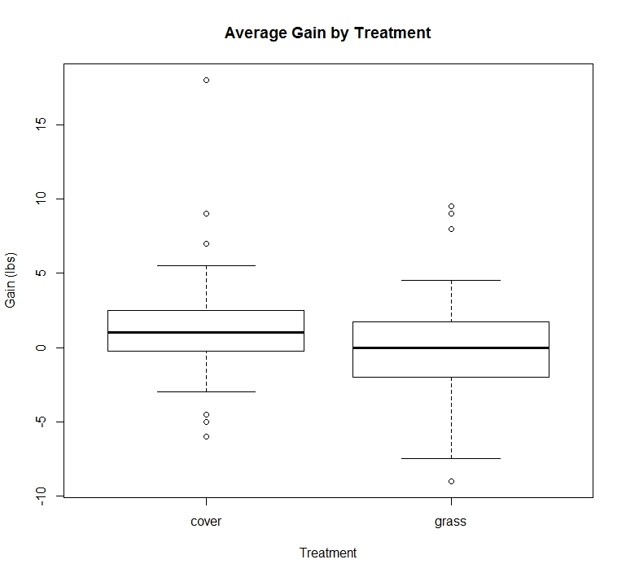
https://www.sas.com
The Stats for this grant were performed in “R” by grad student-Levi Jaster.
Stats Summary | SARE PARTNERSHIP GRANT ONC15-004 JASTER
Average Gain per goat
Anova | DegreesFredom | Sum of Squares | Mean Square | F-value | p-value
treatment | 1 | 63.4 | 63.38 | 4.853 | 0.02977
farm | 2 | 151.4 | 75.71 | 5.796 | 0.00409
Residuals | 106 | 1384.6
Tukey HSD | way to test differences between the means
difference between gain of each treatment
difference grass-covercrop | lower 95% CI | upper 95% CI | p-value
-1.518182 | -2.884569 | -0.151795 | 0.02977
Negative difference when cover crop average gain is subtracted from grass average gain indicates that cover crop gain is greater than grass. (Treatment: significant if less than 0.05)
Average Gain per goat
Cover Crop | 1.509090909 | lbs/period
Grass | -0.009090909 | lbs/period

There were many high weights and several low weights of goats over the 2 year period, the odd weights were “thrown out” by the statistical program to come up with the average gain per goat per period-see chart, “Average Gain by Treatment”.
The SARE Partnership Grant did help us understand that the use of cover crops will improve weight gain in stressful times for goats as well as the soil, but there was one more set of statistics that had not been used, the Grazing Days Calculations or Forage Days by Treatment!
See chart: Forage Days by Treatment
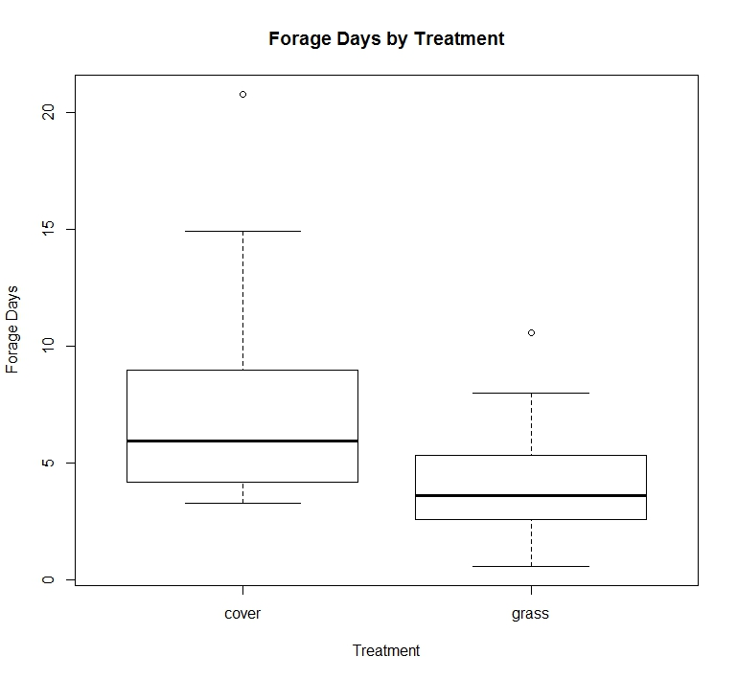

Average Days Forage
Paired Sample t-test
t-value | 2.5507
Degrees of Freedom | 10
p-value | 0.02883 |  | significant if less than 0.05
The t-test tests to see if the null hypothesis is true or not.
Null Hypothesis = The true difference of the means (average for each treatment) is zero.
Alternative Hypothesis = True difference of means is not equal to zero.
Look at boxplot of forage days to see which is higher
Difference of means (one minus the other)
Difference | 3.49709
Lower 95% Confidence Interval |  | 0.4422335
Upper 95% Confidence Interval |  | 6.5519483
Average Days of Forage | Grazing Days
Cover Crop | 7.924545 | days/period
Grass | 4.427455 | days/period

As you can see in the chart and statistical calculation, the selection of tall, leafy and soil improving cover crops gave us nearly double the amount of grazing days in the same space. The significance of using cover crops as annuals, broadcast into perennial pastures will improve our number of grazing days in the same size pasture/paddock. If you can rest the cover crop enhanced pastures/paddock after grazing and come back later, then significant savings over the cost of the cover crops can be realized, especially when grain/feed can be cut back as well during the grazing period. Annuals in perennials will give a boost to weight gain in goats during stressful times and allow longer periods of grazing on the same paddock.
This narrative of SARE Partnership Grant ONC15-004 is a partial report. The full report will be included with photos at the http://www.northcentralsare.org/ under tab: Project Reports, ONC15-004. Please find the report after June 2017.
If you have questions or need more information please contact: Susan Jaster 816-589-4725, jasters@lincolnu.edu .

