What Grows Over the Ground? What Grows Under the Ground?
(Name the vegetable. Circle RED Zone, GREEN Zone OR YELLOW Zone. Circle either OVER OR UNDER)
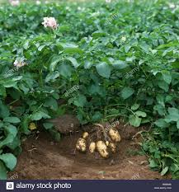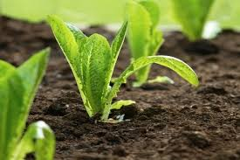

Vegetable:__________________ Vegetable: ___________________

RED OR GREEN OR YELLOW RED OR GREEN OR YELLOW

OVER OR UNDER OVER OR UNDER

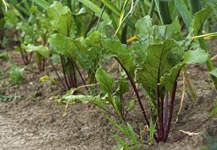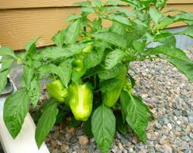

Vegetable:__________________ Vegetable: ___________________

RED OR GREEN OR YELLOW RED OR GREEN OR YELLOW

OVER OR UNDER OVER OR UNDER

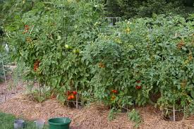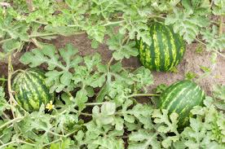
Vegetable:__________________ Vegetable: ___________________

RED OR GREEN OR YELLOW RED OR GREEN OR YELLOW

OVER OR UNDER OVER OR UNDER

