Dung Insects in Eastern South Dakota
Jacob Pecenka¹, Linda Simmons², Jonathan Lundgren³
¹Natural Resource Management Department, South Dakota State University
² Milbank
³USDA-ARS, Brookings, SD.
Dung beetles and other beneficial insects in cattle dung are a very important contributor to the health of pastureland. It is a diverse group of insects that recycles animal dung into the soil and reduces pathogens and parasites associated with dung. It is estimated that there are over 450 species of insects associated with cattle dung in North America. The services of dung beetles alone contribute $442 million to ranchers annually. The ecological services that these insects provide are well documented, but the implications of current herd management practices such as grazing intensity and ivermectin parasiticides on them have received little recent attention.
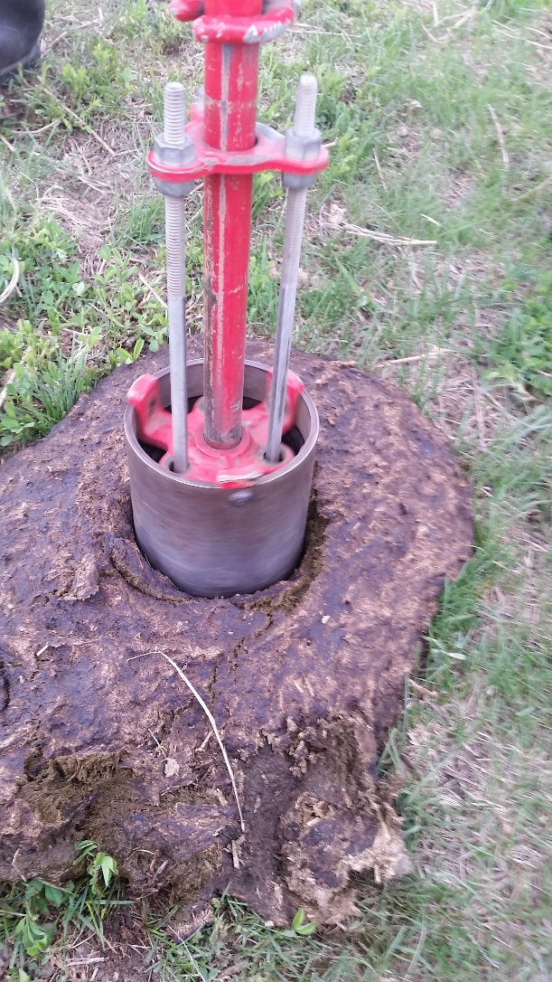
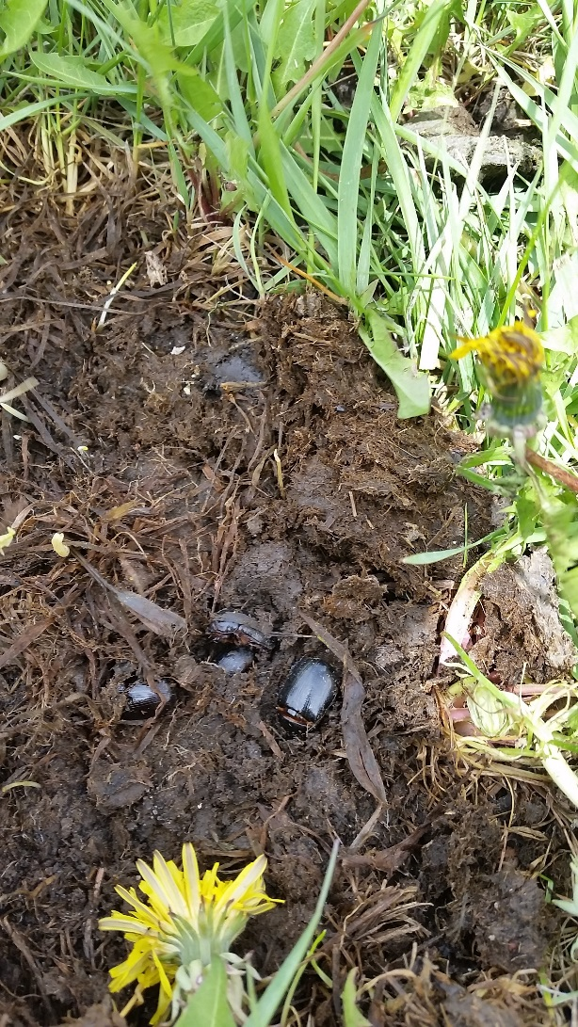

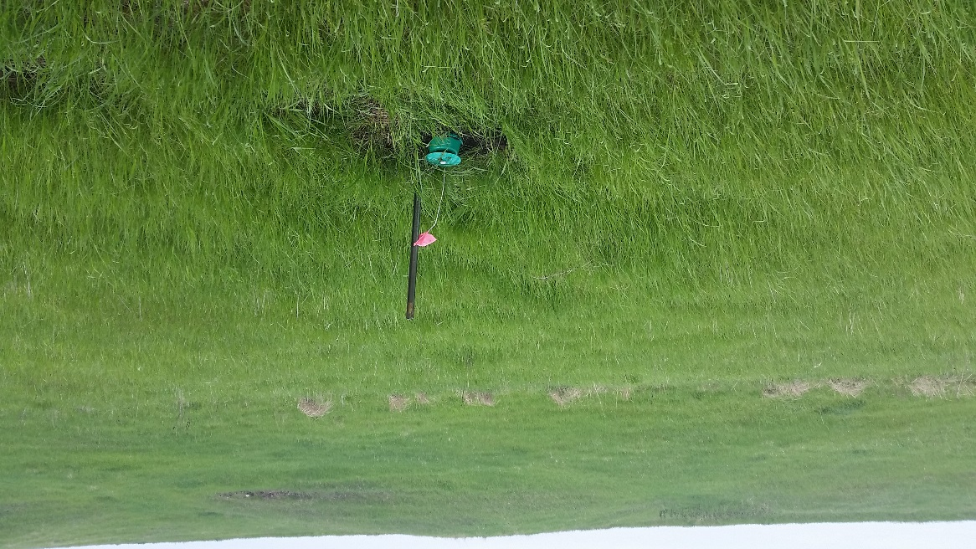
The research conducted by Linda Simmons, Jacob Pecenka, and Jonathan Lundgren will provide a better understanding of how dung insects contribute to dung degradation rates, as well as how current pest management practices in rangeland affect these important insects More specifically, this work will identify which species live in Eastern South Dakota rangelands, and when they are present. Additionally, the research will show how dung insects are affected by ivermectin treatments at various levels, using both laboratory toxicity assays and field sampling. Preliminary results suggest that there are more than eight insects per square inch of dung representing dozens of species!

Baited pitfall or bucket traps are a great way to understand what insects could be crawling around dung pats in a pasture. These traps can be purchased or assembled with common equipment one can find at a grocery store. They could be as simple as burying a plastic cup (so that the rim is flush with the soil surface), and then baited with some dung placed in the hole. If you have a pair of latex gloves you can conduct an even simpler sampling method of digging through 1-2 day old dung pats and observing the insects present. Insects can be collected and placed into alcohol or soapy water to clean them; then the number of species in your pasture can be more easily determined.

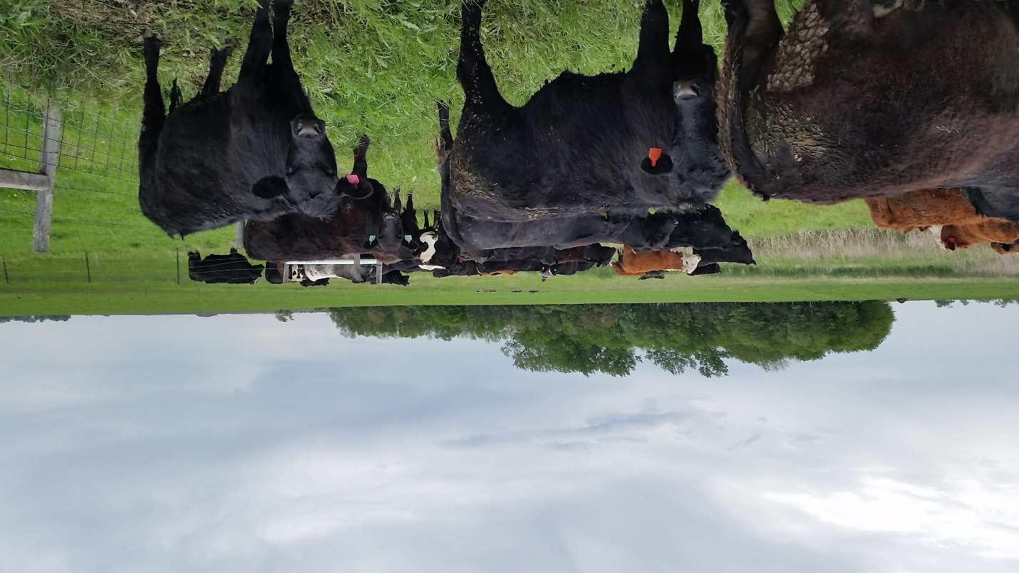
One important job that dung insects perform is dung pat removal, and the speed with which dung is incorporated into the soil is important in reducing pasture fouling and parasites. To measure this on your land, flag some fresh dung pats when you move cows from a pasture, and monitor how quickly the pats are removed. In the healthiest pastures, dung is removed in less than 10 days.

For more information, contact
Jacob Pecenka (jacob.pecenka@gmail.com)
Linda Simmons (uplandlowland@hotmail.com)
Jonathan Lundgren (jgl.entomology@gmail.com)

