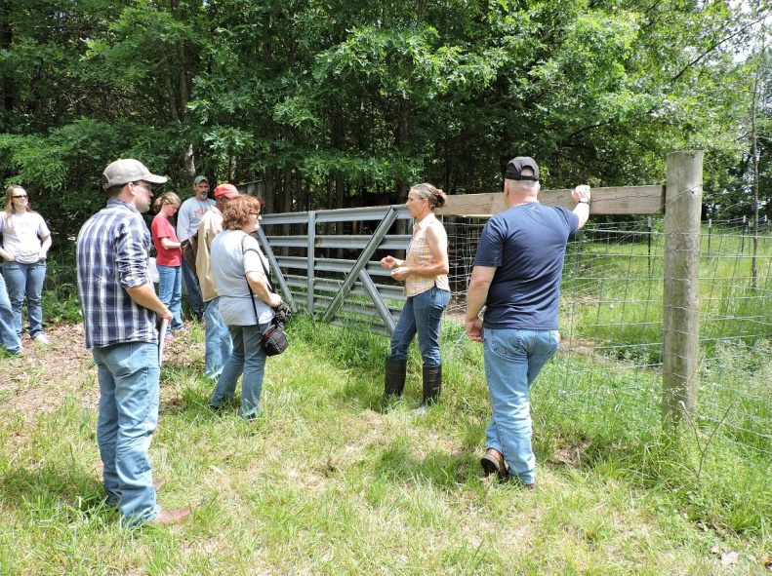
Wendy Lombardi, first workshop on her farm, providing overview of organic practices.
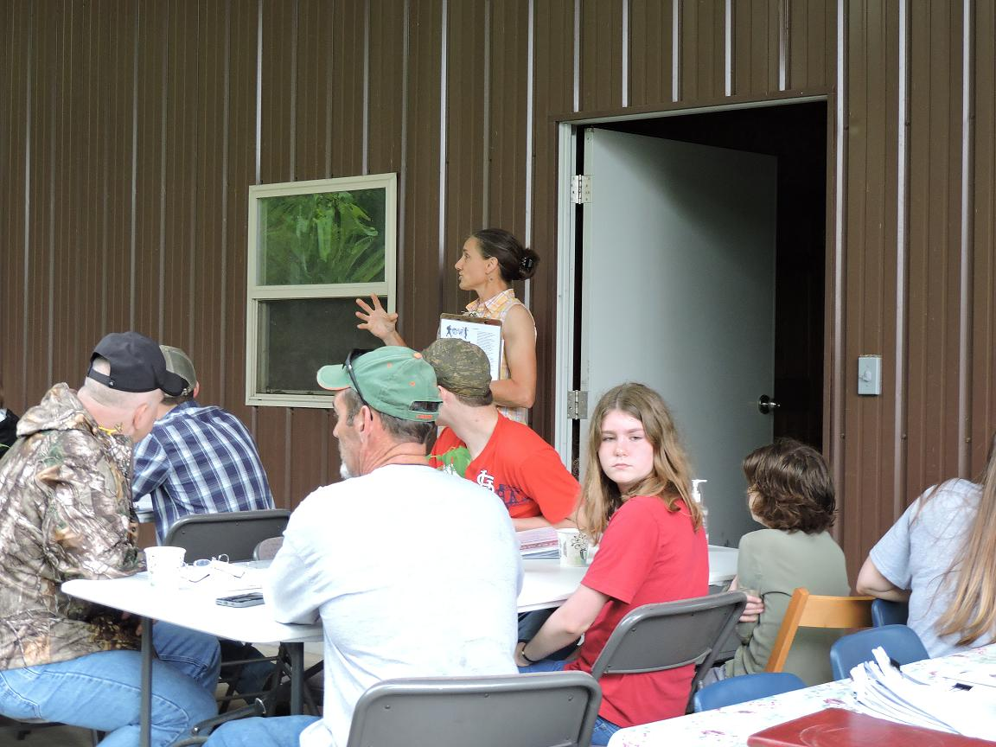
Wendy Lombardi, first workshop on her farm, discussing rotational grazing.
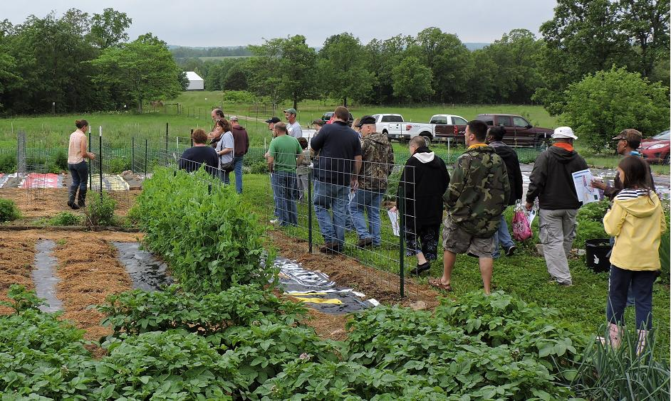
Wendy Lombardi, first workshop on her farm, discussing organic pest control.
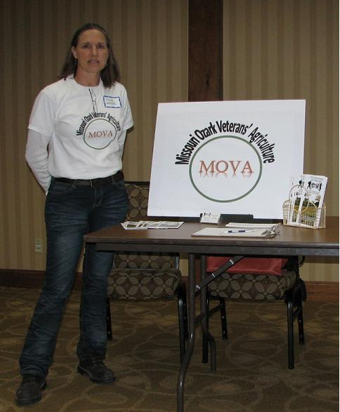
Wendy Lombardi "wo-manning” her MOVA booth

