Establishing a pollinator plot
Cooperative Extension•Delaware State University
Plants that can attract pollinators are crucial for wildlife and to pollinate crops on farms. There are many ways to start pollinator plots and many different plant varieties that can be used, but here is an inexpensive and very effective method and can be done on various scales.

Location and Plot Preparation
Level or gently sloping ground with as much sun as possible is ideal. Tilling and/or herbicides will be needed if planting into grass. The most success that we have had was by tilling in the spring, allowing weed seeds to germinate, spraying with herbicides, and then tilling again. Although this may seem like a hassle, it greatly reduces weed pressure and after a year can lead to a permanent meadow, with minimal management needs.
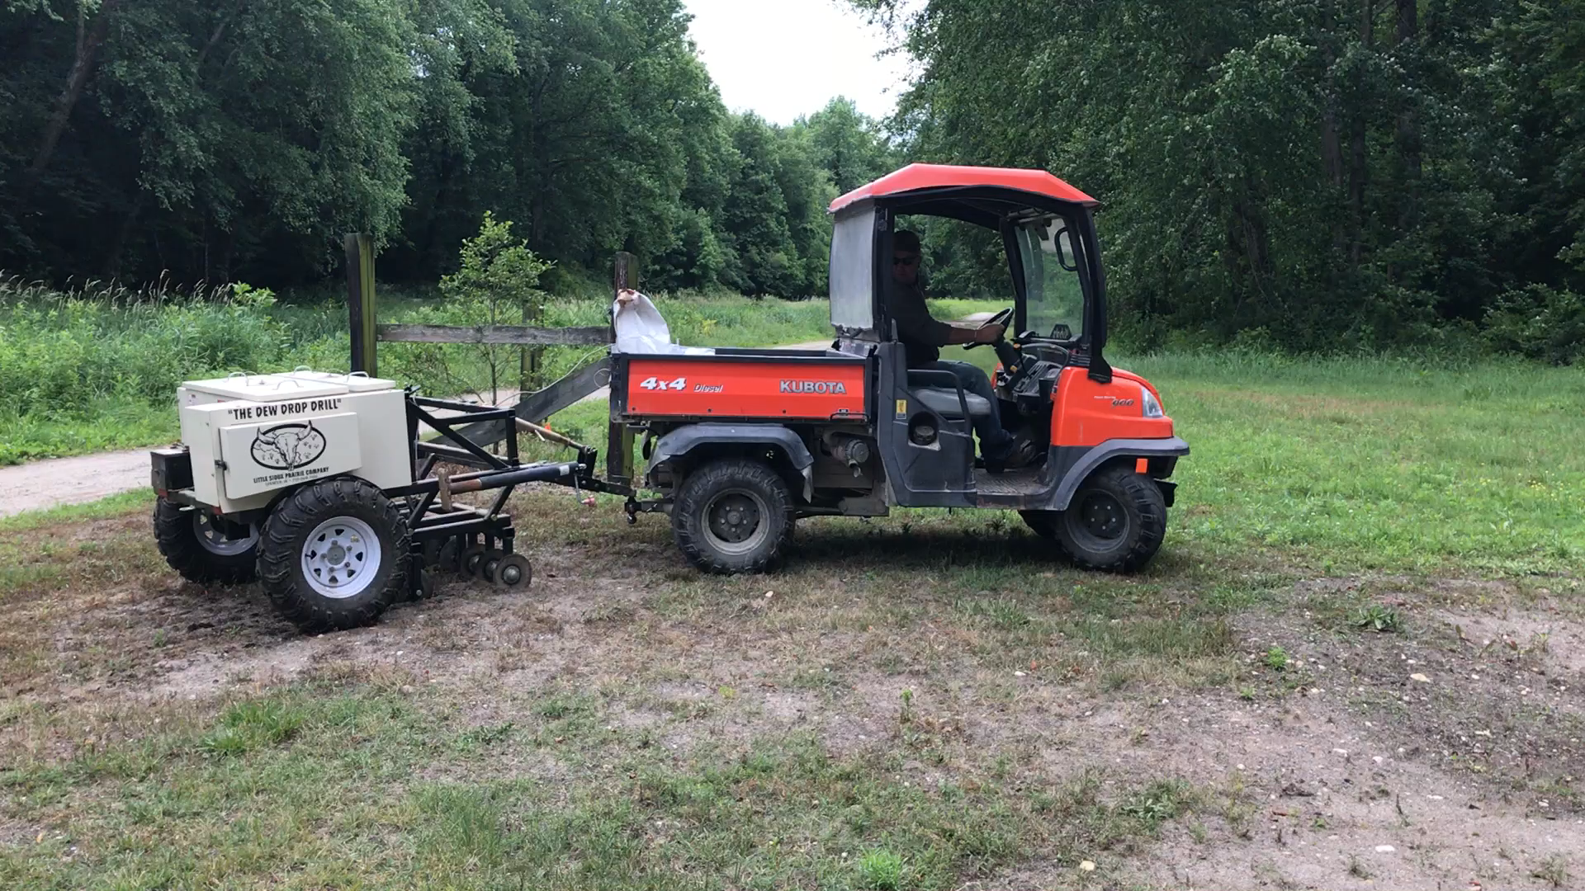
Planting
We used this dewdrop drill to plant, which slices the soil and drops seeds onto the ground, but we also had success with a hand spreader.
Plant varieties
A mix of seeds is ideal because different plants flower at different times of the year. A goal of ours was to have flowers available for pollinators throughout as much of the growing season as possible. To achieve this, we used a mix of zinnias, buckwheat and short and tall sunflowers.
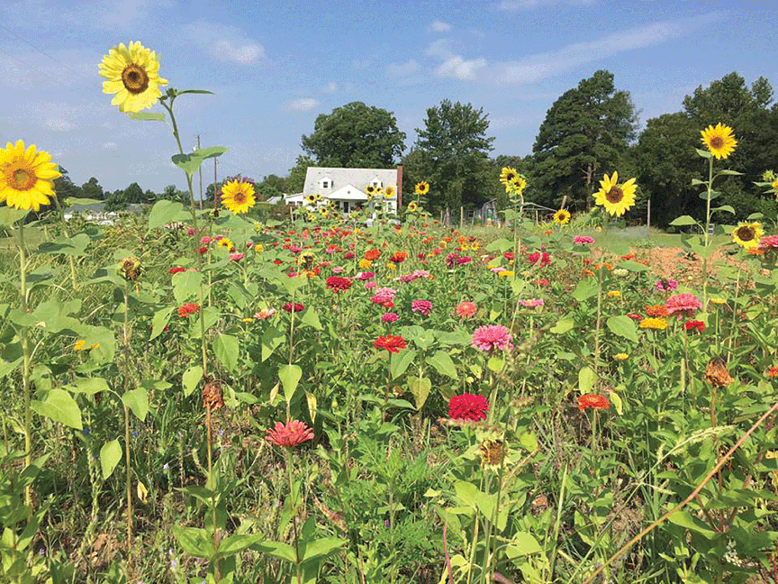
Management
You could water or irrigate if desired, but we had success over multiple years without doing anything to the plots In the fall, we mowed the plots, and planted a perennial mix of asters, clovers, and others. Mesic wildflower mix is a good. If everything goes right, you will now have a permanent pollinator plot that will need minimal maintenance.

For more information contact Jason Challandes, the Regional SARE Educator at jchallandes@desu.edu

Cooperative Extension Education in Agriculture, 4-H and Home Economics, Delaware State University, University of Delaware and United States Department of Agriculture cooperating, Dr. Dyremple B. Marsh, Dean and Administrator. It is the policy of Delaware Cooperative Extension that no person shall be subjected to discrimination on the grounds of race, color, sex, disability, age, or national origin.

