Developing a Pre-Plant Test for Root Knot and Lesion Nematodes for the New York Potato Industry
Adrienne Gorny¹, Xiaohong Wang², Sarah Pethybridge¹, and Frank Hay¹
¹Cornell University, NYS Agricultural Experiment Station, Geneva, NY
²USDA-ARS, Plant Protection Research Unit, Cornell University, Ithaca, NY

Project Objectives:
- Quantify the crop loss associated with root knot and lesion nematodes affecting potato in New York.
- Identify economically important thresholds for root knot and lesion nematodes in potato in New York.
- Develop a DNA-based test that is quick and accurate for identifying root knot and lesion nematodes and quantifying their populations prior to planting.

Activities:
Three potato fields were selected with high populations of root knot (Meloidogyne hapla) and lesion (Pratylenchus spp.) nematodes. These nematodes are known to cause damage to potato and other vegetable crops.

Soil samples were collected from the hills at a depth of about 6 inches. Samples were collected on a 10 × 10 point grid. Distance between sampling points varied from 20 to 50 feet, depending on the size and shape of the field.

Approximately 1 kg (~2 lbs) of soil was taken at each sampling point. Each point was marked with a flag and the location recorded by GPS.

The soil samples were divided into smaller portions for use in the following studies:
Root Knot and Lesion Nematode
Root Knot and Lesion Nematode
Root Knot Nematode

Results to Date:
Counting of root knot and lesion nematodes across all sampling locations within each of the fields found high variability in populations counts (Table 1).

Table 1. Number of nematodes observed per 200 mL of soil from 100 points per field using the “pie pan” technique followed by manual counting under the microscope. Here, 200 mL of soil is about one cupped handful. Population densities were highly variable within the field, with some locations having high densities, while other locations having no detectable nematodes.
 |  | Lesion (Pratylenchus spp) | Root Knot (Meloidogyne hapla)
Field 1 | Maximum | 2,275 | 1,438
 | Minimum | 94 | 0
 | Average | 942.8 | 52.0
Field 2 | Maximum | 554 | 1,588
 | Minimum | 0 | 0
 | Average | 76.8 | 72.0
Field 3 | Maximum | 506 | 1,038
 | Minimum | 0 | 0
 | Average | 72.0 | 115.3

Manual counting of nematodes from individual locations were also used to estimate the density of nematodes over the entire sampling area (Figure 1). This indicated that the number of lesion and root knot nematodes was highly variable across the field, in a generally aggregated spatial pattern.

At many locations, high populations of root knot and lesion nematodes did not necessarily occur together.

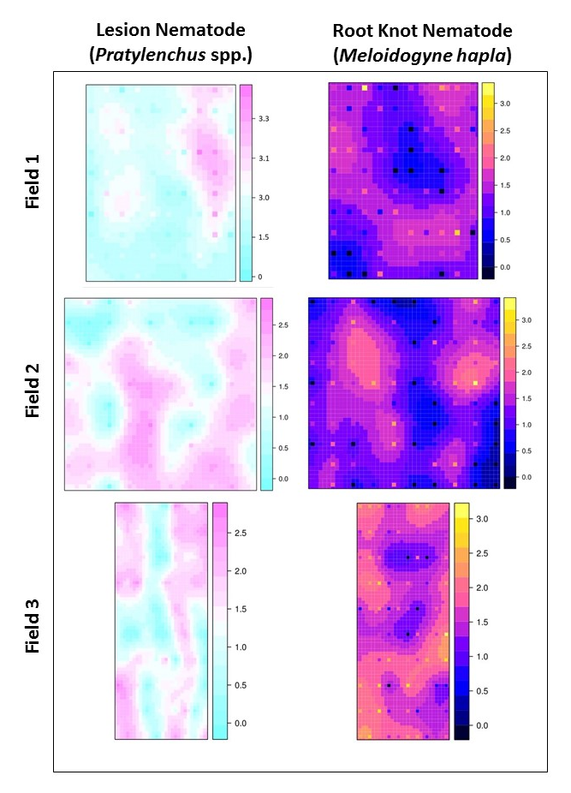
Figure 1. Distribution of root knot and lesion nematodes within three potato fields in New York, as determined by manual counting. Marks in the scale indicate a 10-fold increase in population density. Population densities were highly variable across each field.

Next Steps:
- Conduct soil and tuber sampling from individual locations within each field near harvest and repeat the manual counting and DNA extraction studies. These results will be compared to those obtained prior to planting to determine if the nematode population has changed over the season.
- Collect one tuber from a plant at each sampling location to compare nematode population densities with crop damage observed (nematode feeding damage and yield reductions).
- Compare tuber data gathered at the harvest sampling with pre-plant nematode DNA levels to find a threshold level for fields at risk of tuber damage.
- Determine the species of lesion nematode most prevalent in fields in these potato fields. This may have implications for the amount of crop damage observed.

Data from this project will assist in determining how many nematodes are detrimental to potato production and to define action thresholds.

Vision:
The long term vision for this project is for growers to have information on the levels of nematodes and other soilborne pathogens made available to them by assessing a soil sample prior to planting. This knowledge may be used to identify fields most suitable for potato production, plan rotations and in-furrow pesticide applications. The pre-plant assessments may also be used for mapping of nematode and pathogen populations within the field, potentially allowing for site specific treatment of areas within the field having populations above the determined damage threshold.

Acknowledgements:
Many thanks to Kurt Brehm of Wayland, NY and Karl Hofmann of Springville, NY for their enthusiastic collaboration in on-farm research. Thank you also to Carol MacNeil for facilitating the on-farm research. Funding for this project is provided by the National Institute of Food and Agriculture-CPPM (Award No. 2015-70006-24160), and by a Northeast Sustainable Agriculture Research and Education (SARE) Graduate Student Grant (Award No. GNE15-103). SARE is a program of the National Institute of Food and Agriculture, US Department of Agriculture.

Thank you very much for your support of this project! Please stay tuned for more updates.

