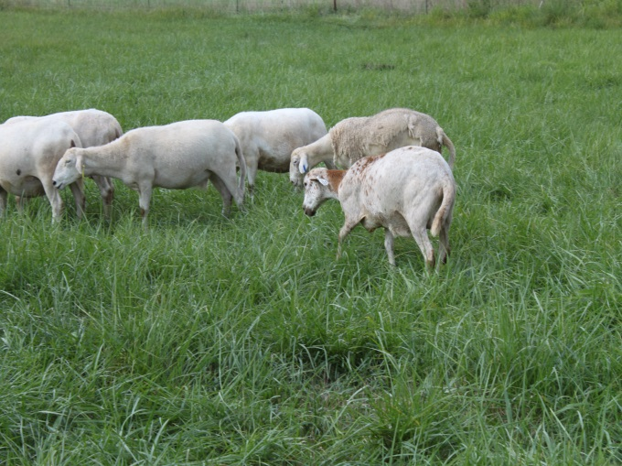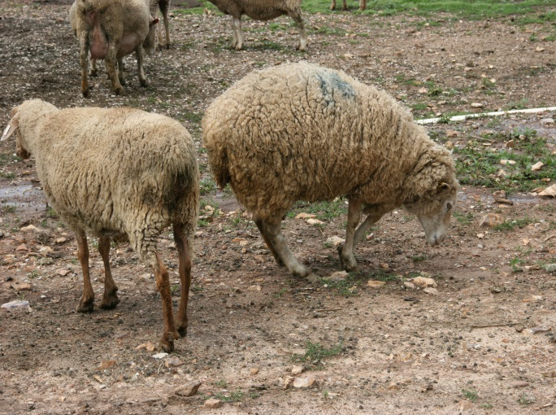

Infected sheep showed moving slowly behind the rest of flock

Infected sheep showed limping and carrying sore foot

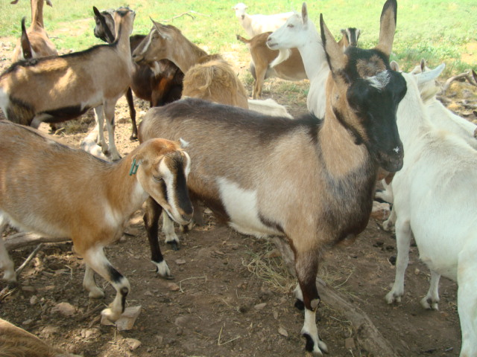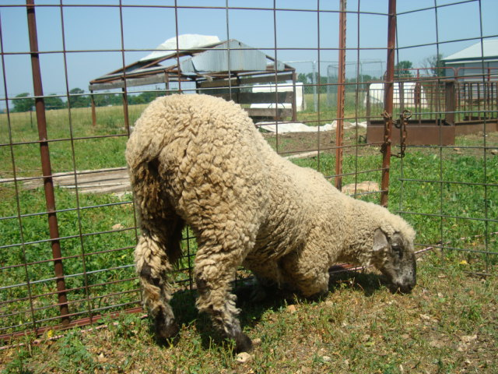

Infected goat showed lifting up its sore foot

Infected sheep showed kneeing and crawling with sore feet