Research and Problem-Solving on the Farm: Project Overview
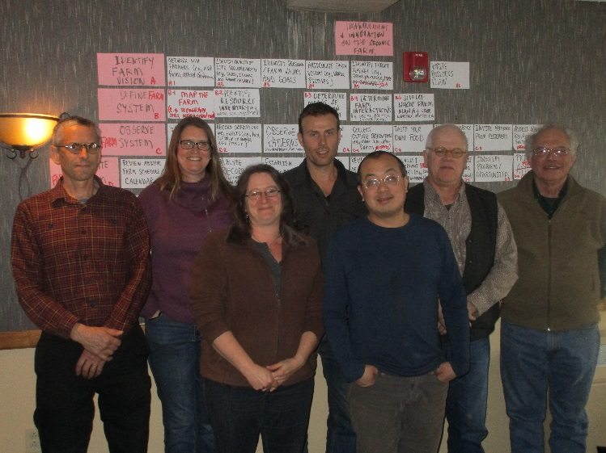
The capacity to problem-solve and experiment with new practices is an essential skill for farmers to master. Some farmers, particularly those well-known as innovators, have developed their own effective systems for identifying and testing new practices. These systems of inquiry enable them to combine research and problem-solving with normal farming operations.
Our goal is to collect this farmer knowledge and make it widely available to others. First, we will learn about how farmers integrate experimentation into their farming operations by collecting information from successful innovator farmers. Using this information, we will create a how-to manual that organizes these proven research strategies into steps that can be followed by other farmers. To begin gathering information from farmer innovators, we held a workshop with eight experienced farmers last March.
March 2016 workshop—farmer innovators: Nicolas Lindholm, Jody Bolluyt, Karma Glos, Brent Welch, Chaw Chang, Eero Ruuttila, and Lou Lego. Not pictured: Klaas Martens.

What information will be in the manual?
- Adaptive whole farm management and the role of experimentation on the farm for problem-solving and innovation
- Farmer-developed research methods: key steps in the process, how this differs from the formalized research cycle
- Case studies of farmer developed experimental designs

What do we need from you, the farmers?
Your stories! Your challenges! Come share with us your insights from your experimenting!
Please join our discussion Saturday at 4:45!
EXPERIMENTATION AND PROBLEM SOLVING ON THE FARM
What methods have farmers developed? 4:45pm Highrock
Working with expert organic farmer-innovators, we have compiled information on eff ective experimentation and problem solving practices developed by these farmers. We will briefly review this information and solicit additional ideas about research methods that farmers can use for experimentation and problem solving on their farms. Ultimately, we will produce a “how-to” manual for farmers and extensionists.
Contact us!
Laurie Drinkwater (Led24@cornell.edu) & Heather Scott (Has224@cornell.edu)
Cornell University School of Integrative Plant SciencesLed24@cornell.edu
Heather Scott, Has224@cornell.edu

