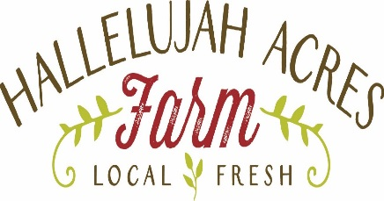

Agenda – 6/28/2017
Tour of Hallelujah Acres Farm
Our story
Solving the big problems
Tool shed tour
Garden tour
Raised beds
Trash can potatoes
Mushroom operation
Q&A

Our SARE Grant – Farmer Rancher

Project Description: Determine if interseeded cover crop system provides effective proactive week prevention in an intensively planted market garden operation. Interseeding will be compared to common methods including biodegradable mulch and manual hoeing. In addition to effective weed prevention, impacts to soil health will be assessed.
The Problem: We need to find and implement an effective, economical solution for week prevention in our small, chemical-free vegetable market garden operation. As a small farmer, it is critical to implement the most effective sustainable agricultural practice.
Measures:
- Soil health before and after season via soil testing.
- Count weed starts in a 1’ x 1’ box before we remove them.
- Track man hours to remove weeds for targeted methods.
- Track man hours to install methods.
- Measure yield and quality of yield.
Pictures are worth a thousand words, and plan to see a presentation in an upcoming Master Gardener meeting.
Cover Crop Selection: Not as easy as it looks. Many can use nutrients the crop needs, which others are difficult to remove except through use of herbicides. Some are not compatible with certain crops. Also, must wait until crop is 1/3 the way through growth cycle before planting cover crop.
Buckwheat, Crimson Clover, Annual Rye, Icicle Radishes, White Clover
Vegetable Crop Selection:
- Green Pepper – Buckwheat, terminate prior to going to seed; paper mulch; hoeing
- Tomato – Crimson clover; red plastic mulch; hoeing
- Broccoli – Crimson clover, hoeing
- Summer Squash – Icicle radishes (harvest when mature); Hoeing (added Nasturtiums for pest prevention)
- Storage onion – Crimson clover; plastic biodegradable mulch (black); hoeing
- Sweet corn and winter squash – Various combinations with crimson clover; hoeing
- White clover in the garden aisles
Look for updates on www.ha-farm.com and the Master Gardener Facebook page.

