2014 Figures of Results

Waller-Duncan K-ratio t Test was used for all means separation analysis

Softwood Cuttings



**C**

**BC**

**B**

**A**

**A**

**A**

Figure 1: This figure depicts the average number of buds retained on cuttings 8 weeks after cuttings were stuck in rooting benches.

Treatment Key (Treatments were applied 3 times over an 8 week period)

1. 125 ppm foliar fertilizer
2. 50 ppm GA 4,7
3. 50 ppm GA3 + 10 ppm 6-BAP
4. water
5. 50 ppm GA 4,7 + 10 ppm 6-BAP
6. 50 ppm GA3

Cultivars H3R11P52 and OSU 408.040 showed equally high bud retention (average of .448-.503 buds), which was significantly higher than cultivar OSU 541.147 (average of .152 buds).



**B**

**B**

**B**

**B**

**AB**

**A**

Figure 2: All cuttings were treated with 100 ppm IBA salt, and this figure depicts the root rating response (1-5 described below) of the cuttings for each foliar treatment.

Treatment Key (Treatments were applied 3 times over an 8 week period)

1. 125 ppm foliar fertilizer
2. 50 ppm GA 4,7
3. 50 ppm GA3 + 10 ppm 6-BAP
4. water
5. 50 ppm GA 4,7 + 10 ppm 6-BAP
6. 50 ppm GA3

Root Rating Scale

1. 1-5 roots
2. 6-10 roots
3. 11-15 roots
4. 16-20 roots
5. 21 or more roots

Cultivar H3R11P52 had a significantly higher root rating (average of 1.724) than both OSU 541.147 and OSU 408.040 which had similar root ratings of (1.132 and 1.02 averages respectively).

Semi-hardwood Cuttings



**E**

**D**

**CD**

**BCD**

**BCD**

**BCD**

**ABC**

**AB**

**A**

Figure 3: This figure depicts the percentage of buds that were alive and retained on the stem out of the total number of buds per stem after 8 weeks, within each treatment.

Treatment Key

1. water
2. water in chamber (cuttings were in the chamber for 6 hours)
3. 500 ppb 1-MCP in gas chamber (cuttings were in the chamber for 6 hours)
4. 1.5 ppm 1-MCP liquid
5. 5 ppm 1-MCP liquid
6. 10 ppm 1-MCP liquid
7. 150 ppm AVG
8. 500 ppm AVG
9. 750 ppm AVG

The two cultivars used in this study showed a significantly different percentage of live buds after 8 weeks, OSU 541.147 (~52%) and ‘Ratoli’ (~85%).

2015 Figures of Results

Experiment 1: Histograms of the number of cuttings rated 1-4 at three separate time points.

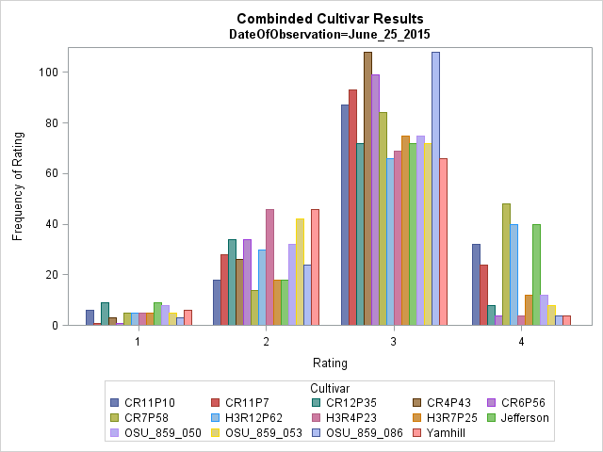

Figure 4: This figure depicts the number of times each cultivar was rated 1-4 on June 25, 2016.

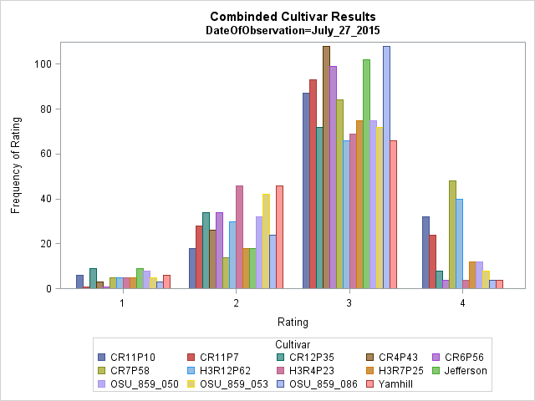

Figure 5. This figure depicts the number of times each cultivar was rated 1-4 on July 27, 2016.

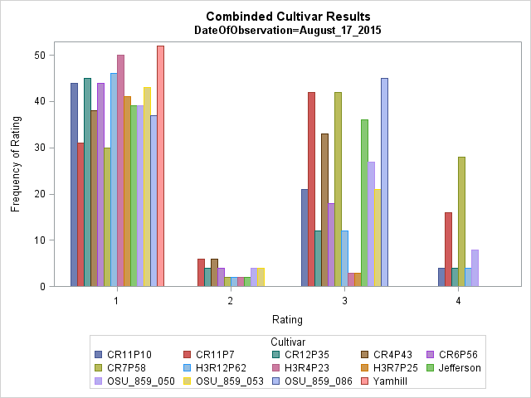

Figure 6: This figure depicts the number of times each cultivar was rated 1-4 on August 17, 2016.

Experiment 2: Histograms of the number of cuttings rated 1-4 at three separate time points.

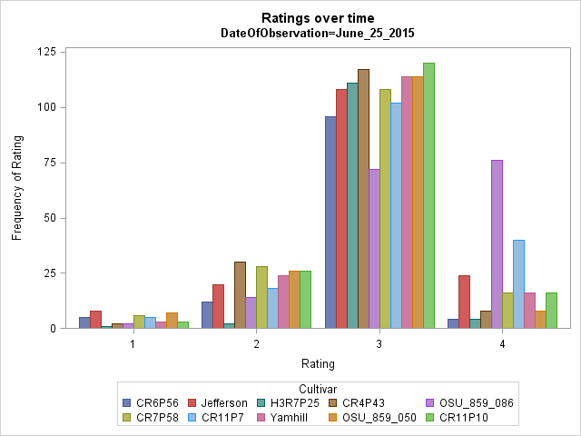

Figure 7. This figure depicts the number of times each cultivar was rated 1-4 on June 25, 2016.

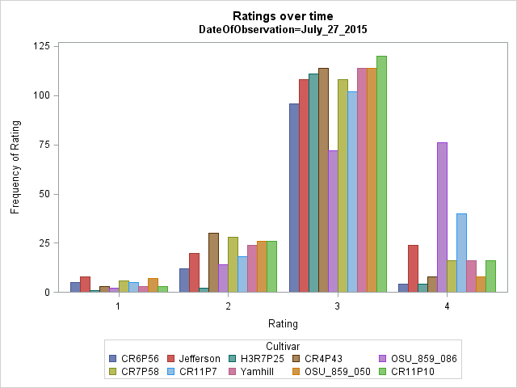

Figure 8: This figure depicts the number of times each cultivar was rated 1-4 on July 27, 2016.

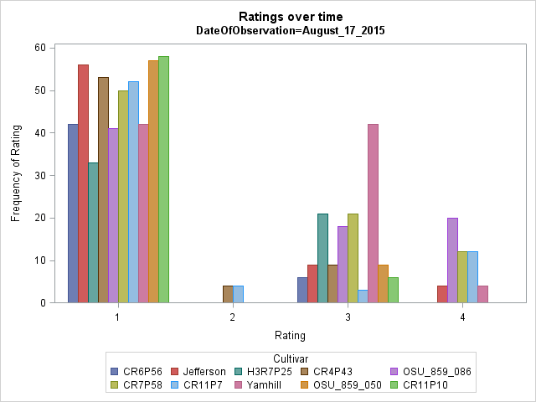

Figure 9: This figure depicts the number of times each cultivar was rated 1-4 on August 17, 2016.