## Tables and Figures

Figure 1. Cover crop height (cm) measured on 28 Mar. 2014 and 28 Mar. 2015, 132 and 128 days after planting, respectively, in a high tunnel in Fayetteville, Ar. Mean separation was performed by LSD at P < 0.05. n = 3 experimental units. Letters represent differences between means for year x treatment combinations.

Figure 2. Cover crop aerial dry biomass (g/m2) sampled on 28 Mar. 2014 and 28 Mar. 2015, 132 and 128 days after planting, respectively, in a high tunnel in Fayetteville, Ar. Mean separation was performed by LSD at P < 0.05. n = 3 experimental units. Letters represent differences between means for year x treatment combinations.

Table 1. Correlation between cover crop variables and parameters, as measured from Austrian winter peas, bell beans, ‘Kodiak’ mustard, and ‘Daikon’ radish grown in a high tunnel in Fayetteville, AR during the winter seasons of 2013-2014 and 2014-2015. For each relationship the Pearson Correlation Coefficients (PCC), p-value, and number of observations (n) are included in the table. Bolded cells are considered significant with a p-value under 0.10. Analysis was conducted with PROC CORR in SAS 9.4.



Figure 3. Relationship between cover crop height and cover crop dry weight biomass, as measured from Austrian winter peas, bell beans, ‘Kodiak’ mustard, and ‘Daikon’ radish grown in a high tunnel in Fayetteville, AR during the winter seasons of 2013-2014 and 2014-2015.

Figure 4. Cover crop and weedy dry biomass (g/m2), sampled on 28 Mar. 2015, 128 days after planting in a high tunnel in Fayetteville, Ar. Mean separation was performed by LSD at P < 0.05. n = 3 experimental units. Upper-case letters represent mean separation between the cover crop biomass and lower-case letters represent mean separation between the weedy biomass measurements.

Figure 5. Relationship between cover crop dry weight biomass and weedy biomass, as measured from Austrian winter peas, bell beans, ‘Kodiak’ mustard, and ‘Daikon’ radish grown in a high tunnel in Fayetteville, AR during the winter seasons of 2013-2014 and 2014-2015.

Table 2. Nutrient content of above-ground cover crop biomass sampled on 28 Mar. 2014 and 20 Mar. 2015, 132 and 128 days after planting, respectively, in a high tunnel in Fayetteville, Ar. F-test conducted to determine interaction effects (n=3, p < 0.05).

|  |  |  |  |  |  |  |  |  |  |  |  |
| --- | --- | --- | --- | --- | --- | --- | --- | --- | --- | --- | --- |
| **Treatment** | % | | | | | mg/kg | | | | | |
| Year | **P** | **K** | **Ca** | **Mg** | **S** | **Na** | **Fe** | **Mn** | **Zn** | **Cu** | **B** |
| **Control** | **0.415** | **3.07** | **1.21** | **0.164** | **0.349** | **214.1** | **1311.0** | **54.5** | **33.1** | **27.6** | **18.9** |
| 2014 | 0.449 | 3.19 | 1.15 | 0.169 | 0.372 | 173.7 | 991.0 | 39.8 | 35.9 | 36.2 | 19.4 |
| 2015 | 0.380 | 2.94 | 1.27 | 0.160 | 0.327 | 254.5 | 1631.0 | 69.2 | 30.3 | 19.1 | 18.4 |
| **Winter Peas** | **0.364** | **3.68** | **1.35** | **0.280** | **0.253** | **587.5** | **352.2** | **53.8** | **78.6** | **17.9** | **20.5** |
| 2014 | 0.366 | 4.17 | 1.30 | 0.277 | 0.250 | 415.1 | 623.9 | 58.2 | 75.4 | 25.2 | 19.8 |
| 2015 | 0.361 | 3.20 | 1.39 | 0.283 | 0.255 | 759.9 | 80.6 | 49.4 | 81.8 | 10.6 | 21.3 |
| **Bell Beans** | **0.315** | **3.47** | **1.22** | **0.216** | **0.208** | **1873.9** | **198.4** | **54.2** | **67.8** | **21.3** | **22.1** |
| 2014 | 0.357 | 4.26 | 1.14 | 0.219 | 0.232 | 1243.0 | 308.3 | 52.0 | 74.5 | 29.0 | 21.8 |
| 2015 | 0.273 | 2.67 | 1.30 | 0.214 | 0.183 | 2504.7 | 88.6 | 56.3 | 61.2 | 13.7 | 22.3 |
| **Mustard** | **0.372** | **3.08** | **1.49** | **0.176** | **0.590** | **193.9** | **675.5** | **37.8** | **32.4** | **21.6** | **29.4** |
| 2014 | 0.396 | 2.72 | 1.70 | 0.208 | 0.583 | 176.6 | 1243.3 | 55.9 | 42.5 | 38.0 | 27.7 |
| 2015 | 0.348 | 3.44 | 1.28 | 0.145 | 0.597 | 211.2 | 107.8 | 19.8 | 22.4 | 5.3 | 31.1 |
| **Radish** | **0.464** | **3.33** | **1.90** | **0.197** | **0.596** | **749.1** | **537.6** | **27.1** | **28.7** | **17.7** | **27.2** |
| 2014 | 0.499 | 3.33 | 2.24 | 0.227 | 0.674 | 603.5 | 1052.2 | 42.2 | 35.6 | 31.8 | 29.0 |
| 2015 | 0.430 | 3.34 | 1.56 | 0.167 | 0.518 | 894.6 | 23.0 | 12.0 | 21.7 | 3.5 | 25.3 |
|  | * | ** | ** | * | * | * | ** | ** | * | * | ** |
| * indicates Trt main effect at p < 0.05 | | | | |  |  |  |  |  |  |  |
| ** indicates Year by Trt interaction effect at p < 0.05 | | | | | | |  |  |  |  |  |

Table 3. Cover crop aerial tissue C and N content from samples collected from above-ground cover crop biomass on 28 Mar. 2014 and 20 Mar. 2015, 132 and 128 days after planting, respectively, in a high tunnel in Fayetteville, AR.

|  |  |  |  |  |  |  |
| --- | --- | --- | --- | --- | --- | --- |
| **Treatment** |  | | | |  | |
| Year | **N%** | | **C%** | | **C/N ratio** | |
| **Control** | **1.75** | **Cz** | **38.81** |  | **23.48** | **B** |
| 2014 | 1.82 |  | 38.56 | cd | 22.66 |  |
| 2015 | 1.68 |  | 39.06 | c | 24.29 |  |
| **Winter Peas** | **3.78** | **A** | **41.17** |  | **11.01** | **C** |
| 2014 | 3.81 |  | 38.67 | cd | 10.32 |  |
| 2015 | 3.75 |  | 43.67 | a | 11.70 |  |
| **Bell Beans** | **3.14** | **B** | **41.13** |  | **13.43** | **C** |
| 2014 | 3.28 |  | 38.83 | cd | 12.05 |  |
| 2015 | 3.00 |  | 43.44 | ab | 14.82 |  |
| **Mustard** | **1.54** | **CD** | **39.17** |  | **25.90** | **AB** |
| 2014 | 1.60 |  | 36.93 | de | 23.26 |  |
| 2015 | 1.48 |  | 41.41 | b | 28.53 |  |
| **Radish** | **1.37** | **D** | **38.56** |  | **28.79** | **A** |
| 2014 | 1.40 |  | 35.52 | e | 25.85 |  |
| 2015 | 1.35 |  | 41.59 | ab | 31.74 |  |
|  | * |  | ** |  | * |  |
| * F-test indicates Trt main effect a p < 0.001 | | | | | | |
| ** F-test indicates Year*Trt interaction effect at p < 0.001  **z**Upper-case letters represent means separation between values within the column for main effects. Lower case letters indicate mean separation between values within a column for the interaction effects. Mean separation was performed by LSD at p < 0.05. N = 3. | | | | | | |
|

Figure 6. Cover crop aerial tissue N concentration (%) mean values from years 2014 and 2015 pooled. Aerial biomass was sampled on 28 Mar. 2014 and 29 Mar. 2015, 132 and 128 days after planting, respectively, in a high tunnel in Fayetteville, AR. Mean separation was performed by LSD at P < 0.05. N = 3 experimental units. Letters represent differences between treatment means.

Figure 7. Aerial tissue C concentration sampled from treatments on 28 Mar. 2014 and 29 Mar. 2015, 132 and 128 days after planting, respectively, in a high tunnel in Fayetteville, AR. Mean separation was performed by LSD at P < 0.05. N = 3 experimental units. Letters represent differences between means for year x treatment combinations.

Figure 8. Cover crop biomass N (g/m2) calculated from aerial biomass sampled on 28 Mar. 2014 and 29 Mar. 2015, 132 and 128 days after planting, respectively, in a high tunnel in Fayetteville, AR. Mean separation was performed by LSD at P < 0.05. N = 3 experimental units. Letters represent differences between means for year x treatment combinations.

Figure 9. Relationship between cover crop aerial tissue N and cover crop height, as measured from Austrian winter peas, bell beans, ‘Kodiak’ mustard, and ‘Daikon’ radish grown in a high tunnel in Fayetteville, AR and sampled on 28 Mar. 2014 and 29 Mar. 2015, 132 and 128 days after planting, respectively.

Figure 10. Relationship between cover crop above-ground tissue C and cover crop biomass, as measured from Austrian winter peas, bell beans, ‘Kodiak’ mustard, and ‘Daikon’ radish grown in a high tunnel in Fayetteville, AR and sampled on 28 Mar. 2014 and 29 Mar. 2015, 132 and 128 days after planting, respectively.

Table 4. ANOVA table of interaction between cover crop treatment (CC) and year on soil organic matter (SOM) and bulk density (BD), measured on 25 April 2014 and 28 April 2015. Significant main effects where P < 0.05 are bolded and shaded.



Table 5. ANOVA for interaction between cover crop treatment (CC) and date on soil C% soil N% and soil C/N ratio, from soil samples collected on 28 Mar. 2014, 25 April 2014, 28 Mar. 2015, and 28 April 2015. Highest-order interactions or significant main effects where P < 0.05 are bolded and shaded.



Figure 11. Soil C/N ratio measured from 15 cm soil cores collected on sampling dates of 28 Mar. 2014, 26 April 2014, 28 Mar. 2015, and 28 April 2015 in a high tunnel in Fayetteville, AR. March sampling dates were prior to cover crop incorporation and April dates were 30 days after incorporation. Mean separation was performed by LSD at P < 0.05. N = 3 experimental units.

Figure 12. Relationship between cover crop biomass N and soil C/N ratio, as measured from Austrian winter peas, bell beans, ‘Kodiak’ mustard, and ‘Daikon’ radish grown in a high tunnel in Fayetteville, AR. Soil C/N ratio was measured from 15 cm soil cores collected on sampling dates of 28 Mar. 2014, 26 April 2014, 28 Mar. 2015, and 28 April.

Table 6. Correlation between cover crop variables and soil variables, as measured from Austrian winter peas, bell beans, ‘Kodiak’ mustard, and ‘Daikon’ radish grown in a high tunnel in Fayetteville, AR during the winter seasons of 2013-2014 and 2014-2015. For each relationship the Pearson Correlation Coefficients (PCC), p-value, and number of observations (n) are included in the table. Bolded cells are considered significant with a p-value under 0.10.



Figure 13. Soil pH measured from 15 cm soil core samples collected on 28 Mar. 2014, 25 April 2014, 8 Aug. 2014, 7 Nov. 2014, 28 Mar. 2015, 28 April 2015, 12 Aug. 2015, and 12 Nov. 2015. March sampling dates are prior to cover crop incorporation, April dates are 30 days after incorporation, August dates are after tomato cropping, and November dates are after broccoli cropping in a high tunnel in Fayetteville, AR. Mean separation was performed by LSD at P < 0.05. N = 3 experimental units. Upper-case letters represent means separation among sampling dates and lower-case letters represent means separation among cover crop treatments.

Table 7. Statistical analysis of variance for interaction between cover crop treatment and sampling date for the variables pH, EC, and nutrient levels (P, K, Ca, Mg, S, Na, Fe, Mn, Zn, Cu, and B) measured from 15 cm soil core samples collected on 28 Mar. 2014, 25 April 2014, 8 Aug. 2014, 7 Nov. 2014, 28 Mar. 2015, 28 April 2015, 12 Aug. 2015, and 12 Nov. 2015. March sampling dates are prior to cover crop incorporation, April dates are 30 days after incorporation, August dates are after tomato cropping, and November dates are after broccoli cropping in a high tunnel in Fayetteville, AR. Highest-order interactions or significant main effects are bolded and shaded.



Figure 14. Soil EC (dS/m) measured from 15 cm soil core samples collected on 28 Mar. 2014, 25 April 2014, 8 Aug. 2014, 7 Nov. 2014, 28 Mar. 2015, 28 April 2015, 12 Aug. 2015, and 12 Nov. 2015. March sampling dates are prior to cover crop incorporation, April dates are 30 days after incorporation, August dates are after tomato cropping, and November dates are after broccoli cropping in a high tunnel in Fayetteville, AR. Mean separation was performed by LSD at P < 0.05. N = 3 experimental units.

Figure 2.1. Tomato leaf chlorophyll estimate (SPAD) mean values from tomatoes grown in a high tunnel in Fayetteville, AR in 2014 and 2015 following cover crop treatments. Upper case letters represent means separation at P < 0.05, N = 3. Means comparison was carried out using Student’s t test.

Figure 2.3. Tomato foliar N concentration measured from leaf samples collected in 2014 and 2015 from tomatoes grown in a high tunnel in Fayetteville, AR after winter cover crop treatments. Means comparison using Student’s t test at P < 0.05. Bars represent standard error from the mean.

Figure 2.6. Tomato yield per plant measured from tomatoes grown in 2014 and 2015 in a high tunnel in Fayetteville, AR following winter cover crop treatments. No significant differences between treatments was detected at P < 0.10. Bars represent standard error of the mean.

Figure 2.11. Broccoli foliar N concentration measured on 6 Nov. 2014 and 5 Nov. 2015 from broccoli grown in a high tunnel in Fayetteville, AR following tomatoes which were preceded by winter cover crop treatments. No significant differences between treatments was detected at P < 0.05. Bars represent standard error from the mean.

Figure 2.12. Broccoli plant fresh weight biomass (g) across years measured on 7 Nov. 2014 and 9 Nov. 2015 from broccoli grown in a high tunnel in Fayetteville, AR following tomatoes which were preceded by winter cover crop treatments. Upper case letters represent means separation by Student’s t Test at P < 0.05, N=3.

Figure 2.13. Broccoli total yield (kg) per plot, with harvest occurring through the month of Oct. in 2014 and 2015 from broccoli grown in a high tunnel in Fayetteville, AR following tomatoes which were preceded by winter cover crop treatments. No differences were detected between treatments means with Student’s t-test at P < 0.05, N = 3. Bars represent standard error from the mean.

Figure 2.14. Broccoli average head weight (g) from harvest occurring through the month of Oct. in 2014 and 2015 from broccoli grown in a high tunnel in Fayetteville, AR following tomatoes which were preceded by winter cover crop treatments. No differences were detected between treatments means with Student’s t-test at P < 0.05, N = 3. Bars represent standard error from the mean.

# Appendix A

Figure A.1.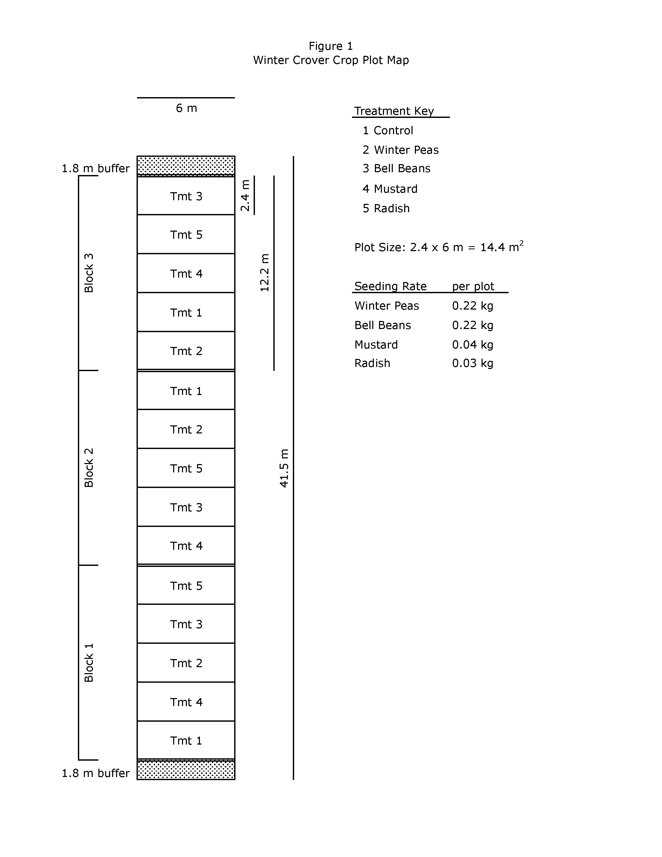

Figure A.2

