SARE - Grossman_Figures and Tables Y2
Preliminary data; do not cite

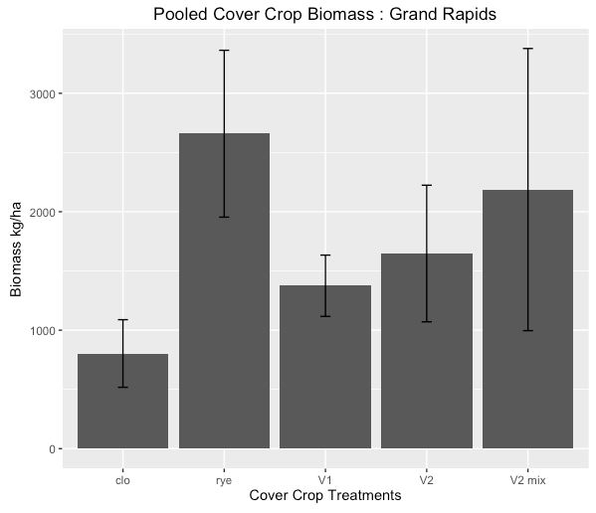
Fig. 1 Cover crop biomass (legume spp. and/or rye) in Grand Rapids, MN, kg/ha, Error bars = standard error

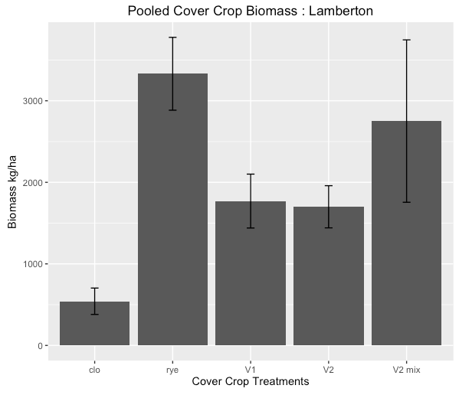
Fig. 2 Cover crop biomass (legume spp. and/or rye) in Lamberton, MN, kg/ha, Error bars = standard error
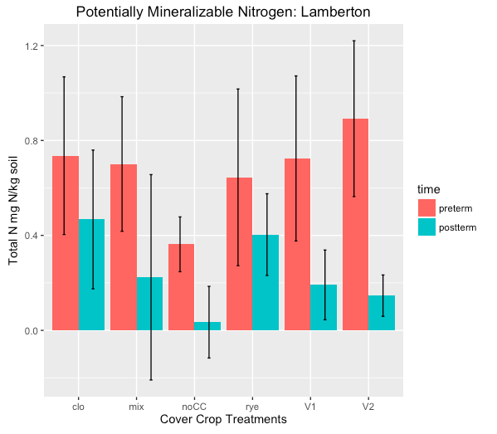
Fig. 3 Potentially mineralizable nitrogen (NH₄⁺ and NO₃⁻), before cover crop termination (preterm) and two weeks after termination (postterm), Lamberton, MN experimental site. Error bars = standard error
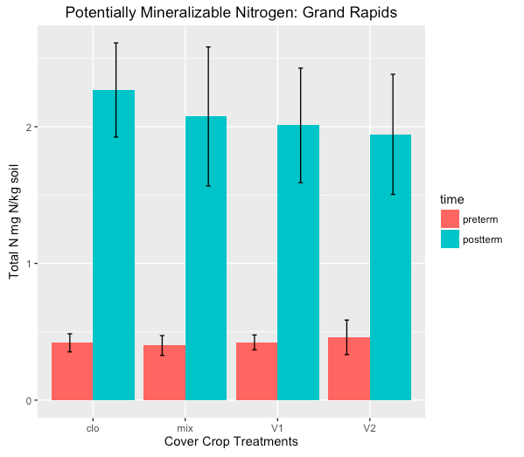
Fig. 4 Potentially mineralizable nitrogen (NH₄⁺ and NO₃⁻), before cover crop termination (preterm) and two weeks after termination (postterm), Grand Rapids, MN experimental site. Error bars = standard error
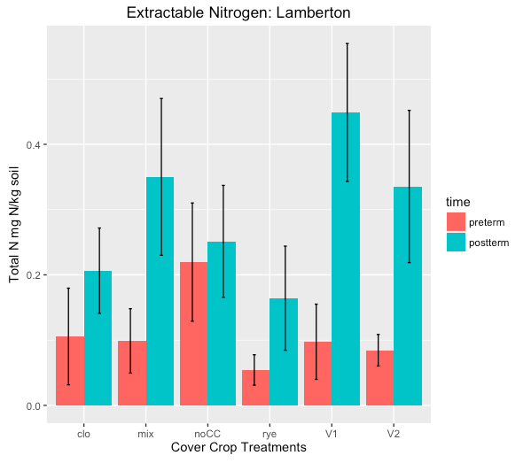
Fig. 5 Extractable nitrogen (NH₄⁺ and NO₃⁻), before cover crop termination (preterm) and two weeks after termination (postterm), Lamberton, MN experimental site. Error bars = standard error

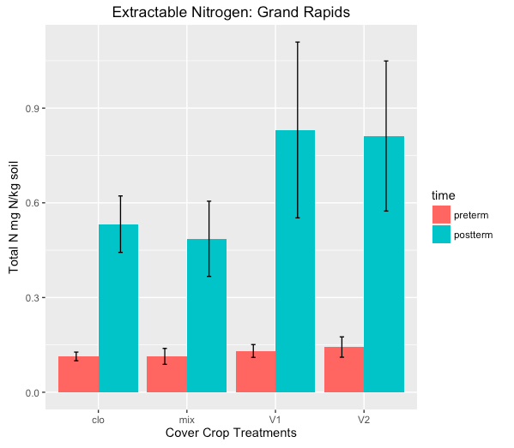
Fig. 6 Extractable nitrogen (NH₄⁺ and NO₃⁻), before cover crop termination (preterm) and two weeks after termination (postterm), Grand Rapids, MN experimental site. Error bars = standard error

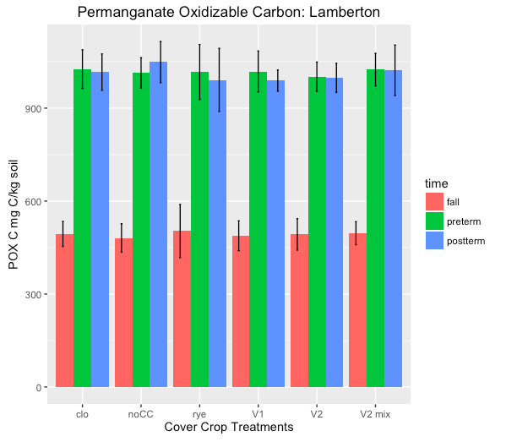
Fig. 7 Permanganate oxidizable carbon (POX-C, mg C/kg soil), at 3 time points: fall pre-cover crop planting (fall), at cover crop termination (preterm) and two weeks after termination (postterm), Grand Rapids, MN experimental site. Error bars = standard error
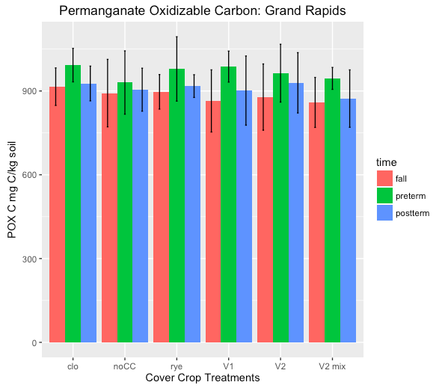
Fig. 8 Permanganate oxidizable carbon (POX-C, mg C/kg soil), at 3 time points: fall pre-cover crop planting (fall), at cover crop termination (preterm) and two weeks after termination (postterm), Grand Rapids, MN experimental site. Error bars = standard error

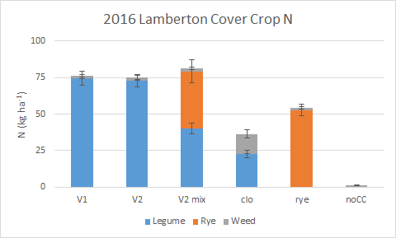
Fig. 9 Cover crop aboveground biomass nitrogen (kg ha-1) at Lamberton in Y2. Error bars = standard error.

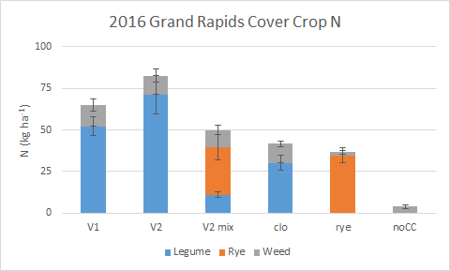
Fig. 10 Cover crop aboveground biomass nitrogen (kg ha-1) at Grand Rapids in Y2. Error bars = standard error.

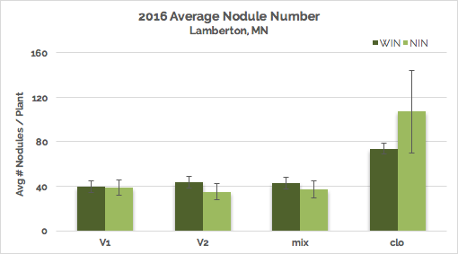

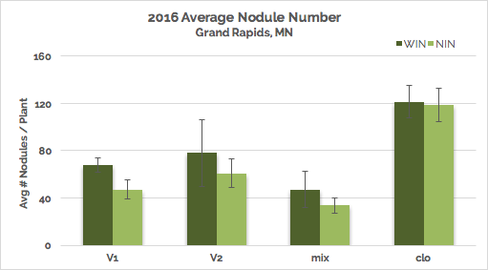

Fig. 11 Average nodule number per plant at Lamberton and Grand Rapids in Y2. Error bars = standard error.

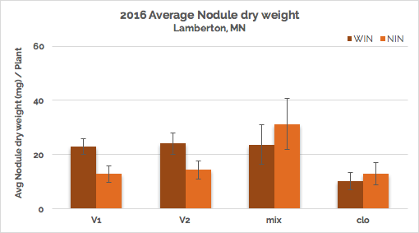

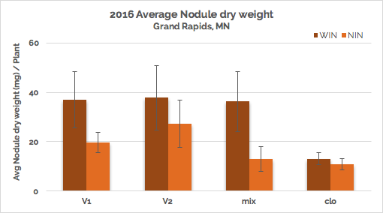

Fig. 12 Average nodule dry weight per plant at Lamberton and Grand Rapids in Y2. Error bars = standard error.

Site | Treatment | NDfA (%)
Lamberton | V1 | 60.73 ± 5.44
Lamberton | V2 | 52.78 ± 4.33
Lamberton | V2 mix | 67.94 ± 2.43
Lamberton | clo | 60.41 ± 3.24
Grand Rapids | V1 | [pending]
Grand Rapids | V2 | [pending]
Grand Rapids | V2 mix | 76.15 ± 3.54
Grand Rapids | clo | 41.01 ± 4.02

Table 1: NDfA (%) across treatments and sites in 2016. V1 and V2 at Grand Rapids are pending analysis. Confidence intervals were determined by standard error.

