Solar drying for fruits and vegetables

Britta Hansen, Michael Reid, James Thompson
Feb 4, 2014

Background information

Introduction to drying
Fruits and vegetables are highly profitable commodities for both small-scale and large-scale farmers. Unfortunately they are very perishable and postharvest losses can be quite high, especially in developing countries. The FAO estimates that roughly one-third of edible products are lost between the growing site and the consumer. In the developing world the majority of these losses occur soon after harvest (2011). Many fruits and vegetables have production peaks when, for reasons such as season, weather, or planting time, high volumes of product are harvested in a short period. During these peaks, product quality is often high, but prices are typically low because there is too much product available. Shortly after the harvest, when the glut of produce has been sold, prices rise. Farmers can take advantage of the higher prices by storing some of their harvest. The primary tool for doing this with fresh fruits and vegetables is refrigerated cold rooms, which can extend shelf life for a few weeks for some crops and up to a year for a few others. Where cool storage is not available or not economically justified, excess product, often of good quality, goes to waste. Freezing and canning are common strategies for processing peak production and adding value but require expensive and large facilities, often not available to small-scale farmers.

An alternative for many crops is drying., Producers all over the world currently dry many of their grain and legume crops using a variety of methods appropriate for each crop. In certain cultures dried fruits and vegetables are a staple part of the diet. In addition to extending the marketing season, drying also reduces the moisture content of the product, substantially decreasing its weight and transportation and storage costs. Traditionally the drying of foodstuffs has been done in the open on a hard surface or a ground cloth. The process is usually slow, and can be accompanied by insect infestation and growth of molds. Rain and dust can be a problem and contamination with animal waste is also possible. For some fruits and vegetables open-air drying also may lead to discoloration and poor flavor quality.

Improved solar drying takes produce off the ground and uses plastic or glass coverings to protect the produce and increase the drying air temperature. Warm air flows past the product, resulting in faster drying, reduced product discoloration and improved flavor. Adding value through improved solar drying is a proven way to extend the marketing period, diversify and increase income, and enter new markets. In Eastern Europe dried apricots and plums are a valued part of the diet, and USAID-supported farmers in neighboring Uzbekistan are taking advantage of this and their large orchards to increase their income and enter the export market. These producers are using a solar dryer, the UCD chimney dryer developed by the Horticulture Innovation Lab for drying grapes, apricots, and plums.

Warm dry air in- warm humid air out
Improved solar drying can be done with three methods: direct, indirect and mixed..

Direct solar drying
is when solar energy directly penetrates the drying chamber, after passing through a clear barrier like glass or plastic. The product is exposed to solar radiation and the solar energy heats the air around the product.
The Mixed-method combines the features of the other methods. The heated air from a separate solar collector is passed through the produce and at the same time the clear walls of the drying cabinet allow the product to be exposed to direct solar heating.
Indirect solar drying uses a separate collector to heat air and that air is then passed over the produce .

Is drying right for us?
There are many issues to consider when deciding whether to use drying as a means of preserving your crop. Answering the questions below will help you evaluate the feasibility of drying in your next project or in the communities where you work.

1. Are there fluctuations in fruit and vegetable production in your region? | Yes No
2. Do smallholder farmers currently use any drying methods for non-horticultural crops? Grains, beans, etc. | Yes No  If yes describe the technology:
3. Could this knowledge and/or methods be easily transferred to their horticultural crops? | Yes No
4. Who in the family might contribute their labor to drying fruits and vegetables? | Men Women Children Hired help
Will this added work take away from other duties? | Yes No
5. In your region, is there a positive perception of eating dried fruits and vegetables? | Yes No
6. Are dried products currently available in your local market?
6b. If yes, what? (fish, meat, fruits, vegetables, flowers, herbs?) | List
6a. Would people buy dried fruits in your local market if they are not available now? | Yes No
6c. What locally produced fruits and vegetables when dried could be added to the market? | What do people have a taste for?
7. Look at the list of materials below, could most or all be found in a local market or regional hub town? At an affordable price? | Yes No
8. Is it typical to get 4-5 warm sunny days in a row during the period when drying would be done? | Yes No
If you answered yes to many of these questions and were able to come up with products that could be sold dried and could likely be incorporated into local diets, then solar drying may be right for your next project. Preview with vendors and producers to see if this is something they could make money with.

Storing dried product
Properly dried fruits and vegetables can be stored for several months to a year. Dried foods should be stored in a cool, dry and dark area.

After drying, the produce should be allowed to cool and then packed into dry, airtight containers or plastic bags. Don’t be afraid to pack the fruit tightly together. A cool temperature is the most important factor in storing your dried product; the higher the temperature, the faster the product will deteriorate.

Produce | Kilos of fresh product | Kilos of dried product
Apples | 10 | 1.04
Grapes | 10 | 1.67
Peaches | 10 | 1.04
Pears | 10 | 1.07
Tomatoes | 10 | 0.36
Fruit should be dried to approximately 20% moisture content; this means that the fruit will still be pliable, not breakable like a twig. Vegetables, on the other hand, should be dried down to 10% moisture; a properly dried vegetable will be brittle and will snap if bent. See Table 1 to compare weights of fresh vs. dried produce.
Table 1. Reference for fresh and dried product quantities

The best method of determining safe product moisture content for storage is to measure the relative humidity of the air in the storage container. It should be less than 65%. Mold will not grow below this humidity.

The least expensive method for measuring relative humidity is a test strip with color change dots. These strips cost a few cents each and can measure humidity to the nearest 10%.

Insects grow when stored product temperature is greater than about 12° to 15°C. Infestation damage can be prevented by cold storage or the use of insecticides. Overdrying to a headspace relative humidity less than 30% will prevent damage but this takes extra time in the dryer or final drying with a desiccant. Products stored in a low headspace humidity may have different quality characteristics than higher moisture content products.

UC Davis Chimney dryer
Horticulture Innovation Lab researchers have been testing a new solar drying design that is low-cost and reduces drying time.. A raised bed (or wooden frame) is covered with black plastic or dark-colored row cover material. The product is placed on wooden trays along the length of the raised bed or the wood frame. A clear plastic sheet placed over the trays traps the sun’s heat and drives water out of the product.

The innovative feature of this dryer’s design is that it causes the drying air to flow at high speed past the product. A chimney at the northern end of the north/south-oriented tunnel produces the airflow. In the southern hemisphere, the chimney would be located on the south end of the tunnel. The heat of the air in the tunnel creates a draught in the chimney, which produces the airflow. The drier is designed so that the product trays are placed with a small distance between the black plastic sheeting underneath them and the clear covering. This forces the air to flow through a small area and at high airspeed past the trays..

Benefits
The UC Davis Chimney design dies about twice as fast as a traditional cabinet drier, yet construction is easy and inexpensive. The lumber, metal screen, and plastic materials purchased to construct the prototype dryer cost less than 30 USD. The trays (the major cost) can be used indefinitely. The design is flexible enough to accommodate a variety of products, from whole peaches and apricots, to smaller items such as sliced tomatoes. The drying trays can be built to size for different products. In Uzbekistan grape growers modified the design, removing the drying trays and adding wires to dry bunches of grapes. Local consumers prefer the round shape of the resulting raisins compared with the flattened raisins obtained when grapes are dried on trays

Materials needed
The chimney dryer can be constructed in two ways, over a long mound of soil or on a wooden frame above the ground. The basic materials needed for the drying section and the chimney are; one sheet of 4 mil polyethylene film 10m x 3m, a 7m x 3m’ sheet of black nonwoven fabric (or plastic, similar to row cover material) plus four 2.5m poles and about 4m of thin wood strips to stabilize the chimney poles. The clear plastic is held above the top trays with a 6m piece of wood positioned just above the trays. It can be supported with stakes placed in the top of the soil berm. The clear plastic is stapled to two 6m wood strips positioned at ground level. Each one meter square tray requires 6 m of thin wood for the frame and a 1m x 1m pieces of screen or plywood. A 6m long wood frame to support the trays in place of the soil berm requires about 70m of thin wood strips. Dryer is assembled with nails and staples.

Soil method
The dryer is constructed from a mound of soil 6 meters long, two meters wide, and 30 cm high. The top of the mound is flat and has a width of 50 cm. Over this mound is placed black plastic, held in place with soil at the edges. The trays with produce sit on the berm covered with the black plastic. At the northern end of the drier, four stakes are driven into the ground to form a chimney, 50 cm wide, 30 cm across, and 2 meters high.
Figure 1. Side view of dryer, soil method.

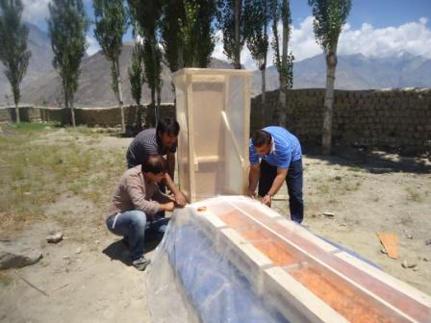
A clear plastic sheet is attached around the chimney except for the top and the bottom 10 cm facing the mound. Fruit or other products are placed on 7 trays, and 8 or 9 trays are placed along the soil mound, with the (preheat) trays furthest from the chimney being empty. A clear plastic sheet is placed over the trays, and is held in place on either side with soil or wooden boards. The sheet is attached to the chimney with staples and duct tape, or whatever is available.

preheat section
0.6m x 0.6m trays separated by 20mm
Stack is 2m high with a
0.6m x 0.6m cross section

Frame method
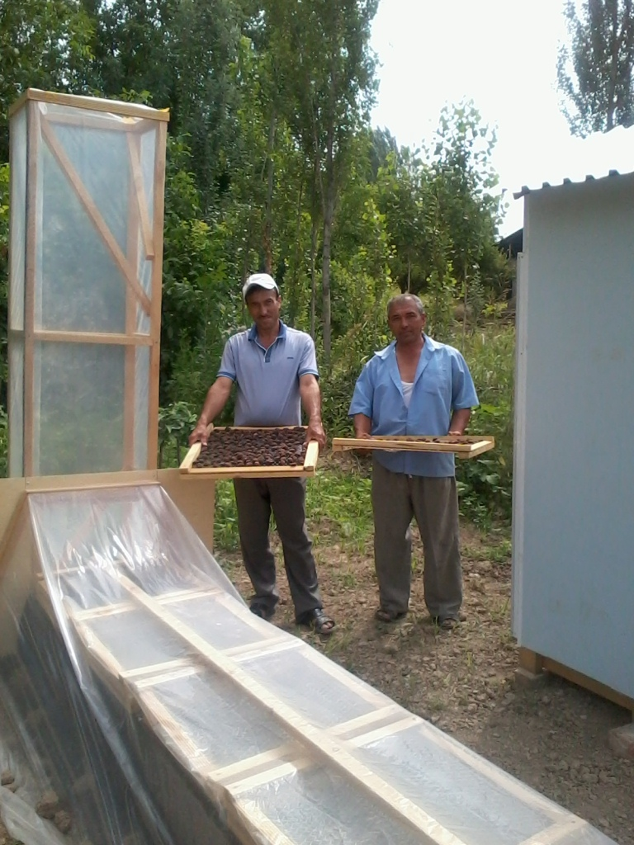
A wooden frame can be constructed to keep the produce off the ground, and to make lifting heavy trays easier. The frame will be 6 meters long, 1 meter wide, and 1 meter high, as shown in the diagrams below.. Construct the chimney the same way as you would if the dryer were on the ground, but make sure to make it 2 meters higher than the top of the drying area. Connect the frame to the chimney making sure to leave to space for the air to flow over the produce and out the chimney.

2 empty trays serve as a preheat section
1m trays separated
by 20 mm

6 m

Brackets to hold rolled up cover

Side view of chimney drier using a wood frame to support trays.

Clear
polyethylene film
1 m
Fill trays with
2-4kg of product
Staple film to wood
pole, allows dryer
to be opened, and tensions the film
Wooden batten along trays to prevent ponding of rain or dew
Black polyethylene

Wooden blocks to
hold trays
1 m

Cross
brace
0.9 m

End cross section of chimney drier using a frame to support trays.

Solid wood sides
90mmmmmmm
1m

Plastic window screen or other mesh
Thin wood strips

Tray design.

Operating a solar drier
Air temperature
High air temperature speeds drying. However air temperature must be limited to prevent damage to the product. Most fruits and vegetables should be dried with maximum air temperatures in the range of 140 - 150°F (60 – 65°C). Cabbage and onions have a maximum air temperature of 135°F (57°C). Nuts and grains have a maximum temperature of about 130°F (54°C) although walnuts should not be dried above 110°F (43°C). Rice cannot be exposed to drying air for longer than is necessary to remove two to three percentage points of moisture. Air temperatures above these recommendations produce quality loss, such as a dark color or decreased storage life. Test dry products to be sure of the conditions they require for best quality.

The dryer described in this publication does not usually produce air temperatures above 130°F (54°C). However, operators should regularly monitor air temperature in the drying area. An inexpensive dial thermometer works well for this.

Solar radiation
Product on the top trays is exposed to direct radiation from the sun. This may cause bleaching of some items and the light color may or may not be desirable. It may also cause excessive heating of the product, which usually causes quality loss. If direct exposure to sunlight is damaging, the top tray can be covered with fabric to shade the product.

The direct radiation also causes the product on the top tray to dry faster than product on the lower tray. This can usually be accounted for by rotating tray positions once or twice during the drying process.

Airspeed
Fast flow of air past the product increases the rate of moisture removal from the product and speeds drying. Make sure the air entrance is not blocked or covered in any way. Do not support the clear plastic cover too high above the trays. This increases the area that air flows through and slows its speed. Ensure there is an open transition between the drying area and the chimney.

Humidity
Low air humidity speeds drying. Heating air reduces its humidity and even in locations with high ambient humidity the drier heats air enough to produce the low humidity required for rapid drying.

Amount of fruit on trays
Adding more fruit to the trays increases the overall amount of fruit dried per day, but it also causes the drying cycle to be longer. Light tray loadings associated with flowers or herbs, less than 0.5 lb/ft2 (2.5 kg/m2) will dry in less than one day. The dryer has been modified to dry grapes in bunches, producing equivalent tray loading of more than 10 lb per ft2 (50 kg/m2). Complete drying was achieved in about 5 to 7 days.

Product size
Thin items like herbs and leafy greens dry in a few hours and products with a large minimum dimension like whole apricots or whole bananas may require several days to dry. Speed drying by removing pits, peeling the product and/or cutting it into thin pieces.

