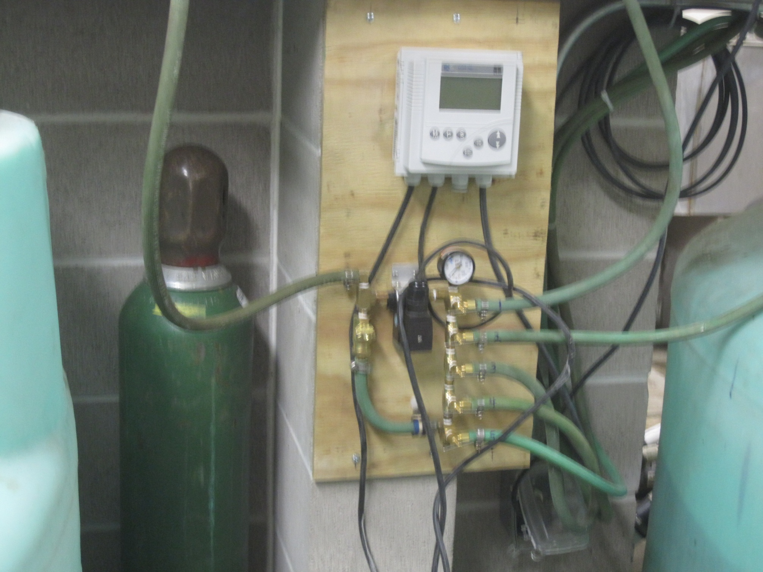

Valved pressure lines to tanks

Bypass Line

Solenoid

Regulator Line to be attached to Oxygen tank

Oxygen Cylinder

DO Controller