Soybean Management and Soil Quality for High Yields
Giovani Stefani Fae and Greg Roth, Penn State Department of Plant Science
At this stop we will assess soil and crop parameters that we have found to be associated with high yields in soybeans. We will be evaluating the impact of planting date, crop rotation, manure and cover cropping on soybean yield potential. We will also demonstrate how crop models can predict crop development and growth, and help growers make more sustainable management decisions.
One key concept in crop yield is the amount of seasonal radiation that the crop can intercept. Two key factors in radiation interception are the row spacing and the planting date in soybeans. We have the ability to use a crop model to assess how radiation interception impacts yield. For this exercise, we will use a Ceptometer in the field to estimate the radiation interception. Record the radiation interception for each of the planting dates in the field. Also record the growth stage. If the field has a 60 bu/ac yield potential, estimate the yield based on Agronomy Guide Table 1.6-5 below. We will discuss how the information could be used in a crop model to estimate yield. Also, we will estimate the impact of narrower rows and increased radiation interception with the Cycles computer model and estimate the potential advantage of more rapid canopy development. Using the KY data (table 2), estimate when the soybeans would have reached Flowering stage or R1. Note that it takes fewer days for earlier varieties or later planted varieties to reach R1.
Record your observations below:
Planting Date | PAR* (Below Canopy) | PAR (Above Canopy) | PAR Intercepted (%) | Growth Stage | Agro Guide Yield Potential | Crop Model Yield Potential
May 2
May 30
June 27
* PAR stands for Photosynthetically Active Radiation
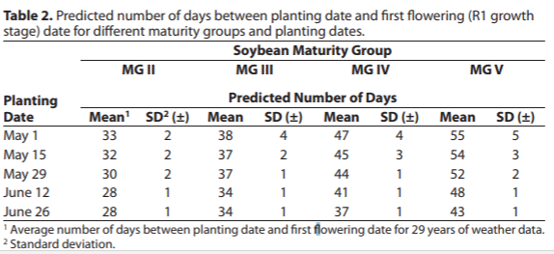
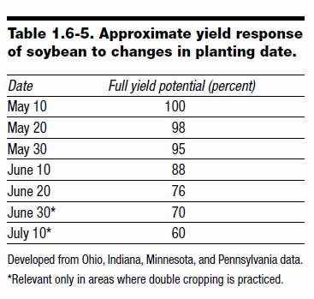
From Univ. of KY: http://www2.ca.uky.edu/agcomm/pubs/agr/agr184/agr184.pdf

Another important part of soybean yield potential is water holding capacity and soil structure. Our Brazilian friends have learned this lesson well and use it to maximize productivity. They will occasionally rotate a field to a perennial grass pasture to restore productivity. In this demonstration, we compare a rotated perennial grass with manure to a typical corn/soybean rotation.
First, observe the soils and the pits in the two plots. Note any differences in rooting depth and soil structure between the “Brazilian treatment” and the corn soybean rotation.
Compare several attributes of the soil between the two systems. Soybeans were planted on May 2.
Treatment | Infiltration rate  (H, M, L) | Penetration  Resistance  (H, M, L) | Rooting score | Nodulation  (H, M, L)
Corn/soy
Cover Crop - Manure/Soy

These results support some of the conclusions from our ongoing research. Our research program has shown that soybean yields are primarily influenced by precipitation and solar radiation in our region. In years with low water stress, seasonal radiation interception was the main driver for high yields. On the other hand, in years with drought, soil water holding capacity was an important component of soybean yields. Planting date was associated with solar radiation interception, and was a key component of high soybean yields. The Cornell Soil Health quality score did not show any relationship with soybean yields in the evaluated fields. Some macro (potassium and magnesium), micro nutrients (zinc and copper), and pH showed positive moderate responses to yield. Soil depth and infiltration rate were both associated with soybean yield, and root depth and infiltration rate appear to be related.
Use this space to describe some findings from our research:

