[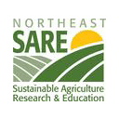](http://www.nesare.org/)****

**Sheep & Goat Workshop**

**October 15, 2016**

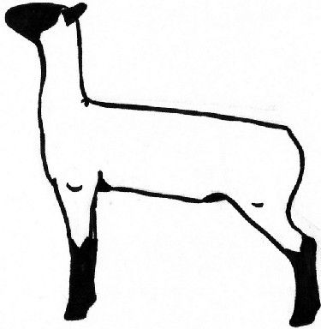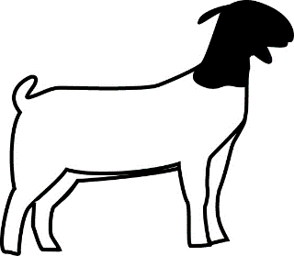**9:30 a.m. Spanishburg, WV**

**Bluestone Valley Fire Dept.**

Enhancing Productivity of Small Ruminants through Reproduction & Parasite Mgt.

Speakers Include: Marlon Knights, WVU Animal Science – Reproduction & Physiology, and Dr. Dahlia O’Brien, Virginia State University Assoc. Professor and Small Ruminant Specialist

|  |  |
| --- | --- |
| Breeding Topics Include:   * Enhancing lifetime productivity of the dam * Selecting the right breeding stock * Management of the replacement female * Increasing the frequency of kidding and lambing * Improving fertility of females bred out-of-season | Parasite Topics:   * Life cycle of stomach worms * Dewormers , resistance, and refugia * Integrated Parasite Management strategies * FAMACHA© and selective deworming * The Five Point Check© |

**Please call the Mercer County WVU Extension Office at 304-425-3079 to register. The program is free and lunch will be provided.**

Programs and activities offered by the West Virginia University Extension Service are available to all persons without regard to race, color, sex, disability, religion, age, veteran status, political beliefs, sexual orientation, national origin, and marital or family status.