Appearing (and reappearing) H₂S in wine
Problem: H₂S is a common contributor to sulfur-like off-aromas in wines, and may be produced in excess during fermentation. It has also been shown to reform during storage under reductive conditions.
Major causes of H₂S during fermentation
- Amino Acid Biosynthesis: H₂S is an intermediate in the biosynthesis of cysteine and methionine. In the absence of sufficient yeast assimilable nitrogen, H₂S will accumulate, diffuse outside of the cells, and cause a “rotten egg” smell.
- Reduction of Sulfur Residues: Elemental sulfur is widely used for powdery mildew, will result in increased H₂S during fermentation. This is a separate pathway from amino acid biosynthesis and cannot be prevented through nutrient addition.
- How late can I spray?
Sulfur residues on fermented grape must should be kept < 1 mg/kg to avoid increased H₂S production during fermentation. Sulfur residue persistence on grapes varies with several factors
- Weather conditions: warmer condition
- Formulation and rate: “Stickier” formulations, e.g. Microthiol will persist longer than simple forms like wettable sulfur, as will higher application rates
- Pre-fermentation practices: clarifying grape must – standard practice for most wine wines - can lower S-residues by >95%
- Quantifying Sulfur Residues
Because of the variability in sulfur persistence, direct measurement is often advisable. Residues on grape must can be quantified using a simple, colorimetric assay, shown below
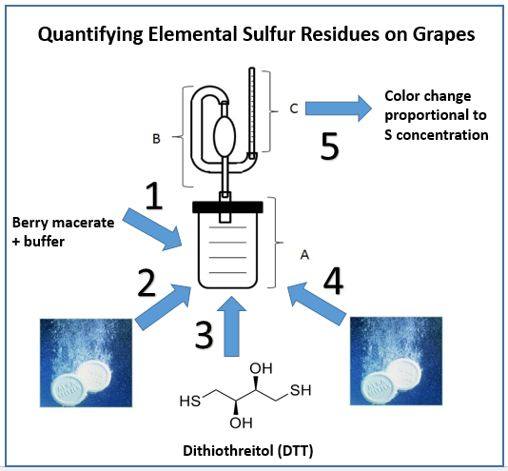
More information on this method is available at: www.extension.org/pages/69748/analyzing-elemental-sulfur-residues-on-grapes (written protocol)
- What if residues are too high?
  - Delay harvest, if possible – weathering will help to reduce sulfur residues.
  - Clarify your juice – for whites and roses, clarification can remove >90% of sulfur.
  - Copper salt additions during fermentation? Be careful . . . see the next paragraph
Causes of H₂S during storage
- H₂S can reform during storage under low-oxygen conditions. Potential precursors include:
  - Copper sulfide complexes: Copper fining will temporarily resolve off-aroma problems by forming odorless complexes. However, these complexes are not easily removed by filtration, and can serve as a reservoir of H₂S if they stay in the wine. Measure your residual copper if you do copper additions!
  - Elemental sulfur degradation products. These species have not been fully characterized yet, but may be polysulfides.
- There may be other sources of H₂S in stored wines, including degradation of cysteine (an amino acid).
Predicting H₂S formation in wines
- Brine dilution in combination with colorimetric gas detection tubes, will detect the presence of copper sulfide complexes.
- Reducing agents, such as TCEP, are currently being investigated for the detection of other latent H₂S sources, including elemental sulfur degradation products.
- These detection methods are simple, inexpensive, and require minimal specialized equipment, making them suitable for small-scale operations.
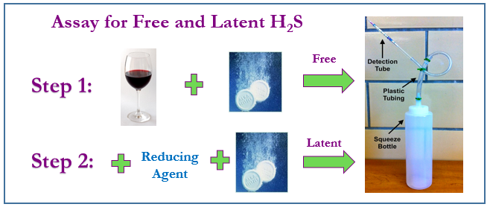
What can be done?
- The classic technique of copper fining is not recommended, since the formation of copper sulfide complexes is shown to be reversible during storage.
- Highly reductive storage conditions (e.g. screw cap closures) should be avoided for wines at risk of developing reductive character.

