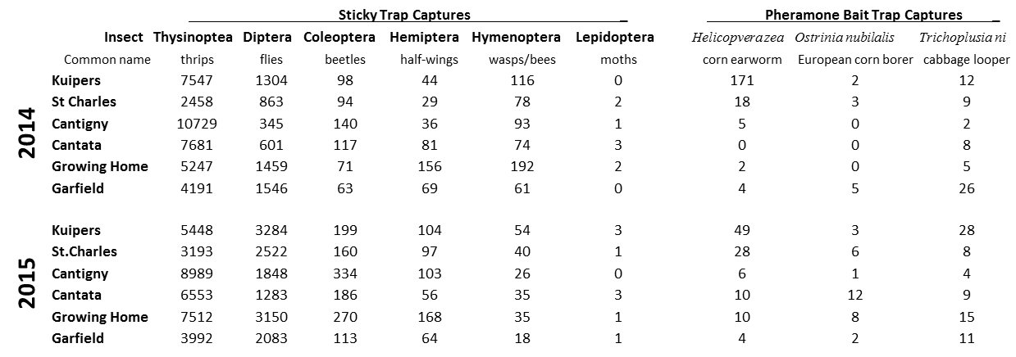

**Table 4:** Insect captures from sticky traps and pheromone bait traps in 2014 and 2015.