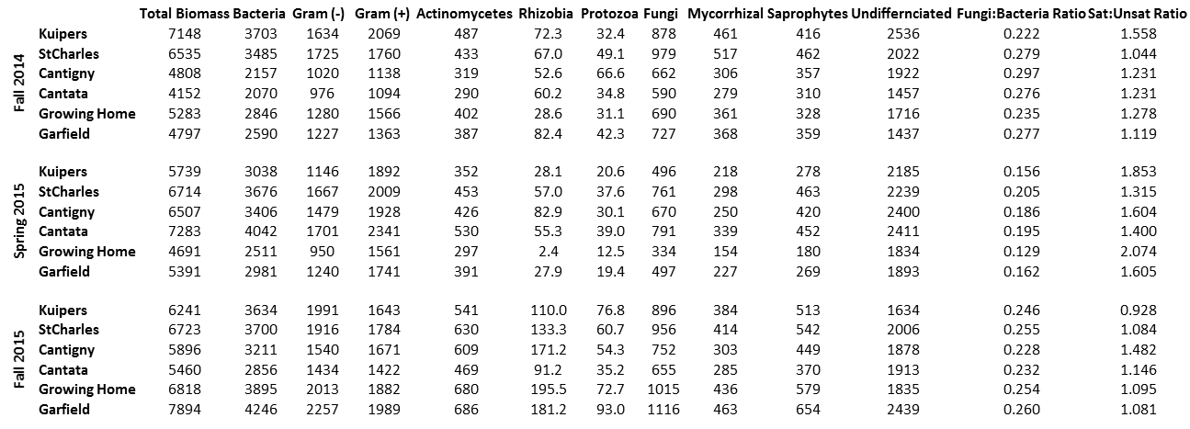

**Table 5:** Biomass measures from phospholipid fatty acid (PLFA) determination of sampled soils from three samplings in Fall 2014, Spring 2015, and Fall 2015. All measures are biomass in µg/g soil except fungi:bacteria ratio and Sat:Unsat ratio. Sat:Unsat ratio is the ratio of saturated membrane fatty acids to unsaturated fatty acids which is a measure of cold or water stress on the microbes.