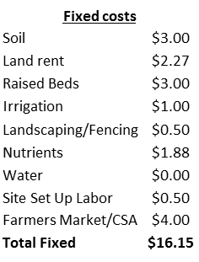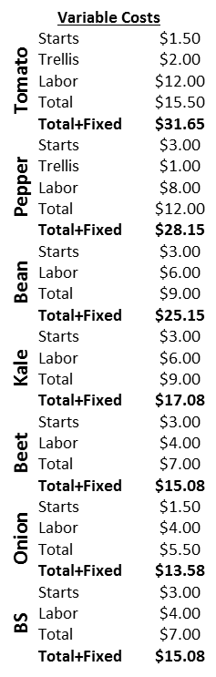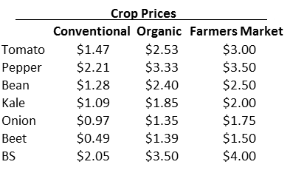

**Table 6:** Fixed and variable costs for individual crops, crop prices, and site overall profitability for economic analysis of project. See text for explanation of fixed and variable costs and crop prices. Site profitability is based on average per-pot profitability averaging all crops together.

