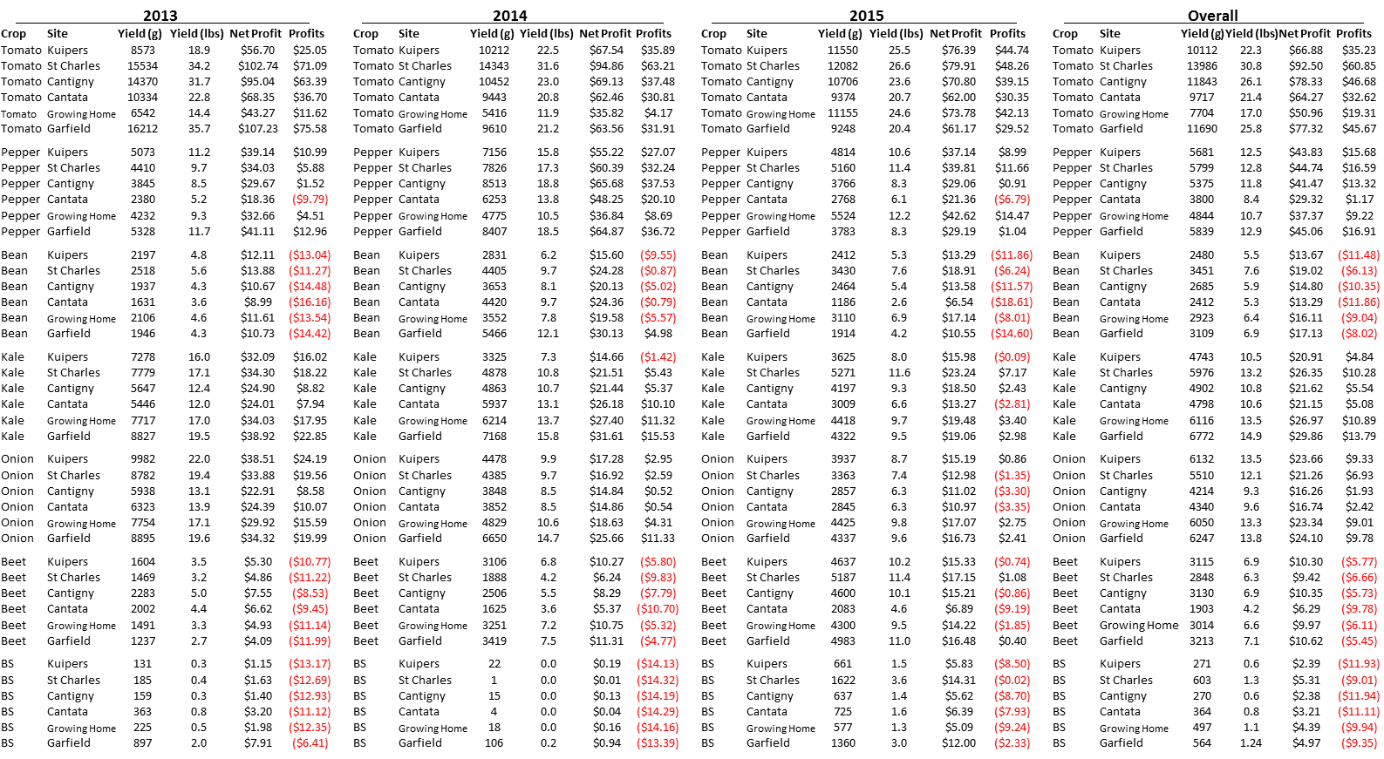

**Figure 7:** Profitability of each crop and site combination on a per-pot basis for each year and average of all three years. Varieties are combined in each pot for this analysis. Red numbers indicate a negative return on profits.