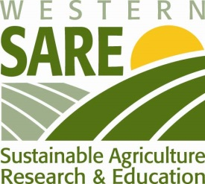
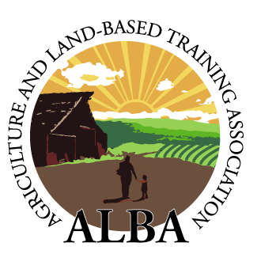
FARMER TRAINING MINI-CONFERENCE
May 29 - 30th, 2015 at ALBA’s Rural Development Center (Salinas, CA) and Triple M Ranch (Las Lomas, CA)
PARTICPANTS:
David Ringuette (Professor and Co-founder, GoFarm Hawaii)
Nicki Anderson (Farm Manager of SLO City Farm, Central Coast Grown - San Luis Obispo, CA)
Steven Marx (Board Member, Central Coast Grown - San Luis Obispo, CA)
Jill Bleher (Garden Project Program Manager, County Jail Honor Farm – San Luis Obispo, CA)
Rob Smith (Operations and Incubator Director, VIVA Farms - WA)
Michael Frazier (Executive Director, VIVA Farms - WA)
Mauricio Soto (Farm Manager and Farmer, VIVA Farms – WA)
Cathryn Henning (Education Coordinator, Wild Willows Farms - San Diego, CA)
Martha Contreras (Chief Financial Officer, Victory Organic Vegetables - Bakersfield, CA)
Pablo Morales (Manager, Victory Organic Vegetables - Bakersfield, CA)
Sandra Chavez (Executive Assistant, Victory Organic Vegetables - Bakersfield, CA)
Tom Bentley (Pajaro Valley High School, Teacher - Watsonville, CA)

TRAININGS AND INFORMATIONAL SESSIONS PROVIDED BY:
ALBA staff and farmers
CA FarmLink
El Pajaro CDC
University of California, Santa Cruz (UCSC)
AGENDA:

Thursday, May 28th (optional) __________________________________________________
6:30-7:30pm - Dinner at Monterey Coast Brewery & Restaurant (downtown Salinas)

Friday, May 29th Rural Development Center (Salinas) _________________________________
8:00- 8:15am - BREAKFAST (bagels, yogurt, fruit, granola, coffee, tea juice)
8:15- 9:45am - Welcome, Introductions and Organizational Overview (Chris Brown)
9:45-10.45am - Farm Tour and Meet Participants (Nathan Harkleroad, Mike Oliver)
10:45-11:00am - BREAK
11:00-11:45am - Adult Education Practices (Damian Parr, UCSC)
11:45-12:30pm - Program Evaluation (Jan Perez, UCSC)
12:30-1:30pm - LUNCH (taco bar) with ALBA staff and farmers (Catered by Taqueria Hidalgo)
1:30-2:15pm - PEPA & Incubator Overview (Nathan Harkleroad)
2:15-3:00pm - Regulatory Compliance (Kaley Grimland)
3:00-3:15pm - BREAK
3:15-4:00pm - Cooler and Food Hub Operations (Patty Howe, Lou Fierro and Karen Marie Feliz)
4:00-4:45pm - ALBA Finances (Patty Howe)
5:00-5:45pm - Partner presentations (CA FarmLink, Pajaro CDC)

Saturday, May 30th_ Triple M Ranch (Las Lomas) & Rural Development Center_________________
8:45-9:30am - BREAKFAST (frittata, yogurt, granola, fruit, coffee, tea, juice) at farmhouse
9:30-11:00am - Triple M Tour (Kaley Grimland)
11:00-1:00pm - LUNCH in area on your own and return to Rural Development Center (Salinas)
1:00-3:00pm - Observe and participate in PEPA Field Day
3pm-onwards - Enjoy Salinas Saturday evening or DEPART

NOTES
- Or consider extending your stay through Sunday, May 31st to enjoy a day of FUN on the Central Coast (*see below for suggested activities!).

- Please RSVP as space is limited! NO COST for the conference itself.

- Breakfast and lunch provided on May 29th, and breakfast on May 30th. All other meals and travel costs will be covered by attendees.

PLANNING HELP
- Further ALBA and Events Details:

- Rural Development Center address: 1700 Old Stage Rd., Salinas, CA 93908 (approx. 8 miles south of downtown Salinas)
- Phone: (831) 758-1469
- Contact: Nathan Harkleroad (cell: 805-234-0546, nathan@albafarmers.org)

- Nearest major airports to ALBA:

- Monterey Regional Airport (MRY) – 27 miles
- San Jose International Airport (SJC) – 73 miles
- San Francisco International Airport (SFO) – 103 miles

- Convenient hotels in Salinas:

- Courtyard Marriot – 17225 El Rancho Way (12 miles)
- Quality Inn – 144 Kern St. (10 miles)
- Others: http://www.tripadvisor.com/Hotels-g33002-Salinas_California-Hotels.html

- *Suggestions of things to do on Sunday:

- Visit the Steinbeck Center in downtown Salinas
- Visit the Monterey Bay Aquarium, Cannery Row
- Visit Santa Cruz downtown, beaches, boardwalk or redwoods
- Kayak Elkhorn Slough and enjoy Moss Landing
- Big Sur
- Wine tasting

