Figure 1. Effects of temperature (4 or 10C) and sand paper scarification (±) Canyon De Chelly seed germination in 2016.

Figure 2. Effects of temperature (4 or 10C) and sand paper scarifiction (±) on Great Basin seed germination in 2016.

Table 1. Canyon De Chelly seed trails for 2017 include either 4 or 8 week chilling (4, 7, or 10C) with 2 or 4 hour GA₃ soaking before chilling. Final %germination, T50 (germination speed) and T10/90(uniformity/germination spread) are given for each treatment and germination trial.
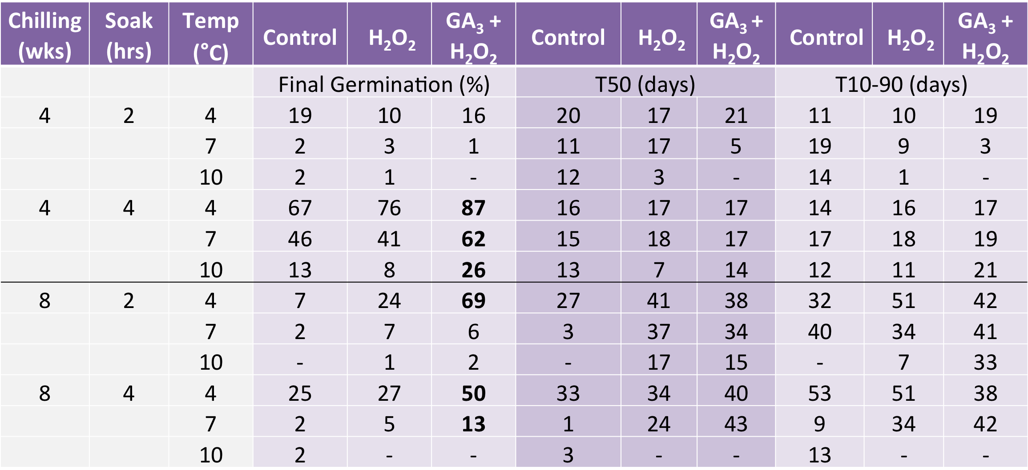

Figure 3. Visual time lapse of seed germination for 4 week chilling trail at 4C with 2 hr. GA₃ soaking.
Figure 4. Visual time lapse of seed germination for 8 week chilling trail at 4C with 2 hr. GA₃ soaking.

Figure 5. Visual time lapse of seed germination for 4 week chilling trail at 4C with 4 hr. GA₃ soaking.

Figure 6. Visual time lapse of seed germination for 8 week chilling trail at 4C with 4 hr. GA₃ soaking.

Table 2. Canyon De Chelly seed treatments include an application of GA₃ (500, 750, or 1000ppm) ± Promalin(600ppm) ± H₂O₂ chilled at 4 or 7C. Final %germination, T50 (germination speed) and T10/90(uniformity/germination spread) are given for each treatment and germination trial.
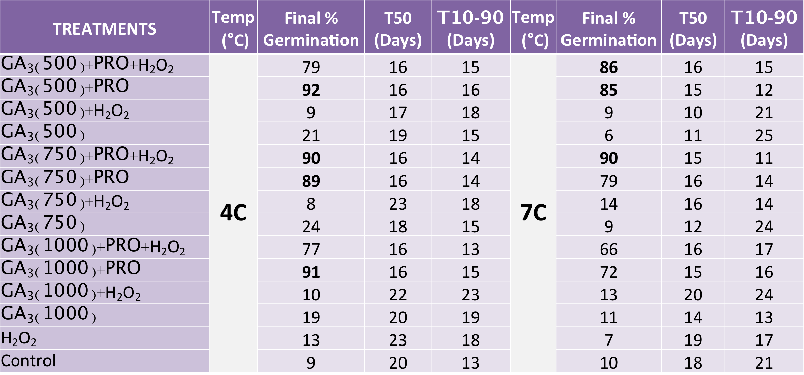

Table 3. Canyon De Chelly seed treatments include an application of GA₃ (500, 750, or 1000ppm) ± Promalin(600ppm) ± H₂O₂ chilled at 10C. Final %germination, T50 (germination speed) and T10/90(uniformity/germination spread) are given for each treatment and germination trial.
TREATMENTS | Temp (°C) | Final % Germination | T50 (Days) | T10/90 (Days)
GA₃(500)+PRO+H₂O₂ | 10C | 45.6 | 16 | 16
GA₃(500)+PRO |  | 68 | 13 | 13
GA₃(500)+H₂O₂ |  | 4 | 11 | 11
GA₃(500) |  | 4 | 9 | 8
GA₃(750)+PRO+H₂O₂ |  | 72 | 14 | 12
GA₃(750)+PRO |  | 73.6 | 16 | 15
GA₃(750)+H₂O₂ |  | 3.2 | 14 | 23
GA₃(750) |  | 4 | 9 | 13
GA₃(1000)+PRO+H₂O₂ |  | 42.4 | 17 | 24
GA₃(1000)+PRO |  | 62.4 | 15 | 15
GA₃(1000)+H₂O₂ |  | 0 | NA | NA
GA₃(1000) |  | 3.2 | 4 | 23
H₂O₂ |  | 3.2 | 11 | 4
Control |  | 4.8 | 7 | 22

Figure 7. Visual time lapse of seed % germination after being treated with GA₃ (500ppm) + Promalin and chilled at 4, 7, or 10 C.

Figure 8 Visual time lapse of seed % germination after being treated with GA₃ (750ppm) + Promalin + H₂O₂ chilled at 4, 7, or 10 C.

Figure 10. Historic remnants of Navajo drying techniques of Navajo Spinach at Canyon De Chelly National Monument. Photo taken by Winston Hurst.
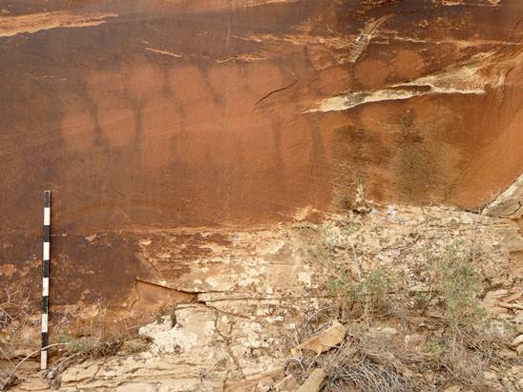

Figure 11. Close up photograph of upper right section in Figure 10. Photo taken by Winston Hurst.

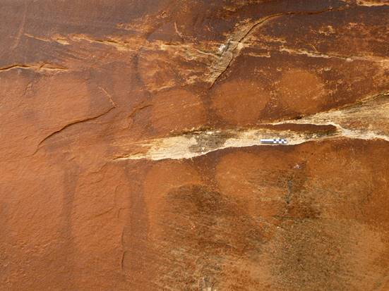

Figure 12. Cleome serrulata seed close up.
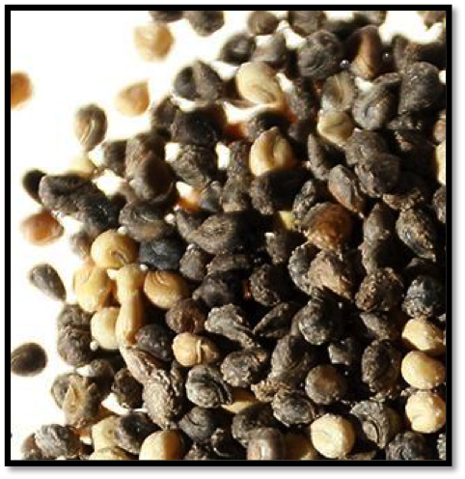

Figure 13. Cleome serrulata white seed in pod
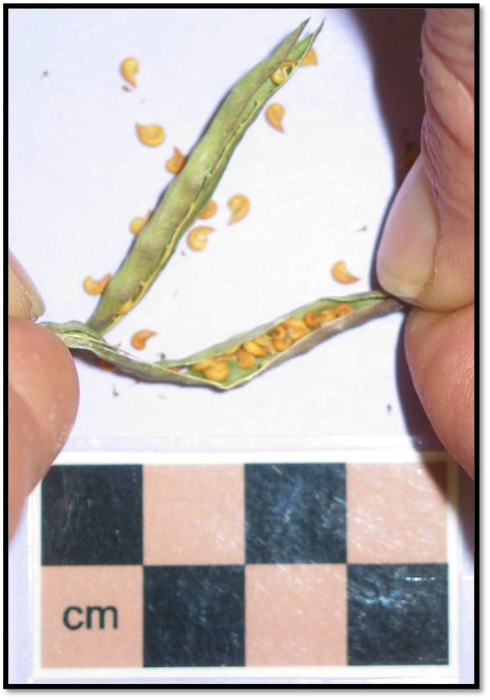

Figure 14. Close up of seed pods for Cleome serrulata
