SMALL FARMS, NEW MARKETS

Webinar Series Illuminates how Farmers and Buyers Connect
In recent years, a variety of new wholesale opportunities have opened to small and mid-sized farmers. Whether its a brick and mortar venue such as a food hub, distributor or grocery store, or a virtual venue such as an online marketplace, these new avenues provide countless new ways to get your product out to bigger customers. But how do you decide which wholesale market is the right one to pursue?
You can find out by tuning in to Small Farms: New Markets, a 4-part webinar series. The webinars feature a dairy, mushroom, livestock and produce farmer that have transitioned successfully to one or more new wholesale markets. Farmers reflect on their decision making process, benefits and challenges, costs, and infrastructure needed to get their products to bigger markets. Each webinar also features one of the farmer’s ‘wholesale’ buyers who describe how they establish productive relationships with smaller farms, and outline their business models and buying requirements.

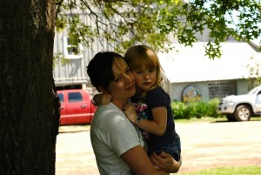
“Turning Milk to Gold (Butter)” with Shannon Mason of Cowbella and Sonia Janiszewski & Richard Giles of Lucky Dog Food Hub
In 2010, Shannon Mason started turning the fresh Jersey milk from her family’s historic Catskill dairy farm into cheese and butter. She marketed the new product line, Cowbella, through farmers’ markets, on-farm retail and specialty grocery stores. Today, Cowbella products can be found in 35 locations across NY, including 7 Price Choppers, 6 Tops Markets, and 4 Shop-Rites. Mason’s most recent wholesale market is Lucky Dog Local Food Hub based in Hamden, NY. Lucky Dog started as an organic vegetable farm in 2000, but owner Richard Giles saw an opportunity to create a ‘hub’ when he had extra space on the refrigerated truck he used to transport his vegetables to New York City markets. The extra space in the truck is available to other regional small farms who need help transporting and delivering product to NYC buyers. Learn more about how Shannon Mason and other upstate farmers work together with Lucky Dog Food Hub to reach larger markets in the NYC metropolitan region. (Recorded on April 6th, 2015) Watch the Archived Webinar

“Mushrooms to Dining Rooms” with Alan Kaufman of Shibumi Farm and Jennifer Goggin of FarmersWeb
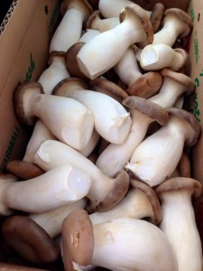
Alan Kaufman began growing exotic mushrooms as a hobby in his home basement in 2003. Today he produces as much as 5000 pounds of mushrooms a week, supplying unusual varieties to highly regarded chefs in New York and New Jersey from his Shibumi Farm in Princeton, NJ. Kaufman’s 35 unique strains of mushrooms are all cultivated indoors in a temperature and humidity controlled fruiting chamber. With ecological health in mind, Kaufman’s growing medium is locally sourced and sustainably harvested wherever possible and he avoids synthetic pesticides or fertilizers. Last year, Alan started using FarmersWeb online business management software for farms, food hubs, and local food artisans. FarmersWeb has helped Shibumi farm manage its wholesale business with new and old customers alike. With more time for growing, Shibumi has expanded its wholesale business to include more restaurants, corporate kitchens, and purchasers such as the Natural Gourmet Institute. CEO Anthony Fassio will speak to how the NGI connects with small farmers like Alan and purchases regional farm products for use in their chef training programs. (Recorded on April 20th, 2015) Watch the Archived Webinar

“Upstate Livestock Farm Reaches NYC Restaurants” with Stephen Winkler of Lucky 7 Livestock Company and Seth Mosner of Mosner Family Brands
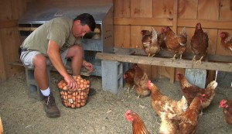
In 2000, Stephen Winkler and his family were selling their Lucki 7 Livestock Farm products to neighbors and through local farmers markets, grossing a little over $20,000 annually. In the years that followed, the rising demand for locally produced food enabled Lucki 7 Farms to start selling to white tablecloth distributors and retailers such as Whole Foods and Wegmans. Today, the farm’s annual sales include 800-1000 hogs, 35 head of beef, 700 meat chickens, and 7000 dozen eggs a year. In 2013, Stephen started selling pasture raised hogs and grass fed beef to Mosner Family Brands. Founded in 1957, Mosner Family Brands is a wholesale meat company based in the Bronx, NY, supplying high quality products to premium food service distributors, distinguished restaurants and high-end retailers. Mosner’s philosophy in partnering with small and mid-sized farmers is to empower them to focus on agriculture and farm management, rather than processing, logistics and other ancillary market-making functions. In doing so, Mosner has helped small family farms scale, become job creators and enhance farm operations through improved and consistent cash flow. Learn more about how Stephen Winkler and other livestock farmers work with Mosner Family Brands to reach restaurants and retail stores. (Recorded on October 12th, 2015) Watch the Archived Webinar

“Selling Produce to Groceries” with Dan Kent of Kent Family Growers
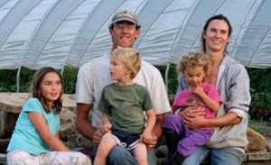
Dan and Megan Kent, along with a 3-member seasonal crew, rotate organic cash crops with cover crops on 20 acres near the St. Lawrence River in the town of Waddington, NY. Although they sell some of their produce through direct-marketing channels such as the Canton Farmers Market and a 40 week CSA, they have diversified their marketing mix to include a variety of wholesale outlets as well. They sell to several local food stores, including the Potsdam Food Coop and Nature’s Storehouse, a natural foods store in Canton. They also have their produce trucked down to Brooklyn where they have business connections with the Park Slope Food Coop, Perelandra Natural Food Center and Flatbush Food Coop. In this presentation, Dan Kent will share how he made connections with his wholesale customers, and describe any changes he made in infrastructure, packaging, labeling, invoicing and production to meet the needs of his wholesale clients. (Recorded on October 19th) Watch the Archived Webinar.

