Bokashi
Bokashi is a soil fertility amendment produced by fermentation. Bokashi has Japanese origins, and is being used in agriculture around the world. Like compost, it can be made with various feedstocks. Typically, some type of bran, such as rice or wheat bran is mixed with molasses and a microbial inoculant. This is then fermented for two to four weeks. Sometimes this is later added to additional materials such as food wastes, and other times the fermented bran mixture is the final product used as bokashi. Table 1 illustrates a variety of bokashi recipes used in other places. Bokashi has been shown to successfully raise crops and improve soil fertility in research studies all around the world, however the volume of studies published does not even come close to those that focus on composts, and little work has been done on it in the United States. Bokashi holds the promise of a faster turnover of wastes on a smaller footprint of land with less production equipment required.
Recipe | Author(s)/Information Source
EM, chicken manure, wheat bran | Daiss et. al. (2008)
Sheep manure, molasses and yeast | Gómez-Velasco et. al., (2014)
Cow manure (1000 kg), ground corn stocks (300 kg), local soil (1200 kg), fine charcoal (100 kg), wheat bran (25 kg), brown sugar (4 kg), baker's yeast (1 kg)- materials moistened, tarp covered materials. Pile turned daily for 12 days. | Jaramillo-López et. al. (2015)
Plant residues, poultry litter, bone mean, castor cake | Lima et. al. (2015)
Wheat bran,, molasses, EM-1 | Mayer et. al. (2010)
Molasses (8 ml), water (800 ml) and EM-1 (8 ml) rice bran (3.5 kg) and rice husk (2.0 kg), rapeseed oil mill cake (1.5 kg), and fish meal (1.0 kg) | Yamada and Xu (2001)
Chicken manure, coffee husks, saw dust, rice bran, molasses, forest litter/topsoil | Co-op in El Salvador
Cow manure (300 kg), Wheat straw (200 kg), Soil (300 kg), ground corn stalks (300 kg), ash/charcoal (50 kg), yeast (0.5 kg), molasses (8 L) | Co-op in Mexico
Table 1. Summary of various recipes used in producing bokashi.

Effective Microorganisms
In our research we used the inoculant, Effective Microorganisms®, or EM, developed by researcher Teruo Higa in Japan. EM is a consortium of lactic acid bacteria, photosynthetic bacteria, yeasts and actinomycetes coexisting in liquid at a pH of 3.5. Higa promotes EM to drastically accelerate the breakdown of organic matter and release of nutrients, boosting yields while also providing plants with other compounds such as amino acids, organic acids, polysaccharides and vitamins. Here is a synopsis of the main groups of microbes in Higa’s EM-1 and their pertinent characteristics:
LACTIC ACID BACTERIA
Lactic Acid Bacteria (LAB) are chemoheterotrophs, meaning they use energy from chemical reactions for ATP and in order to form their own organic compounds, they obtain carbon from things like carbohydrates, lipids, proteins, or sulfur compounds. LAB species present in EM including Lactobacillus plantarum and Lacctococcus lactis, are used in the fermentation of food products. These bacteria will convert carbohydrates to different organic acids, mainly lactic acid, and alcohols.
Lactic acid is multifunctional within the soil community, suppressing disease-causing microbes and facilitating the breakdown of lignin. This is not the only acid created by LABs, for example Lactobacillus casei, in their exertions to obtain energy will create Indoleacetic acid (IAA) and Indolebutyric acid (IBA), which are both auxins, a type of plant hormone that promotes plant growth. IAA, one of the most active auxins, stimulating cell division and cell elongation, is preceded by tryptophan, an amino acid also produced by different fermentation microbes.
PHOTOSYNTHETIC BACTERIA
Also known as purple bacteria, this group of microorganisms are capable of producing their own food via photosynthesis. Sunlight is the ultimate factor in plant growth and development, and thus agricultural production; it all begins with photosynthesis. The actual utilization rate of solar energy by plants ranges between 1 and 7%. Plants will only utilize certain wavelengths of visible light, so how do we increase the efficiency of a given land surface? Higa reasons that strengthening the populations of photosynthetic bacteria, which may utilize wavelengths different from green plants is one solution. EM-1 contains particular species Rhodopseudomonas palustris and Rhodobacter sphaeroides that are able to make use of wavelengths of light that green plants do not, and in turn produce nucleic acids, amino acids and sugars that are then used by LAB.
YEASTS
Yeasts perform similar functions as both LAB and the photosynthetic bacteria. They use the sugars and carbohydrates produced by photosynthetic bacteria (like LAB), and in turn create enzymes and hormones that may a) be used by plants for their growth and development, or b) used by lactic acid bacteria who may in turn create more substances useful for plant growth. For example, Saccharomyces cerevisiae has been found to produce tryptophan, which as previously mentioned, is the precursor to IAA production- an auxin. The yeasts included in Higa’s EM-1 liquid culture include Saccharomyces cerevisiae and Candida utilis.
THE ACTINOMYCETES
Actinomycetes are filamentous bacteria, their filaments branching through the soil to connect soil particles in a similar fashion as fungi- this promotes good soil structure. Unlike other bacteria, they can withstand a wide range of pH, and are skillful in breaking down the more slowly decaying substances such as cellulose and chitin, that other microbes are not as quick to digest.
The main take away point about the microbes that make up the EM-1 inoculant is that they are all fairly flexible species, able to withstand aerobic or anaerobic environments, as well as a wide range of temperature and pH and salt content. More information can be found about individual species at Dana’s blog: www.undergroundgalaxy.wordpress.com

Step-by-step Guide of How to Make Bokashi
Here I describe the steps involved in making your own batch of bokashi. It is a fairly simple, relatively pleasant process (minimal stench) requiring very little infrastructure and materials. Here’s what you’ll need:
- Organic wastes: food scraps, kitchen wastes, etc.
- Wheat bran
- EM-1 inoculant
- Molasses
- Water (Fluoride free)
- Bucket fitted with a spout
- Large garbage bag
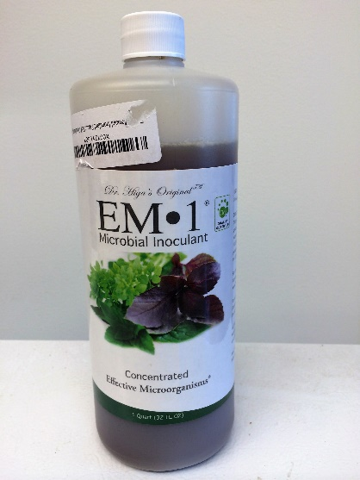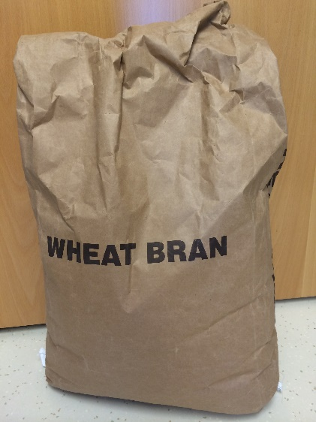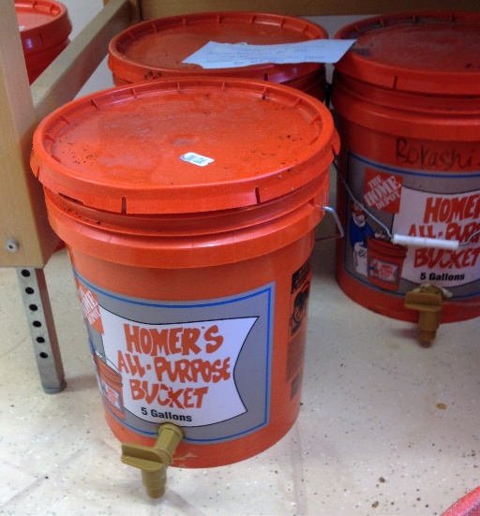
This recipe makes a 12 lb batch of wheat bran, which can be used to make anywhere from 100-200 lb of bokashi (wet weight). I followed the recipe outlined in Adam Footer’s book, Bokashi Composting: Scraps to Soil in Weeks.
- You’ll need one gallon of water. Of that, heat one pint of water and dissolve 3 Tbsp of molasses in it.
- Put the remaining water inside a 5-gallon pail (doesn’t have to be fitted with a spout) or some other container of similar size.
- Add the heated molasses water to the room temperature water in the pail. Add 6 Tbsp of the EM-1 inoculant.
- Mix this solution around. Then slowly start adding the wheat bran into the microbe molasses water, mixing as you go to ensure all the wheat bran is moistened.
- If after adding all of the bran, it does not remain in a loose ball after squeezing in your hand, add a little bit more water, just a few tablespoons at a time.
- When it has been thoroughly mixed and reached proper moisture, put the bokashi bran into a doubled up garbage bag. Make sure all of the air is squeezed out, then secure as tightly as you can so that minimal oxygen enters the environment.
- Let the bokashi bran sit for two weeks. During this time period, you are allowing the microbes to multiply, using the molasses as a carbon source and converting it into different acids and alcohols.
- When the two weeks is up, it is time to assemble your bokashi buckets. Take your 5-gallon pail fitted with a spout. Sprinkle a dusting of bokashi bran onto the bottom.
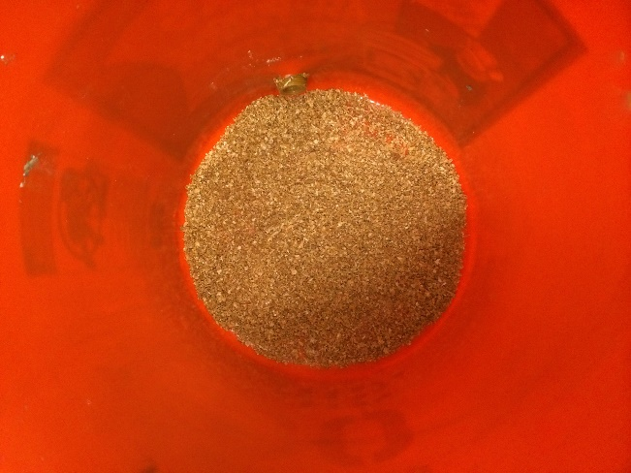
- Add a layer of food waste, roughly 6 inches thick. Top it with another layer of bokashi bran and press down so that the layer compacts. Here’s where the range in weight comes, in terms of how far the 12 pounds of bran will go. Depending on your feedstock, you may add more or less bokashi between the layers. Food scraps with a lot of lignin or cellulose such as melon or pineapple peels, or if you added meat to your layers, adding more bran in these places adds more “microbe power” to transform those materials. If you’re adding things like bread or rice, a thinner layer of bokashi bran would be sufficient.
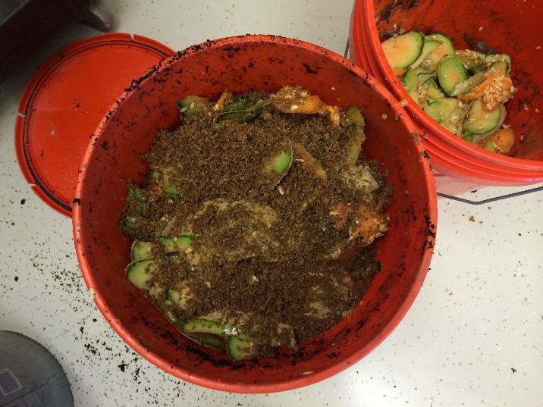
- Keep alternating between food and bran layer, adjusting bran layer accordingly and pressing down after each layer to compact everything. Remember the idea is for minimal oxygen to be entering the system. Be sure you top the bucket with bokashi bran, going as far as you can to the top.
- Put the lid on tightly and let your microbes and food scraps interact with one another for at least two weeks. I’ve let batches go for as long as 4 weeks before using them.
Using Bokashi
After this second fermentation, your bokashi is ready to be applied. You’ll notice that it doesn’t really look any different coming out of the bucket than it did going in, just as pickles still resemble cucumbers. Don’t expect to see decomposed material resembling compost right out of the bucket; there’s a bit more work to be done to get the bokashi to that point. This type of bokashi works best if buried in the soil. I dug trenches in the soil, about 8 inches deep, filled them halfway and then covered them again with about 4 inches of soil. If I were to do this again I would dig the trenches a little deeper, covering them with at least 6 inches of soil. Despite what you read on the internet, bokashi does smell, perhaps not as strongly as rotting food waste, but still strong enough for critters to catch a whiff. I had a few problems with animals pulling things up from my trenches, so the deeper you bury the better. However, don’t bury it so deep so that your crop roots won’t be able to reap the benefits of the amendment.
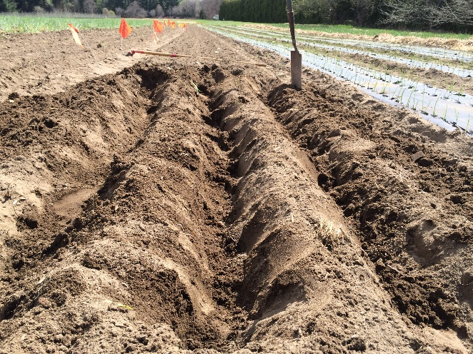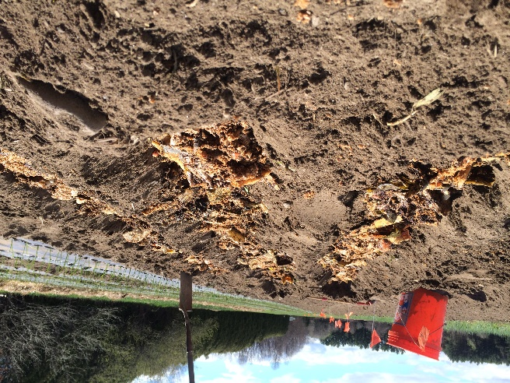

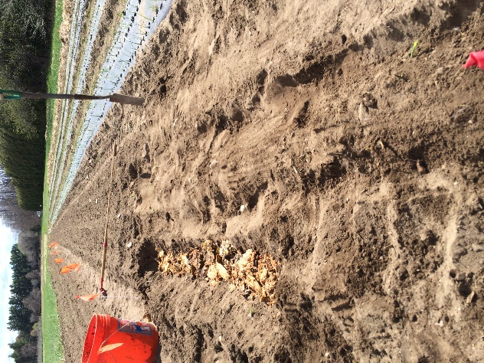
People have also buried bokashi in holes next to fruit trees, or incorporated into the middle of compost piles to further decompose it before using.
Thoughts, questions, stories, or experiences to share? Contact me (Dana) at dana.mae.christel@gmail.com or 920-323-7212

