EVENT! Field Workshop on Preparing and Using Bokashi
August 25, 2016
3:00pm- 5:00pm
UVM Horticulture Research and Education Center

Cost: Free!
Learn how to make and use bokashi, a type of fermented compost with Japanese origins. This two hour workshop held at the UVM Hort Farm will provide with you with an overview on the differences between bokashi and compost, how to prepare bokashi bran with a microbial inoculant and use it to make bokashi, and how to use the resulting product in a garden or on a farm. We will also have the opportunity to share results from a graduate student SARE project, which compared the use of bokashi alongside compost and vermicompost and its effects on soil quality and crop growth. Event will provide snacks for workshop attendees and informational handouts to take home.
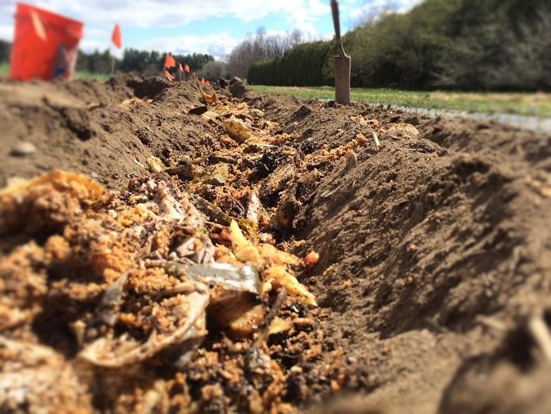
Contact Dana Christel at 920-323-7212 or dchrist2@uvm.edu with any questions. Please to RSVP by contacting her by August 20, 2016.
