 | Total N (%) | Total C (%) | C/N Ratio | NH₄⁺ | NO₃⁻ | Total Inorganic N | P (Plant Avail. ) | Ca | K | Mg | Na | Al | Fe | Mn | B | Zn | S | pH
Vermicompost | 3.41 | 38.05 | 11.15 | 20.75 | 4745 | 4765.75 | 2705 | 9850 | 22250 | 4225 | 5900 | 130.5 | 0 | - | - | - | 960 | 6.73
Thermophilic Compost | 1.16 | 20.38 | 17.62 | 10.2 | 33.6 | 43.8 | 905 | 6900 | 4920 | 1640 | 1380 | 14.25 | 3.9 | 65 | 1.25 | 5 | 230 | 7.48
Bokashi (Field Trial) | 2.45 | 45.22 | 18.49 | 1055 | 40.2 | 1095.2 | 3645 | 615 | 6250 | 1830 | 2390 | - | 14.4 | 42.5 | - | 22.6 | - | 4.23
Bokashi (Greenhouse Trial) | 3.54 | 46.85 | 13.25 | 1410 | 25.95 | 1435.95 | 3950 | 6400 | 8250 | 2695 | 1755 | 184 | 28.5 | 25.5 | - | 23.5 | 575 | 4.21
Table 1. Nutrient Profiles of amendments used in studies. Units in mg kg⁻¹ if not specified.
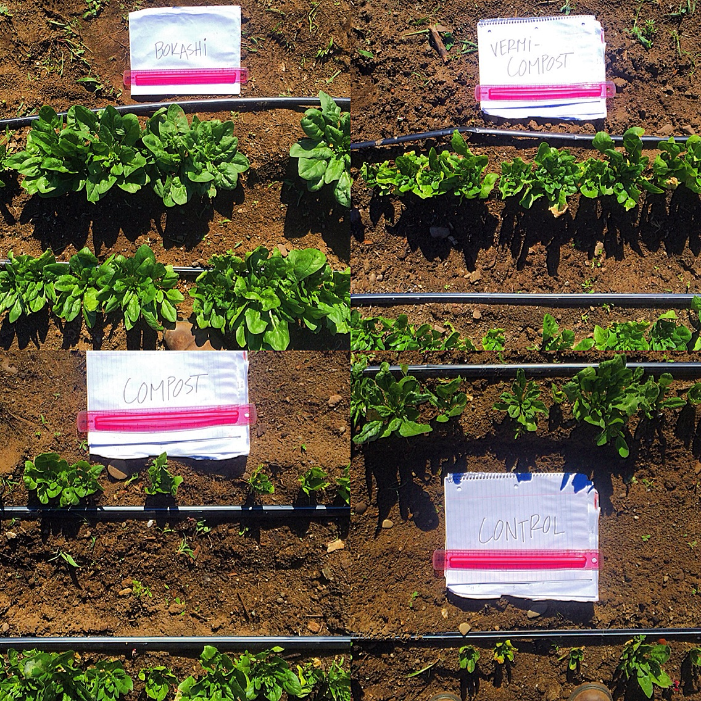
Figure 2. Comparison of spinach growing in different treatments. Top left: Bokashi, Top right: Vermicompost, Bottom left: Compost, Bottom right: Control
Figure 1. Yield comparison across treatments of 1st and 2nd cuttings, and total.
Different letters indicate significant differences between treatments (p<0.05)

Figure 3. Comparison of nitrogen speciation of treatments over time. Different lowercase letters indicate significant differences among treatments. Different uppercase letters denote significant differences between sampling points (p< 0.05)
Figure 5. N concentration in spinach leaf tissue. Different letters indicate significant differences between treatments of that harvest (p<0.05)
Figure 4. pH of bokashi from time of planting to end of experiment.

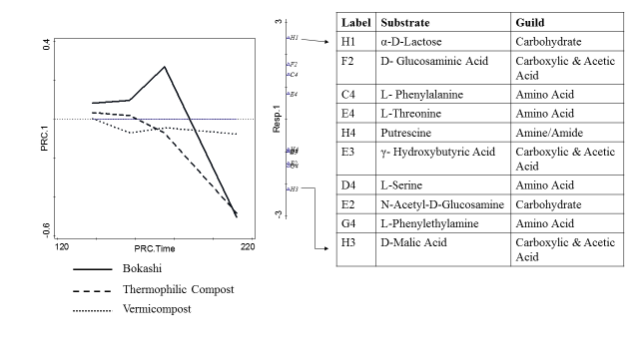
Figure 6. Plant available phosphorus concentrations in soil over time. Lower case letters indicate significant differences between treatments, uppercase letters indicate differences of a particular treatment across sample date(p<0.05)
Figure 7. Principal response curve of carbon substrate utilization with control plot used as baseline. The scores of the 10 best fit substrates are shown on the right axis. The substrates are listed in the table at the right along with their respective guild.

Figure 7. Principal response curves of C-Substrate utilization of treatments with the absorbance of untreated plots used as the baseline. The scores of the 10 best fit substrates are shown on the right axis. The substrate names are listed in the table in descending order from highest to lowest scores. Arrows indicate the corresponding substrate on the score axis with the name in the table.
7

 | Carbohydrates | Carbox./ Acetic Acids | Amino Acids | Polymers | Amines/Amides | Species Richness
Bokashi | 1.00 | 1.00 | 1.00 | 1.00 | 1.00 | 31.00
Thermophilic Compost | 0.90 | 0.85 | 0.78 | 0.92 | 0.83 | 26.67
Vermicompost | 0.97 | 1.00 | 0.94 | 1.00 | 1.00 | 30.33
Control | 0.80 | 0.74 | 0.72 | 1.00 | 1.00 | 25.00
Table 2. Proportion of carbon-substrate guilds used by treatment on sample date 5/16/16.
 | Carbohydrates | Carbox./ Acetic Acids | Amino Acids | Polymers | Amines/Amides | Species Richness
Bokashi | 1.00 | 0.96 | 0.94 | 1.00 | 0.83 | 30.00
Thermophilic Compost | 0.93 | 0.81 | 0.83 | 1.00 | 1.00 | 27.67
Vermicompost | 0.93 | 0.81 | 0.78 | 1.00 | 1.00 | 27.33
Control | 0.90 | 0.89 | 0.67 | 1.00 | 1.00 | 27.00
Table 3. Proportion of carbon-substrate guilds used by treatment on sample date 6/2/16.
 | Carbohydrates | Carbox./ Acetic Acids | Amino Acids | Polymers | Amines/Amides | Species Richness
Bokashi | 1.00 | 0.96 | 1.00 | 1.00 | 1.00 | 30.67
Thermophilic Compost | 0.83 | 0.85 | 0.83 | 1.00 | 1.00 | 27.00
Vermicompost | 0.90 | 0.85 | 0.78 | 1.00 | 0.83 | 27.00
Control | 0.97 | 0.85 | 0.83 | 1.00 | 1.00 | 28.33
Table 4. Proportion of carbon-substrate guilds used by treatment on sample date 6/23/16.
 | Carbohydrates | Carbox./ Acetic Acids | Amino Acids | Polymers | Amines/Amides | Species Richness
Bokashi | 0.77 | 0.70 | 0.78 | 0.92 | 1.00 | 24.33
Thermophilic Compost | 0.60 | 0.37 | 0.44 | 0.67 | 0.83 | 16.33
Vermicompost | 0.87 | 0.44 | 0.89 | 0.58 | 0.50 | 21.33
Control | 0.80 | 0.41 | 0.72 | 0.58 | 0.50 | 19.33
Table 5. Proportion of carbon-substrate guilds used by treatment on sample date 7/30/16.

