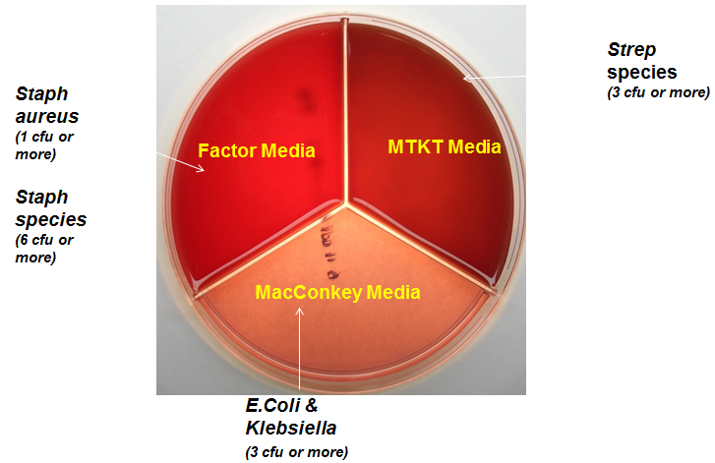

**CURC**

**Plate Reading and Protocols for Mild and Moderate Mastitis**

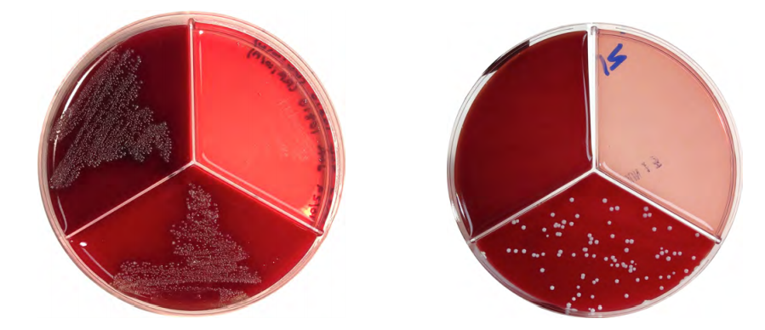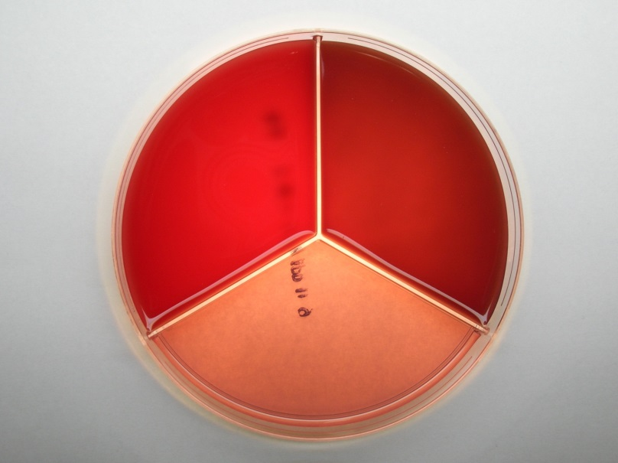

NO GROWTH.

Put FCULT event in and

MAST protocol = NO TREAT

Is it “powdery” looking? NO.

Staph spp.

Put FCULT event in and

MAST protocol = Polymast 3 days

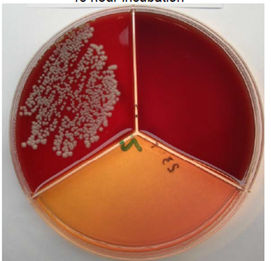

Is it “powdery” looking? YES

Likely Yeast, confirm with microscope

or confirm with QMPS

Put FCULT event in and

MAST protocol = NO TREAT

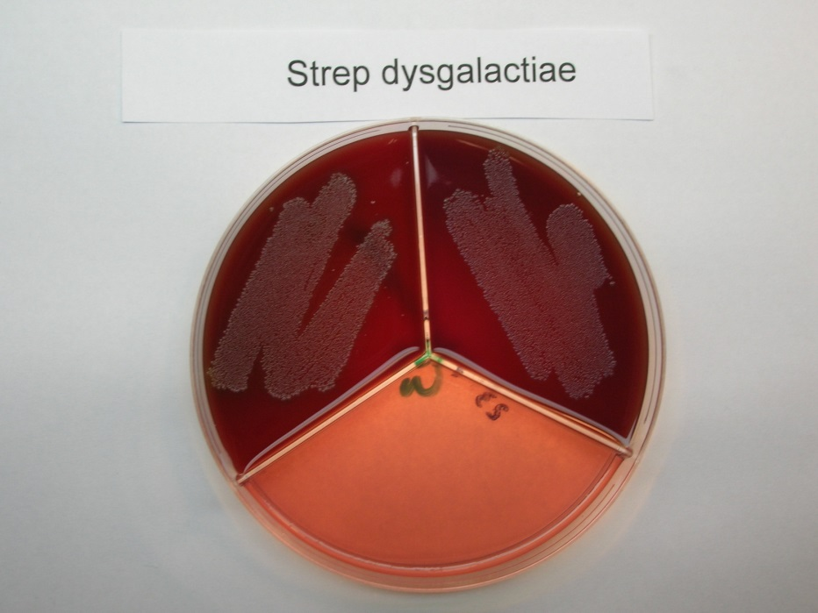

Strep spp.

Put FCULT event in and

MAST protocol = Polymast 3 days

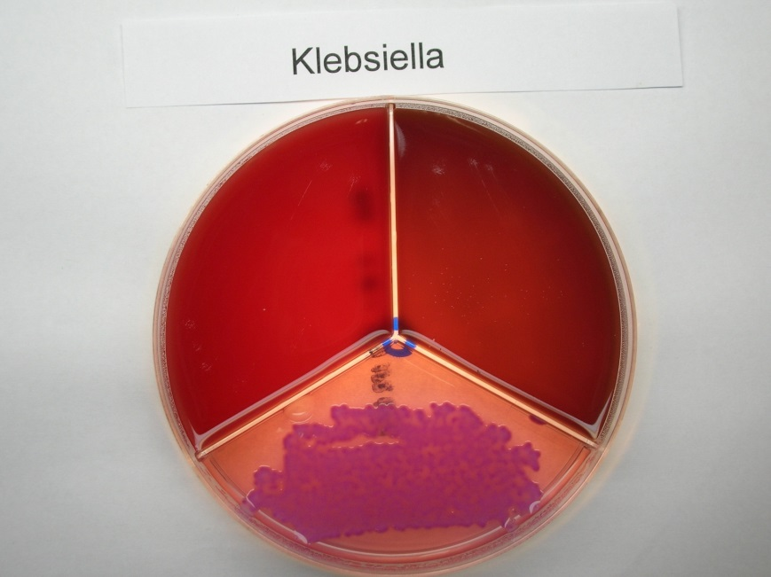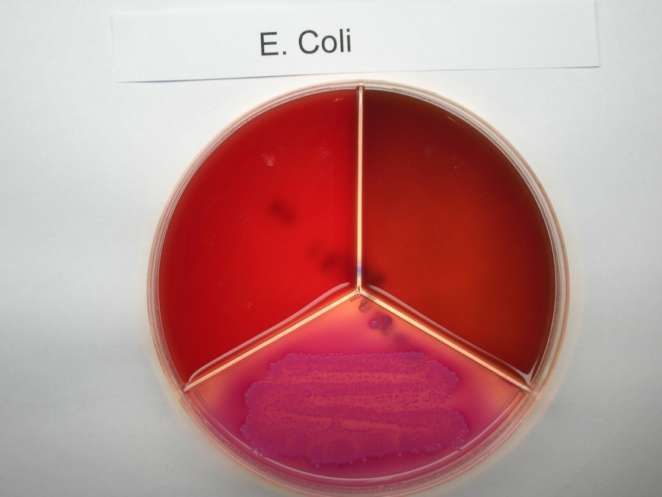

E. coli

(Pink Haze around colonies)

Put FCULT event in and

MAST protocol = NO TREAT

Klebsiella

(Yellow colonies with pink edges, and goopy)

Put FCULT event in and

MAST protocol = Spectramast 5days

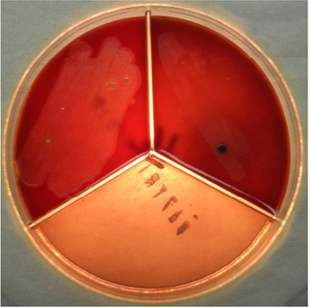

T Pyogenes

Growth on factor media, pinpoint colonies and hemolysis

Put FCULT event in and

MAST protocol = NO TREAT

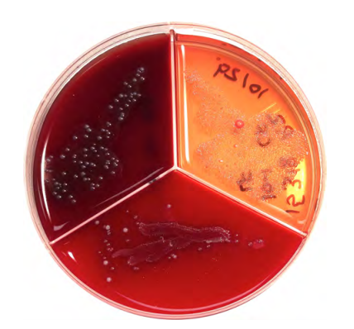

Contamination (usually)

Growth in all 3 zones

Put FCULT event in

Resample or follow Staph spp. protocol if quarter is not resolving

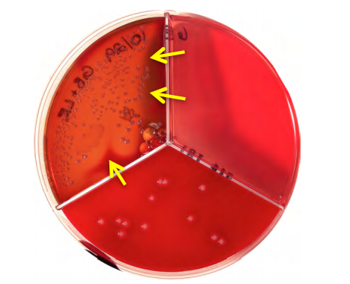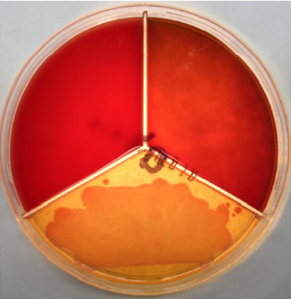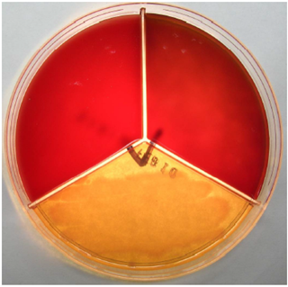

Growth on Factor and MTKT with hemolysis in the MTKT

Strep ag

Put FCULT event in

Submit for confirmation to QMPS

Consult management

Other Gram negative

Put FCULT event in and

MAST protocol = NO TREAT

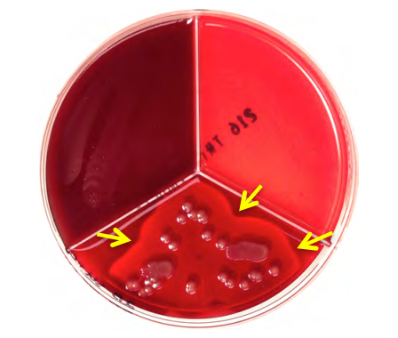

Growth on Factor with hemolysis

Staph aureus

Put FCULT event in

If young healthy animal, first time mastitis and no history of high SCC,

MAST Protocol= Pirsue 8 days

Otherwise, consult management about culling

